The history and composition of the Carnegie *Diplodocus*

**Michael P. Taylor.** Department of Earth Sciences, University of Bristol, Bristol BS8 1RJ, UK. [dino@miketaylor.org.uk](mailto:dino@miketaylor.org.uk) (corresponding author)

**Amy C. Henrici.** Section of Vertebrate Paleontology, Carnegie Museum of Natural History, Pittsburgh, Pennsylvania, USA.

**Linsly J. Church.** Section of Vertebrate Paleontology, Carnegie Museum of Natural History, Pittsburgh, Pennsylvania, USA.

**Ilja Nieuwland.** Huygens Institute, Royal Netherlands Academy of Arts and Sciences, Netherlands.

**Matthew C. Lamanna.** Section of Vertebrate Paleontology, Carnegie Museum of Natural History, Pittsburgh, Pennsylvania, USA.

**Abstract**

Diplodocus is a sauropod dinosaur from the Upper Jurassic Morrison Formation of North America. It is known around the world primarily because of a single skeleton, that of the Carnegie Diplodocus, because the millionaire industrialist Andrew Carnegie had casts of this specimen mounted in nine prominent cities around the world between 1905 and 1930. As well as these iconic casts, the original fossil material was mounted at the Carnegie Museum (now Carnegie Museum of Natural History) in 1907, and underwent a series of minor changes through the years before a major remount as part of the Carnegie's Dinosaur Hall renovation in 2005–2007. The composition of the original mount was never fully described, and the changes made since the initial mount have not been extensively documented. The bulk of the skeleton consists of bones from the Diplodocus carnegii holotype CM 84. The paratype CM 94, a referred specimen CM 33985, and a specimen of a related species CM 307 all provide additional fossil material. However, significant parts of this mount are casts or sculptures, including the skull, atlas, numerous caudal vertebrae, forelimbs (including forefeet), and most of the left hindlimb. The left forelimb and both forefeet used in the original mount were cast from a camarasaurid, and the right forelimb from that of the diplodocine Galeamopus (= “Diplodocus”) hayi. The humeri, radii, and ulnae were replaced in the 2007 remount by scaled-up sculptures based on probable diplodocid elements; and the forefeet by scaled-up sculptures of another diplodocine specimen. Numerous divergent length measurements exist for this specimen, but the current mount is about 26.1 m long based on photogrammetric and LIDAR models.

**Keywords:** Diplodocus, sauropod, skeletal mount, cast, history, Carnegie Museum

To the extent possible under law, the authors have waived all copyright and related or neighboring rights to “The history and composition of the Carnegie *Diplodocus*”. This document is in the public domain, as specified by [the CC0 Public Domain waiver](https://creativecommons.org/public-domain/cc0/). No rights reserved.



Table of Contents

Introduction 3

Nomenclature 4

Institutional abbreviations 4

Historical background 5

Material in the mounted skeleton 15

The original mount at the Carnegie Museum 15

Changes made to the mount at the Carnegie Museum 20

Replacement of skull with replica of CM 11161 20

Suspension of neck 21

1999 replacement of forefeet with CM 662 replicas 21

2007–2008 refurbishment of the dinosaur exhibition 21

Forefeet WDC-FS001A 21

Forelimb elements from BYU material 22

Caudal vertebrae 23

The casts made from the Carnegie molds 27

Discussion 27

The length of the Carnegie *Diplodocus* 27

Documenting skeletal mounts 30

Acknowledgments 31

References 32

Tables 39

Figures 43

# Introduction

*Diplodocus* is a sauropod dinosaur from the Late Jurassic of North America, found in the extensive Morrison Formation of the western United States. Although larger and more complete sauropods are now known, *Diplodocus* was the first giant dinosaur known from a substantially complete skeleton: the Carnegie Museum’s iconic specimen CM 84, the holotype of the species *Diplodocus carnegii* (Figure 1). As explained below, casts of this important specimen were sent to cities throughout Europe and in Latin America and Russia, and as a result this individual became — and remains — the single best-known dinosaur in the world.

However, although the mounted skeleton is often referred to as CM 84, it is actually a composite containing substantial portions of the *D*. *carnegii* paratype CM 94 and smaller parts of other specimens, as well as some cast and sculpted elements. The precise composition of the mount has changed since its initial unveiling, and the eleven casts that were made from its molds used slightly different elements again. Documentation of the choice of elements has not been comprehensive, and as a result, most of the museums around the world that are exhibiting a Carnegie *Diplodocus* do not know exactly what bones went into its construction.

In this paper, we will summarize the history of the original Carnegie *Diplodocus* and determine which fossil elements are included both in the fossil mount at the Carnegie Museum and in the many mounted casts based on this material.

## Nomenclature

The mounted *Diplodocus* skeleton at the Carnegie Museum does not have a specimen number of its own. It is often referred to loosely as CM 84, since that is the specimen that contributes most of the original fossil material to the mount, or, more carefully, as CM 84/94/307, since those are three of the four specimens that contribute fossil material. In this paper, we will refer to this mounted skeleton as “the Carnegie mount”; when we refer to CM 84, we mean the particular individual specimen, not the mount. When referring to the various cast mounts, we refer to them by the name of the city that they were originally mounted in (e.g., the London cast, the Berlin cast, the Vernal cast); the sole exception is that we refer to the Russian cast by the name of the nation in which it resides, as because it was initially installed in St. Petersburg but currently stands in Moscow.

The diplodocine specimen initially designated CM 662 was traded to the Cleveland Museum of Natural History in November 1956, because Carnegie Museum director Graham Netting had instructed head of vertebrate paleontology J. LeRoy Kay to trade large dinosaur specimens due to lack of storage space (Tschopp et al. 2019:10). Around the same time (1854–56), accession records show that the Carnegie Museum acquired 10,803 bird specimens from the CMNH, likely in exchange for the diplodocine. In Cleveland the diplodocine skeleton was given the specimen number CMNH 10670. In 1963, however, the specimen was sold for $15,000 to the Houston Museum of Natural Science, where it was cataloged as HMNS 175. (The CMNH’s *Haplocanthosaurus* (now the holotype of *H*. *delfsi*) was excavated between 1954 and 1957 (McIntosh and Williams 1998:4–5), and it is possible that the diplodocine CMNH 10670 was sold because it became apparent that there was not enough space to mount two large sauropods.) The Houston Museum mounted the skeleton in 1975 — ironically completing it with elements cast from second-generation Carnegie *Diplodocus* molds supplied by the Utah-based commercial casting company Dinolab, Inc. (Taylor et al. 2023) — then restored and remounted it between 2013 and 2015. For simplicity, we refer to this specimen throughout by its original designation CM 662, as it was under this specimen number that most of its role in this story was played out.

A distinction is made between molds and casts. A mold is a negative structure made from an original specimen (or, less commonly, from a cast or a sculpture), in which the spaces inside the mold match the shapes of the original specimen. A cast is a positive structure, a copy made of a specimen made by filling a mold, and its shape matches that of the original specimen.

Vertebrae are designated as follows, for a vertebra at position *n* in a part of the spinal column: cervical vertebrae C*n*, dorsal vertebrae D*n*, sacral vertebrae S*n*, and caudal vertebrae Ca*n*.

When measurements are quoted in both imperial and metric units in either order, e.g. “84 feet (= 25.6 m)” or “23.5 m (= 77 feet)”, the first measurement is as originally reported, and the second is converted.

## Institutional abbreviations

* AMNH — American Museum of Natural History, New York, New York, USA.
* BMNH — British Museum of Natural History, London, England. (Now the Natural History Museum, using the abbreviation NHMUK.)
* BSP — Bayerische Staatssammlung für Paläontologie und Geologie, Munich, Germany.
* BYU — Brigham Young University, Provo, Utah, USA.
* CM — Carnegie Museum of Natural History, Pittsburgh, Pennsylvania, USA.
* CMNH — Cleveland Museum of Natural History, Cleveland, Ohio, USA.
* HMNS — Houston Museum of Natural Science, Houston, Texas, USA.
* MfN — Humboldt Museum für Naturkunde, Berlin, Germany (formerly HMN). Fossil reptile specimens are designated MB.R.*nnnn*.
* MNHN — Muséum National d’Histoire Naturelle, Paris, France.
* TAMU — Texas A&M University, College Park, Texas, USA.
* USNM — United States National Museum, Washington, District of Columbia, USA. (Now National Museum of Natural History, Smithsonian Institution.)
* WDC — Wyoming Dinosaur Center, Thermopolis, Wyoming, USA.
* YPM — Yale Peabody Museum, New Haven, Connecticut, USA.

# Historical background

On 27 November 1898 (not 28 November as reported by Rea 2001:222), the *St. Louis Globe-Democrat* published an article written five days earlier by Grant Jones entitled “An animal 130 feet in length” (Jones 1898). It reported the discovery by William H. Reed of “the petrified bones of the most colossal animal ever taken from the earth’s stratas [sic]”, claiming an exaggerated length of eight feet for a femur, despite including an illustration of Reed standing next to the femur that showed him slightly taller than it. The article optimistically extrapolated a total length of 130 feet, hip height of 35 feet and shoulder height of 25 feet. Coggeshall (1951a:238) implies that Reed had a reputation for inflating the sizes of his finds, so it is likely that Jones was merely relaying dimensions relayed to him by Reed.

On 1 December 1898, the much more widely read *New York Post* published an anonymously condensed version of Jones’s article titled “The Dinosaur of Wyoming” (Anonymous 1898a). This came to the attention of industrialist and philanthropist Andrew Carnegie (Figure 2A), who at age 63 was beginning to turn his attention away from industry and had become founder and funder of the Pittsburgh museum that bore his name. Excited by this report, Carnegie scrawled on a copy “My Lord — Cant you buy this for Pittsburgh — try. Wyoming State University isnt rich — get an offer — hurry AC” (Figure 3). He sent this to William J. Holland (Figure 2B), director of the Carnegie Museum, and followed it with a cheque for $10,000 (about $370,000 today) (Holland 1930:84). (Many accounts — including that of Holland (1930:83) himself — credit a later article in the *New York Journal and Advertiser* (Anonymous 1898b), which depicts a “Brontosaurus giganteus” in bipedal posture, peering into an 11th story window, for triggering Carnegie’s interest, but Carnegie’s handwritten note shows that the earlier article was the significant one.)

Holland used Carnegie’s money to hire experienced field paleontologists away from other museums: Reed from the University of Wyoming and Jacob L. Wortman and Arthur S. Coggeshall from the AMNH (Coggeshall 1951a:238). He sent them out to collect Reed’s “Most Colossal Animal.” It soon became clear, however, that this discovery consisted only of the proximal third of an apatosaurine femur (Coggeshall 1951a:240), which was acquired by the Carnegie Museum as specimen CM 83 and is currently on display in the public gallery. The specimen appears about the same size as the femur of the *Apatosaurus louisae* holotype CM 3018, which measures 1785 mm (5 feet, 10 inches) (Gilmore 1936:232), so Reed evidently exaggerated the size of the specimen as well as its completeness. With this specimen proving a disappointment, the team’s remit was broadened to a search for spectacular sauropod specimens that could be mounted in the museum.

Carnegie’s interest in large dinosaurs wasn’t unique; at the time, dinosaurs — particularly sauropods — began to be used as the impressive centerpieces of grandly constructed natural history museums funded with private capital. On the one hand, “Robber Barons” wished to be identified with these powerful and dominant creatures. On the other, in a time of rising economic inequality and subsequent labor disputes, such philanthropism was designed to demonstrate that capitalism could be altruistic as well as competitive (Semonin 1997, Rieppel 2019:8-10).

On 2 or 3 July 1899, Wortman or possibly Coggeshall (accounts differ) found the first bones of a largely complete sauropod specimen at Sheep Creek in Albany County, Wyoming (Figure 4). (This date is sometimes given as 4 July — Independence Day — perhaps because that was when Wortman wrote to Holland with information about the new finds. In Coggeshall’s (1951a:240 version, it was he who found the first bones, and the date was 4 July; but his reminiscences at a distance of more than 40 years are not reliable and contain verifiable errors on other matters.) Wortman and his team (Figure 5) collected the skeleton across a period of several months (Hatcher 1901:3–4, Nieuwland 2019:44). This specimen was designated CM 84. It consisted of 14 cervical vertebrae C2–15 (although see Taylor 2022a:8–11 on uncertainties about the neck material), all 10 dorsal vertebrae D1–10, the complete sacrum S1–S5, caudal vertebrae Ca1–12, 18 dorsal ribs, both sternal plates, left scapulocoracoid (not right as stated by Hatcher), almost complete pelvis, right femur, and two thin bones of uncertain identity which Hatcher thought might be clavicles (McIntosh 1981:20).

In 1900, Olaf A. Peterson (Figure 2C) and Charles W. Gilmore collected another, slightly smaller, specimen of the same sauropod species from the same quarry (Hatcher 1901:3). This specimen was designated CM 94. It consisted of nine cervical vertebrae, nine dorsal vertebrae, the sacrum, some number of caudal vertebrae (39 as reported by McIntosh 1981, but see below), fragments of dorsal ribs, five chevrons, both sternal plates and scapulocoracoids, the complete pelvis, the left femur, and the right tibia, fibula, astragalus, and pes (McIntosh 1981:20).

Both specimens were prepared out of their matrix by Arthur S. Coggeshall (Figure 2D) and his team (Figure 6).

On 15 May 1901 (Nieuwland 2019:46), the classic description of both these specimens of *Diplodocus* was published (Hatcher 1901), written by John Bell Hatcher (Figure 2E), the Carnegie Museum’s head of paleontology. This monograph illustrated CM 84 in some detail and named it as the holotype of the new species *Diplodocus carnegii* in honor of the museum’s sponsor. (Hatcher’s (1901:56–57 diagnosis of the new species is arguably rather thin, depending almost entirely on the orientation of the neural spines of anterior caudal vertebrae, but renowned sauropod expert John S. McIntosh considered *D*. *carnegii* legitimately distinct from the type species, *D*. *longus* (Rea 2001:ix), and this separation has been widely followed.) The illustrations included a skeletal reconstruction of *Diplodocus* (Hatcher 1901:plate XIII; Figure 7).

In early October 1902, King Edward VII of England paid a surprise visit to Carnegie at Skibo Castle in Scotland (Nieuwland 2019:50), shortly after being crowned King, with the likely aim of taking inspiration from Carnegie’s state-of-the-art castle for the renovation of long-neglected palaces. There, according to most sources, he saw a framed copy of the skeletal reconstruction of *Diplodocus* from Hatcher’s descriptive monograph. As Coggeshall (1951b:276) told it nearly half a century later, however, what the King saw on his visit to Skibo Castle was a watercolor sketch of the Carnegie *Diplodocus* that had been executed by Holland even before Hatcher’s description was published. And in Holland’s (1930:84) telling, it was a lead-pencil sketch.

Happily, we were able to resolve these contradictions. Victoria Connor of The Carnegie Club (pers. comm., 2024), which now owns Skibo Castle, informed us that no relevant watercolour or lead-pencil artwork remains in the castle today, and suggested that whatever artwork was involved, the Andrew Carnegie Birthplace Museum might have acquired it. Jennifer Jones of the Birthplace Museum was able to confirm (pers. comm., 2024) that they have no watercolour or lead-pencil artwork of the *Diplodocus*, but that the printed plate in question was donated from Skibo Castle to the Birthplace Museum as part of its founding gift in 1928, along with other items associated with the King’s 1902 visit. The print is accessioned as ACBM 1928/461 and remains at the museum, although it is not currently on display (Figure 8). All evidence therefore suggests that it was this print that the King saw — a print which we have confirmed is identical to that included in Hatcher (1901).

At any rate, the King was impressed by the *Diplodocus* skeletal reconstruction, and requested a specimen for the British Museum (Natural History) in London, of which he was a trustee (Nieuwland 2019:50). Carnegie, keen to gain favor with men of influence, happily undertook to provide one as a gift, and on 2 October wrote to Holland to ask him to excavate another *Diplodocus* for the British Museum (Figure 9).

In late December 1902, when Carnegie had returned to Pittsburgh, Holland explained that finding a comparable specimen was unlikely, and would be expensive even if luck was on their side. He was able to persuade Carnegie that a cast of their existing specimen would be a more practical gift (Nieuwland 2019:58). That same month, Holland began arranging the details of the donation in correspondence with E. Ray Lankester, his counterpart at the British Museum (Natural History), writing that “the whole [is] to be executed in the very highest style of art.” The offer would be formally accepted by the British Museum Trustees on 23 February 1903 (letter from Holland to Lankester, 10 June 1904, reproduced by Barrett et al. 2010:24).

As early as 4 August 1903, Carnegie was thinking bigger than a single cast. In a letter to Holland, he wrote “I think better to make more than one cast of *Diplodocus* — if I visit all the Crowned Heads could send one to their National Museums” (Carnegie 1903). Again, Coggeshall’s (1951b:276) account is slightly different: in his telling, it was Holland’s foresight, not Carnegie’s, that led to multiple copies being made — and Holland’s (1903:2) letter of 31 January 1903 corroborates this interpretation: “The first issue from the molds will be your gift to the British Museum […] Subsequent issues may be employed by you to gratify the scientific acquisitiveness of such men as the Kaiser and the Czar, the President of the French Republic, the King of Belgium, *et id omne genus*.” Whoever originated this idea, it appealed to Carnegie as it allowed him to exploit *Diplodocus* to gain support from those with authority to advance peace arbitration, the main focus of his philanthropy at this time.

Starting in 1903 and extending into 1904, the Carnegie Museum made molds of the *Diplodocus* bones and the first set of casts from these molds. The work was led by Arthur Coggeshall, the chief preparator of fossils at the Carnegie Museum, who was also in charge of designing the armature to carry the cast bones. A crew of Italian plasterers led by Serafino Agostini (Figure 2F) was employed, thanks to their expertise in casting artworks and Agostini’s experience at the AMNH (Nieuwland 2019:71). Having come from Italy to the USA at age 15, Agostini had worked for eight years with a Pittsbugh manufacturer of church statuary (Seneff 1947:118). Other members of the Italian crew included Emile Poli and Manno Fabri (Krishtalka 1988:15). The molding and casting process was elaborate, as described by Seneff (1947:118):

To produce the plaster dinosaurs, a cast had to be made of each bone. The entire bone could not be copied at one time but, protected by a thin coating of wax, must be marked off by wax ridges into small sections, sometimes as many as twenty to one bone. Then plaster was poured on. Assembled in the shape of the whole bone, this shell was filled with glue, which hardened. After the sections of plaster were removed, a complete plaster cast of the bone was made around this glue model. The plaster could not be cast directly on the bone because of its brittleness. Wire and iron reinforcements were then added to the bones.

Although the *Diplodocus* skeleton was made up of about 200 bones (counting the skull as a single unit), the molds consisted of 600 pieces (Madsen 1990:2), as some of the more elaborately constructed vertebrae required twenty- to thirty-piece molds to capture their complexities (Holland quoted in Nieuwland 2019:63).

Agostini continued to work for the Carnegie Museum for another 44 years until retiring in 1948 (Krishtalka 1988:15), and remained an important part of the operation; for example, the museum’s Annual Report for 1934 states that “Mr. Agostini made some excellent moulds [sic] and casts of the skulls of *Apatosaurus* and *Diplodocus* during the year and one of these skull casts has been mounted on our great skeleton of *Apatosaurus* which stands in the exhibition hall” (Carnegie Institute 1934:40).

Although we, and other sources, speak freely of molds and the casts made from them, the reality is rather more complex. As Holland (1903) wrote in a letter to Carnegie, “the condition of our bones […] is such that we cannot without endangering the specimens in some cases pour plaster about them to make piece molds. […] It will become necessary for us to carefully model in sculptor’s clay a number of at least the vertebrae, and then from the models make molds, from which an indefinite number of reproductions can in future be made.” Thus the molds of at least some of the complex vertebrae are actually molds of sculptures, not of the original bones; and so the casts created from them do not precisely match their original fossil counterparts.

In the early summer of 1904, the cast created for the British Museum was temporarily mounted as a trial in the Main Hall of the Pittsburgh Exposition Society at The Point in downtown Pittsburgh (Figure 10; photograph in Nieuwland 2019:figure 3.1). At this point, it was the only available building in the city big enough to house the skeleton, the museum’s new Dinosaur Hall not yet having been completed. The work was led by Coggeshall, who was responsible not only for executing the mount but also for creating the techniques. At the start of the 20th Century, there was little prior art for mounting large fossil skeletons. The most experienced crew was that responsible for mounting all the Bernissart *Iguanodon* specimens in Brussels (Belgium), but they maintained little to no contact outside the francophone world, and guarded their secrets. Coggeshall had to work out for himself how the cast bones could be mounted in a lifelike posture, informed by some experience with fossil mounts in his previous post at the AMNH, but nothing on the scale of a complete sauropod. The mounting was carried out by a team of three: Coggeshall himself aided by Agostini and L. S. Coggeshall (Coggeshall 1951b:276), the latter almost certainly Arthur’s brother Louis.

By 4 June, Hatcher (1904a) was able to write that “The *Diplodocus* skeleton is rapidly assuming form in the Exposition building, and we shall, I think, have the mount complete by the 1st of July,” and on 14 June “The mounting of our skeleton of *Diplodocus* in the Exposition building is rapidly nearing completion and in two weeks more it will be an accomplished fact” (Hatcher 1904b). The work was on the predicted schedule, and the skeleton was shown to an invited party on 29 June, then to the public on the 30th, before being disassembled again on the 2 July. On the very next day, Hatcher died of typhoid fever at only 42 years of age — but he had at least seen the skeleton that he had described in its mounted state before his death (Holland 1906:226). Carnegie field worker William H. Utterback (1904) wrote that Hatcher’s sudden death was “a sad blow indeed. Having been the warmest of friends for many years and associated with him in this work under the most trying of circumstances I feel his loss more than words can express […] The loss to science and to our institution will never be fully realized.”

The Carnegie Museum’s *Diplodocus* cast was therefore (albeit briefly) the first mounted sauropod in the world, eight months ahead of the AMNH’s composite *Brontosaurus*, AMNH 460, which was to be unveiled on 16 February 1905 (Brinkman 2010:104).

With limited space at the museum before the completion of the Dinosaur Hall, which by 14 June had only just begun (Hatcher 1904b), the *Diplodocus* molds were stored in a brick horse stable behind 419 Craft Avenue in the Oakland neighborhood of Pittsburgh (Krishtalka 1988:15). The casts that had been made from them were shipped from Pittsburgh on 3 December 1904 in a shipment of 36 packing cases, and arrived safely at the British Museum on 11 January 1905.

By February 1905, not only were the molds and the BMNH cast complete, but four additional sets of cast elements had been made, all at a total cost of $8,558 (Nieuwland 2019:75) — about $300,000 in 2023 money. This cost did not include that of shipping and mounting the casts, which was typically rather more expensive than their production had been. Each cast skeleton weighed 6,000 lb (2.7 tonnes), or 10,900 lb (4.95 tonnes) when packed for shipment.

In April 1905, Holland and Arthur Coggeshall arrived at South Kensington and supervised the assembly of the first cast skeleton (Holland 1905:443). At 1pm on 12 May 1905, the mounted cast was unveiled at the BMNH — see photographs in Holland (1905:plates XVII and XVIII). It was placed in the Hall of Reptiles, as the Hall of Palaeontology was full (Rea 2001:ix). At a lavish event, speeches were given by Ray Lankester, Andrew Carnegie, Lord Avebury speaking for the trustees, Holland (including a tribute to the recently deceased Hatcher), Sir George Trevelyan (the longest-serving of the trustees), and Sir Archibald Geikie (representing British geologists). Although the material for the mount had been completed as early as October of the previous year, the public unveiling had been delayed until the spring of 1905 in the hope that more of London’s dignitaries could be present. The king himself, disappointingly to Lankester and Carnegie, was not among those in attendance. It is likely his unavailability had something to do with Prime Minister Balfour’s attempts to rein in the new monarch’s public appearances at occasions unrelated to matters of state (see Ridley 2007:297–299.)

However, the event attracted a great deal of press coverage, not only in London and Pittsburgh but across Britain and America, and even in Canada and Australia. The next day, the exhibit was opened to the general public, and attracted the largest crowds that had ever attended the museum (Holland 1906:264). As later recounted by Holland (1930:85), on his return from London he received a telegram from President Theodore Roosevelt congratulating him on the installation, lamenting the extinction of *Diplodocus* and writing “What glorious shooting we would have had on the Little Missouri had it survived to our time!”

After Hatcher’s death, Holland had succeeded him as the scientific leader of the work on *Diplodocus*, even though the latter’s principal field of study was lepidopterology. In 1906, his monograph on *Diplodocus* osteology (Holland 1906) was published, using two new specimens to expand on Hatcher’s (1901) description with more detail especially on the skull, atlas, tail, sternal plates, and supposed clavicles.

By 1906 or perhaps late 1905, work had begun to mount the original *Diplodocus* fossils at the Carnegie Museum — a logistically demanding undertaking. “The work of mounting the original specimen, owing to the great weight of the bones and their extreme brittleness, is a far more difficult task than the work of mounting the replica which is now in the British Museum” (Carnegie Museum, 1906:30). This annual report, published in Spring 1906, expressed an optimistic hope that the mount would be complete by 1 November of that year. The next year’s report said that Arthur and Louis Coggeshall and Agostini “have with remarkable skill and ingenuity completed the mounting of the great skeleton of the *Diplodocus*” (Carnegie Museum, 1907:25), presumably some time before the report’s cut-off date of 31 March.

The mounted skeleton’s public debut was on 11 April 1907 (Nieuwland 2019:92), nearly two years after the London cast. The skeleton was unveiled as part of the opening of a huge extension to the Carnegie Museum building on Forbes Avenue in Oakland. As will be discussed in detail below, this “original material” mount in fact included elements from multiple specimens, casts of several more, and sculpted elements based on yet other specimens. The next day, Carnegie met with the German Theodor von Möller and the Frenchman Paul Doumer, each of whom asked him to gift *Diplodocus* casts to their respective countries. Carnegie agreed, and on the next day — the last of the three-day inaugural festival — Holland announced the gifts to all the guests. Although the *Diplodocus* mount had been only one part of the Carnegie festival, its fame quickly grew with the local population, and it “became increasingly identified with the museum itself to the point where one could wonder whether it contained anything else” (Nieuwland 2019:97).

Holland and Coggeshall worked on the casts destined for Berlin and Paris, hoping initially to install the Paris cast first but finding it difficult to get the necessary arrangements solidified. In the end, both casts were constructed on the same European trip. The German cast was erected at the Humboldt Museum für Naturkunde in Berlin beginning on 14 April 1908, and the work was complete by 13 May. Coggeshall (1951b) claimed that during the trip he was interrogated by the German Secret Service at their headquarters under suspicion of being an English spy, until he was able to produce a card signed by the Kaiser explaining the work that he was doing. The exhibition was opened to disappointingly little fanfare, with no formal unveiling event at the museum, although a celebratory dinner at the prestigious Hotel Adlon was reported widely in the press. The mounted cast was positioned off to the side of the main hall, which remained dominated by whale skeletons (Nieuwland 2019:115–118).

On 22 May, Holland and Coggeshall arrived in Paris to erect the third cast at the Muséum National d’Histoire Naturelle, to find that the French press were already raising public excitement. It had been decided beforehand to mount the cast with its tail curled back in a loop, because of space restrictions. The work was completed in time for a lavish public ceremony on 15 June, in great contrast to the muted launch of the Berlin cast. The Paris unveiling was attended by the French president and prime minister, the Parisian police prefect, the American ambassador, and a selection of scientists and artists (Nieuwland 2019:139–140). Carnegie himself was strangely unconcerned, and did not attend the festivities.

The visibility of the Carnegie *Diplodocus* in multiple locations, in its mammal-like upright posture, provoked some controversy: Hay (1908, 1910, 1911) and Tornier (1909) — independently, so he claimed — argued that its erect-legged posture was incorrect, and that it should instead sprawl like a lizard. Tornier also criticized the positions of the neck and tail. Abel (1910) and Holland (1910a) emphatically rebutted these suggestions; Matthew (1910) also disagreed — showing rather more respect to Hay than Holland did, and critical of Holland’s tone, but dismissive enough of Tornier to write that “the subject appears, frankly, to be somewhat outside the range of his studies, and his comparisons are not broad or thorough enough to be at all convincing”.

The donation of a cast to the Kaiserliches und königliches naturhistorisches Hof-Museum in Vienna, Austria was not wholly welcome to the museum director Franz Steindachner. But once emperor Franz Joseph of the Austrian-Hungarian empire had requested the gift from Carnegie, Steindachner had little option but to find space for it somewhere. This proved difficult — a mooted new building was cancelled due to lack of funds, and in the end the skeletal cast was mounted in a three-meter-wide corridor (Nieuwland 2019:216–219). The emperor was present for the unveiling on 24 September 1909, but the ceremony appears to have been a rather unspectacular affair, lasting only fifteen minutes. The novelty of the Carnegie *Diplodocus* was wearing off, and most of the subsequent gifts would be received with less than extravagant gratitude.

On 27 October 1909, the last of the original batch of five casts was mounted in Bologna, Italy. While the name of King Victor Emmanuel III was invoked, gratifying Carnegie’s desire to be seen to be responding to requests from heads of state, Giovanni Capellini, the director of the Aldrovandi museum at the university, was the true originator of the request (Nieuwland 2019:227–228). Although previously casts had been erected in only the capital cities of the countries they were donated to, Bologna was considered an appropriate venue, perhaps partly because Università di Bologna is the oldest continuously operating university in the world.

The original casts had now all been given away, but requests kept coming in, which led Carnegie and Holland to have another five casts prepared. The first planned donation, to Rio de Janeiro, was thwarted by the tumultuous quagmire of Brazilian politics. However, a cast was installed in St. Petersburg, Russia in June and July of 1910, again supervised by Holland, who confided to Carnegie that he was “really getting tired of ‘the old Dip’” (Nieuwland 2019:232), together with Coggeshall. Holland (1910b, 1913:249–250) told colorful and somewhat contradictory tales of the in-progress mount’s catastrophic collapse when visited by a party of officials, and these have been retold (e.g., Krishtalka 1988:15–16). But Coggeshall’s (1951c:313–314) published reminiscences of his work in Russia with *Diplodocus* made no mention at all of this incident, and we considered it apocryphal until Konstantin Rybakov sent us a translated account from a contemporary Russian journal (Vejberg et al. 1911:22) containing the words “this rather difficult work was completed safely, except for a small breakdown of pelvis and several vertebrae that broke off the chains at the first attempt to lift them, which was fixed without much difficulty in a few days”. So Holland’s stories seem to be broadly true, though exaggerated.

The precise date of the cast’s completion is impossible to determine, as there was no official opening event. On 5 July 1910, Holland wrote to Carnegie that “work on the St. Petersburg *Diplodocus* is drawing to a close” (Holland 1910d), and he reported getting home on 22 August, so these dates give us bounds on completion of the mount. In an earlier letter to St. Petersburg museum director Theodosius Tschernyschew on 3 January (Holland 1910c), Holland had outlined plans to visit the First Entomological Congress in Brussels immediately after setting up the Russian cast. That conference took place from 1–6 August. Assuming that he did in fact attend, the journey from St. Petersburg to Brussels must have taken about a week, so that places the possibility of finishing the work between roughly 7 July and 23 July. He may have spent some time in Berlin before the conference as well, so “early to mid July” is the best estimate available. This particular cast would go on to endure a turbulent history (see Taylor, in prep.).

Although Holland had by now grown weary of traveling across the Atlantic each summer to set up yet another *Diplodocus* cast, he was persuaded to travel to Argentina for that purpose in 1912 (Otero and Gasparini 2014). The request had come from Argentinian President Roque Sáenz Peña via the American ambassador in Buenos Aires, Charles Sherill. While Carnegie’s efforts had thus far been aimed at European states, by 1911 Argentina was looking as though it could well become the most influential state in the southern hemisphere, and even rival the power of some of Europe’s nations. It was therefore an interesting nation for Carnegie to ply with a *Diplodocus* replica. Carnegie briefly even threatened to send the original *Diplodocus* to the museum in La Plata, but was stopped from doing so by Holland (Nieuwland 2019:238–239), who wrote to Carnegie with uncharacteristic bluntness (Holland 1911):

It would be just as wise to send the original *Diplodocus* which we have here to some out-of-the-way museum as it would be for King Edward to donate the Kohinoor from the crown jewels to a museum. No Sir-ree! The one only and original Diplodocus stays in Pittsburgh. […] If you attempt to take his glorious old “Nibs” away from us here we are going to fight. Banish such thoughts from your mind.

By this time, *Diplodocus* itself had begun to fade in the light of German discoveries of huge sauropods in their East African colony (present-day Tanzania; Maier 2003), which in this period began to become the yardstick by which dinosaurian hugeness was measured.

By July of 1912, the Argentinian cast was ready for shipment, and it arrived at the Museo de La Plata in August; Holland and Coggeshall followed a month later. Constructing the dinosaur itself presented no meaningful challenges to so experienced a team. Of course, the reception of an object this size caused some discussion, mainly about the orientation of the skeleton and the position of the tail. In the end, it was decided to orient *Diplodocus* towards rather than away from the main hall of the building, and to introduce a Parisian-style curl of the tail. By mid-October, the project had been finished. The Argentinian president was unable to conduct an official opening himself, because the departure from Buenos Aires to La Plata would have involved a formal handing over of authority to the vice president (Coggeshall 1951c:314–315). The donation received very little publicity at the time, although Holland’s memoir of the trip gave it some notoriety afterward (Holland 1913).

Shortly after the preparations for the La Plata cast had begun, in January of 1912, the Spanish ambassador was ordered to request a *Diplodocus* from Carnegie on behalf of King Alfonso XIII (Pérez García and Sánchez Chillón 2009). In marked contrast to Argentina, public interest in the Spanish *Diplodocus* was far greater than it had been in any country since France (Nieuwland 2019:243–246). The Madrid cast was prepared concurrently with the Argentine cast and sent to Spain in September of 1913. Holland and Coggeshall, who arrived in Madrid on 11 November 1913, were treated as guests of honor, and took longer to complete their work than they had in La Plata due to numerous social obligations (Coggeshall 1951c:314). The cast was complete by 28 November and donated in absentia to the monarch who was nominally the cast’s recipient. On 2 December 1912, Queen María Cristina and her daughter, Infanta Beatriz, opened the new museum hall containing the *Diplodocus*, which was perhaps the closest thing to an official unveiling of this specimen (Pérez García and Sánchez Chillón 2009:140).

The outbreak of World War One put an end to Carnegie’s arbitration campaign, and affected him deeply as a person: he retreated almost entirely from public life to his New York apartment, where he died in 1919. As a consequence, the *Diplodocus* donation scheme came to a halt. It had been a great success, however: Holland was later to write to Carnegie’s widow Louise that “Your dear husband once said to me: ‘I never got as much pleasure or as much publicity from so small a sum of money as I have through your happy thought of making replicas of the animal, which bears my name’.” (Holland 1928).

By the time of his death, Carnegie had mostly succeeded in giving away his fortune, and it soon became clear that the museum’s previously luxurious financial circumstances were to be exchanged for relatively spartan ones. The continuing funding from Carnegie’s trust “certainly did not allow the natural history museum to keep up its competition with New York’s AMNH” (Nieuwland, 2019:250). As noted by Gangewere (2011:24), Carnegie’s gifts to his Institute and Library during the last 20 years of his life amounted to $11,729,470 (about $200,000,000 in current dollars); but in the 20 years after his death, only an additional $1.4 million (in the dollars of the time) was provided – at 12% as much – and relatively little of this would have gone to the Natural History Museum. While Holland had considered closing the Carnegie Quarry, near Vernal, as early as 1917 (Carpenter, 2018:13), the reduction in funding must have played some part in the eventual decision to abandon it in 1922.

Around this time, the molds from which the casts had been made went into storage, and were not used again for forty years (Untermann 1959:364). However, of the ten casts that had been created from them, two still remained in Pittsburgh, though incomplete.

In 1922 Holland retired from the museum, aged 74, but his involvement with *Diplodocus* would require one last trip. Seemingly unaware of rising political tensions between the United States and Mexico, he supported a request for a *Diplodocus* cast from the Mexican ambassador in a letter to Louise Carnegie in 1927 (Rea 2001:204–207). She was persuaded to spend part of the money in the *Diplodocus* restoration fund on having the last two casts completed and to gift one of them to Mexico. On 6 April 1930, at the age of 81 (not 80 as stated by Nieuwland 2019:250), Holland arrived in Mexico City together with Arthur Coggeshall’s brother Louis, to set up his last *Diplodocus* at the Universidad Nacional Autónoma de México, the oldest university in the Western Hemisphere. He was compelled to return home shortly before the mount was completed (Rea 2001:209), and the task was finished by Louis Coggeshall, but there was no formal unveiling ceremony in Holland’s absence. A year and a half later, Holland died of a stroke on 13 December 1932.

The remaining *Diplodocus* was completed, boxed, and shipped to Munich’s Bayerische Staatssammlung für Paläontologie und Geologie in November and December of 1934, completing an exchange for fossils received from Germany five years previously (Carnegie Institute 1934:40). On arrival, however, the cast was not mounted, but instead stored in the basement of the Alte Akademie, which also housed the rest of the paleontological collections. The replica was long assumed to have been destroyed during World War Two, specifically during a British Royal Air Force bombing in April 1944, along with the *Spinosaurus aegyptiacus* holotype BSP 1912 VIII 19 and other dinosaur remains from Egypt. However, the cast had been removed from the building before the bombing raid, and while the elements themselves were not destroyed, the record of where they had been moved to was lost. It now seems the cast was taken to an abandoned convent on the outskirts of Munich. It is believed that a group of hippies, holding parties in the convent during the 1960s, found some cast bones, took them home, and attracted the attention of authorities who then discovered the crates (sources who wish to remain anonymous, pers. comm., 2022). At any rate, the cast was returned to the Munich museum in 1977 but has remained in storage ever since. Calls for it to be mounted as one of the attractions of a new museum at the Nymphenburg castle came to nothing, partly because the museum authorities favored a lighter and stronger resin cast over the maintenance-intensive plaster one.

Although this was the last of the ten plaster casts created at the Carnegie Museum, the molds were to be called into service at least one more time. In 1952, J. LeRoy Kay, the museum’s curator of vertebrate paleontology, gifted the now decrepit molds to the Utah Field House of Natural History in his home town of Vernal, Utah (Untermann 1952). There they were used to create a concrete cast which was erected outside the Field House in 1957 (Untermann 1959), where it stood until 1989 (Taylor et al. 2023). It is not clear what happened to the molds after this: see the extensive discussion in Taylor et al. (2023). The concrete cast was then dismounted, repaired and used to create a second-generation set of molds by Dinolab, Inc. These molds have since been used to create further *Diplodocus* casts, and also to supply missing elements for the AMNH’s rearing *Barosaurus* mount (Taylor et al., in prep.).

In 1992, one of these second-generation casts was sent to Japan as part of a traveling exhibition organized by the Carnegie Museum in association with the Japanese department store Mitsukoshi (Duda 1992). Also included in the traveling exhibit was the skull CM 11161 attributed to *Diplodocus* (but see below) “whose value and delicate condition required that it be accompanied by museum staff on the trip to Japan” (Duda 1992). Andy Redline (who headed the project) and Norm Wuerthele were the staff members who hand-carried the skull in July 1992. However, on entry into Japan, customs officials opened the boxes containing the skull and mandible without the presence of either staff member. When the skull was returned to them, it had been damaged by inexpert handling. Because of this, it was not used in the exhibition. At some point during the Japanese visit, the armature that had supported this skull and mandible was also lost. When the exhibition period was over, in October 1993, Redline and Wuerthele returned to Japan to collect the skull, and one of us (Henrici) repaired it on its return.

See Table 1 for a summary of all the original Carnegie *Diplodocus* casts and the original mount, in chronological order; see Taylor et al. (2023:table 1) for a summary of all known second-generation casts.

# Material in the mounted skeleton

## The original mount at the Carnegie Museum

Hatcher’s (1901) descriptive monograph on *Diplodocus carnegii* was written well before any of the material was mounted, and so does not comment on the material comprising the mount. Hatcher (1901:4) did provide material lists both for the *Diplodocus carnegii* holotype CM 84 itself and for the paratype specimen, CM 94, which provided much of the other material in the mount. But his list contains at least one error — it is the left scapula and coracoid that are preserved, not the right (McIntosh 1981:20).

Hatcher’s (1903) brief further notes on *Diplodocus carnegii* also did not touch on the planned mounting. He did however revise the interpretation of the manus to be more plantigrade than previously proposed: this was exactly wrong, as would be shown only a year later in Osborn’s (1904) paper beginning “My previous figures and descriptions of the manus are all incorrect” and illustrating the now familiar vertical semicircular arcade of metacarpals. Two years later, Holland (1906:226), either unaware of or unconvinced by Osborn’s paper, would claim that the manus should be even more plantigrade than Hatcher had argued.

Holland (1905) provided an account of the presentation of the first cast to the BMNH, and especially of the speeches given during the presentation ceremony. (In this account, and in subsequent papers, Holland referred to Carnegie’s *Diplodocus* species by the name “*Diplodocus carnegiei*.” Although this spelling of the species name should perhaps have been used in the original description, the fact is that it was not, and Hatcher’s (1901) prior publication of the species name *carnegii* has priority.) Although Holland’s (1905) account is more political than scientific, it does contain the detail that the proximal end of the right tibia shows theropod tooth marks. (As noted by McIntosh (1981:20), the right tibia is actually from the paratype CM 94, not the “core specimen” CM 84.)

Holland’s (1906) follow-up on the osteology of *Diplodocus*, while dealing in part with the cast that was mounted at the BMNH in 1905, also antedated the 1907 mounting of the original fossil material at the Carnegie Museum. This paper was therefore unable to provide a comprehensive catalog of which bones from which specimens were used in the mount, but it did provide some relevant information especially about the skull. The holotype CM 84, the specimen from which the Carnegie mount is mostly assembled, does not include any skull material. Holland (1906:227) explained that the skull supplied to the BMNH as part of the *Diplodocus* cast presented to it in May 1905 was a composite sculpture based on several specimens.

* The posterior portion was sculpted based on material from CM 662, which was described in detail and illustrated by Holland (1906:230–246; plates XXVII and XXVIII). This specimen was initially referred by Holland (1906) to the genus *Diplodocus*, and subsequently made (by him) the holotype of the new species “*Diplodocus” hayi* (Holland 1924:399). The species has since been made the type species of the genus *Galeamopus* (Tschopp et al. 2015:267).
* The remainder of the skull was based on USNM 2673 (illustrated by Holland 1906:plates XXIII–XXV), the specimen on which Marsh (1896:175–179) had primarily based his description of the skull of *Diplodocus*. With the USNM’s permission, the Carnegie Museum made a cast of this skull, of which only the left side had been fully prepared. They used this to restore the unprepared right side. Ironically, this skull has since been referred by Tschopp et al. (2015:228) to *Galeamopus*, meaning that both fossils on which the Carnegie mount’s skull were based are now considered to belong to that genus rather than to *Diplodocus*.

Holland (1906:228–230) was ahead of his time in determining the orientation of the skull as being strongly inclined relative to the cervical column. Citing Marsh’s (1896:175–176) observation that “the occipital condyle […] is placed nearly at right angles to the long axis of the skull,” Holland (1906:229–230) rightly observed that “to place the skull with its longer axis in a line parallel with that of the cervical vertebrae was a mechanical and anatomical impossibility [and] involves the dislocation of the neck.” Instead he arranged for the skull of the London cast to be strongly inclined downwards. Yet when the Senckenberg Museum in Frankfurt, Germany opened in 1907, displaying a bas-relief half-mounted *Diplodocus* skeleton supplied to it by the AMNH, the skull was oriented incorrectly, with its long axis parallel to the neck (photograph in Anonymous 1907:figure 1), and it remains in this impossible posture even in a subsequent remount (see, e.g., Norman 1985:188–189). Over a century later, it is still common to see artwork of *Diplodocus* (and other sauropods) with their heads parallel to their necks, as for example in the cover art of Lindsay (1992) and even the silhouette on the cover of Nieuwland (2019).

Holland (1906:246–249) also described and illustrated in detail the atlas of AMNH 969, but did not specify that it was the one used as the basis for the sculpture used in the mount — and indeed it does not appear to be, as his illustrations of the disarticulated odontoid, atlantal intercentrum, and neural arch halves (his figures 11–21) do not resemble the fully ossified atlas depicted in his photograph of the mounted skull and anterior neck (his figure 1). (See below for details.)

Holland (1906:257–264) also discussed the bone that Hatcher (1901:41) had tentatively described as a clavicle, but was unable to reach a conclusion as to its true identity, dismissing the suggestion of Nopcsa (1905) that it was a baculum and suggesting that it could instead be a sternal rib. A pair of sculpted clavicles based on a similar element from CM 662 were tentatively included in the BMNH cast during its mounting, and photographed (Holland 1906:figures 25–26), but were removed after a few days due to the uncertainty about their true identity (Holland 1906:263–264; see photograph in Holland 1905:plate XVIII). They do not seem ever to have been incorporated in the Carnegie mount, and are not present in the current mount (Figure 11). A single putative clavicle labelled CM 84, presumably the same bone, remains in the collection area, parts of it exhibiting theropod tooth marks. It is the only original fossil bone of CM 84 not incorporated into the mount. More recently, it has been suggested that this bone, and the similar bone in CM 662, are interclavicles (Tschopp and Mateus, 2012:6–9).

Only these scraps of information on the mounted skeleton can be gleaned from Hatcher’s and Holland’s publications. In fact, we have not been able to locate any detailed published account of the material used in the mount earlier than that of McIntosh’s (1981) catalog of the Carnegie Museum dinosaur collection. McIntosh’s account is understandably terse, given that he was writing notes on hundreds of specimens, so we reproduce the relevant sections in full here:

***Diplodocus carnegii*** Hatcher, 1901

Cervicals 2–15, dorsals 1–10, sacrals 1–5, caudals 1–12, 18 ribs, left scapula (not right as stated by Hatcher), left coracoid, right ilium and a fragment of the left, pubes, ischia, right femur, both sternal plates, supposed clavicle.  
[…]  
This specimen forms the core of the skeleton which was mounted and put on display in 1907. The latter was completed by additions from several other individuals as follows: CM 94 (median caudals, right scapula-coracoid, right tibia-fibula-pes), CM 307 (distal caudals). The skull was modelled from the braincase of CM 662 and skull USNM 2673. The right forelimb (and also the left forelimb of the eleven casts of the skeleton sent to museums throughout the world) was accurately modelled from the smaller individual CM 662. The forefeet were modelled from the larger manus AMNH 965 now known to belong to *Camarasaurus*, and too many phalanges were assigned to the manus. In the Carnegie Museum of Natural History original only, the left forelimb CM 21775 now assigned to *Camarasaurus* was used, as were the left fibula and partial pes CM 33985.

(McIntosh noted that the right “tibia-fibula-pes” of the mounted skeleton was furnished from CM 94, He did not explicitly mention the right astragalus, but given that CM 94 includes this element it seems reasonable to assume this was also used in the mount. The CM 94 astragalus cannot presently be located in the collection, providing additional evidence for its incorporation into the mount.)

Hatcher (1901:4) noted that CM 94 “pertained to a somewhat smaller individual” than CM 84. Frustratingly, he gave few measurements of CM 94, and those he did give (e.g., of the ilium, p. 46) mostly do not correspond to measurements he provided for CM 84. The exception is the femora, which Hatcher (1901:47) reported as 1542 mm in length for CM 84 and 1470 mm for CM 94. On this basis, CM 94 is 95% as large as CM 84, and including elements from it in the skeletal mount based primarily on CM 84 is therefore warranted. (The CM 94 femur is proportionally less robust than that of CM 84, though, being only 78% as broad across the proximal end and 89% as broad across the distal end.)

CM 662 had not been discovered at the time Hatcher wrote his 1901 monograph. It was described by Holland (1906) but with a strong focus on the skull, and no measurements were given — a distressingly common problem even in modern publications on non-avian dinosaurs (Wedel 2009). No subsequent description has been published of this excellent specimen, neither while it was at the Carnegie Museum, nor during its time at the Cleveland Museum of Natural History, nor since its arrival at the Houston Museum of Natural Science. McIntosh (1981:20) mentioned it being “the smaller individual” compared with CM 84, but did not quantify this. However, McIntosh (2005a:68) gave the femur length of CM 662 as 1448 mm. As a cross-check, he also (p. 61) gave the humerus length as 910 mm (left) and 936 mm (right), and on the previous page gave the humerus:femur ratio as 0.64, implying femur lengths of 1422 mm (left) and 1463 mm (right) — and the given femur length falls close to the middle of this range. Given the 1542 mm femur length of CM 84, CM 662 is therefore 94% as large: very similar in size to CM 94, and sufficiently close to CM 84 that inclusion of its casts in the mount is justified, at least as regards size.

Holland (1906:254) gave a more precise account of the source of the caudal vertebrae in the London cast: Ca1–12 were from CM 84, Ca13–31 and Ca33–36 were from CM 94, and Ca32 and Ca37–73 inclusive were from CM 307. Curtice (1996:73) believed that the CM 307 caudals were mounted about six vertebral positions further posteriorly than they should have been. (The CM 307 caudals were identified by McIntosh (1981:21) as *Diplodocus* sp., not necessarily *D*. *carnegii*, and in fact they may not belong to the genus *Diplodocus* at all. Tschopp et al. (2019:19–21) referred them to Diplodocinae indet.) See below for more details on the caudal vertebrae in the Carnegie mount.

McIntosh’s (1981) account of the mounted fossil skeleton omits the sources of several elements, and these omissions have not been remedied by any subsequent publication known to us. The elements of unspecified origin are the atlas (C1), chevrons, and left ilium, femur, and tibia. Furthermore, while McIntosh noted that the left fibula and several left pedal elements of the original mount were taken from CM 33985 and that these were not used in the casts, he did not indicate how the left fibula and pes were furnished in the casts.

As best we can determine, the atlas used in the casts and the original Carnegie mount (Holland 1906:figure 1) was a sculpture rather than a cast of a specific element from another specimen. It does not resemble the atlas illustrated by Marsh (1896:plate XXVII, part 1) as belonging to *D*. *longus*, and reproduced by Hatcher (1901:figure 4). Nor, as noted above, do its neural arches resemble those of AMNH 969, illustrated by Holland (1906:figure 14). Furthermore, it seems that the atlas in the present Carnegie mount is different yet again, having longer and slenderer posterior processes of the neural arch than those of the atlas used in the London cast and possibly for the original Carnegie mount as well (Figure 12). This change may have been made at the same time that the original skull replica was replaced by a cast of CM 11161 (see below), or alternatively a different sculpt of the atlas may have been used in 1907 for the original version of the Carnegie Museum’s own mount.

The ribs of the atlas present another mystery. Holland’s (1906:figure 1) illustration of the skull and anterior neck of the London cast omits these, and they seem to have been absent from the original Carnegie mount itself as well (see detail in various figures herein). Neither are they present in the current Carnegie mount (detail in Figure 1; Taylor, pers. obs., 2019). However, the Paris cast features a pair of very large atlantal ribs that extend posteriorly well past the posterior end of the axis. They resemble the element illustrated by Holland (1906:figure 20) as a “supposed rib of the atlas of *Diplodocus* preserved in the American Museum of Natural History” and may therefore be sculptures based on this element. However, the second bone that Holland (1906:figure 21) illustrated as the putative rib of the axis is not included in the Paris mount. The Vienna cast has long atlas ribs similar to those of the Paris mount, but they are not identical, having a wavy ventral rather than dorsal margin, and possessing a dorsal expansion of their proximal end (Taylor 2024). Atlantal ribs are currently absent from the London mount (Taylor 2022b) and also from the Berlin mount (Daniela Schwarz, pers. comm., 2022), and they were absent from the latter cast even before its remount in the 2000s (Taylor, pers. obs., 2005). Bizarrely, the Russian cast has different and simpler, rod-like, atlantal ribs (Taylor 2024). Why differing large atlantal ribs were included in the Paris and Vienna casts, and small ones in the Russian cast, but these elements were omitted from the Carnegie mount and the London and Berlin casts, is unknown.

Hatcher’s (1901:4) list of the material of CM 84 does not mention chevrons, but the quarry map (Hatcher 1901:plate 1) shows seven proximal chevrons in place below their caudal vertebrae, so it is likely Hatcher simply omitted to mention them in the list. He later refers to the chevrons of “Cs [i.e. caudals] 2–6 inclusive”, “C. 6 to C. 11 inclusive” and a sequence “commencing with C. 13” (Hatcher 1901:36). He presumably included in these sequences elements from both CM 84 and CM 94, with the chevrons of caudals 2–7 likely being those from CM 84. His material list for CM 94 (Hatcher 1901:4), unlike that for CM 84, does include chevrons, but says only that “these remains were found associated with a few chevrons,” reiterated in his mention on page 34 that “associated with No. 94 there were found […] several chevrons” — clearly not enough to furnish all the necessary chevrons for the tail of the mounted skeleton.

Holland (1906:255) wrote that “the anterior chevrons used in making the reproduction [i.e., the London cast] were those found with our specimen No. 84,” presumably those illustrated in the quarry map. McIntosh’s (1981:20) catalog entry for CM 94 says “[other elements] and chevrons were used to complete the mount of CM 84,” though the entry for CM 84 does not mention this, and McIntosh does not say which CM 94 chevrons were used. Further confusing matters, Holland (1906:255–256) continued “Many of the chevrons after the first six [not seven as we might expect] are reproductions of those found and described by Professor Osborn in his paper on *Diplodocus*,” i.e., those of AMNH 223, described by Osborn (1899). The use of AMNH 223 casts for many of the rest of the chevrons is corroborated by Brinkman’s (2010:240) observation that the London cast “was also missing a long series of chevrons, casts of which had been urgently requested from the American Museum, which was slow to fill the order.” Nine or ten chevrons of CM 94 remain in the Carnegie Museum collection today, and it is not clear why they were not used in the mounted skeleton.

Disappointingly, Holland (1906) did not comment on the provenance of the left hind limb or ilium used in the London cast. The paratype specimen CM 94 includes the left femur, and it is likely that it was cast for the London mount. It would have made sense also to use the original bone in the Carnegie’s fossil mount, but as McIntosh (1981:20) points out, the left femur was among the material of CM 94 that was transferred to the Cleveland Museum along with CM 662 — and this is confirmed by accession records at CMNH (Amanda McGee, pers. comm., 2022), which note that “most of other femur” and six anterior caudals were also transferred. In an unpublished manuscript, Madsen (1990:5) said of the Carnegie mount that “Sculpted elements include the left femur and tibia,” but gave no further details. Inspection of the current mount shows that the left femur and tibia are indeed sculptures, as is the left ilium. No records have been located indicating which elements the sculptures were based on, but most likely the left femur is another cast of that of CM 94, the left ilium is a sculpture mirroring its counterpart from the right side of CM 84, and the left tibia mirrors the right of CM 94.

Table 2 summarizes the contributions from different specimens to the Carnegie mount (and subsequent modifications, and the casts). Figure 13 shows graphically the contributions of the different specimens. Figure 14 shows the original mount as it appeared in 1907, and highlights the difference between humeri, that of the left forelimb having been supplied from the camarasaurid specimen CM 21775.

## Changes made to the mount at the Carnegie Museum

### Replacement of skull with replica of CM 11161

The first known change made to the Carnegie mount was the replacement of the original sculpted skull that had been based on CM 662 and USNM 2673. We have been unable to locate records stating which skull was used in the replacement, but it is still in place today, and judging from first-hand inspection, it is evidently based on CM 11161. This specimen is a complete and superbly preserved diplodocine cranium and mandible (often, though not always, referred to *Diplodocus longus*; see, e.g., Tschopp et al. 2015), described and illustrated in detail by Holland (1924). It was discovered on Thanksgiving Day of 1912 from the Carnegie Quarry at what is now Dinosaur National Monument in Utah (McIntosh 1981:17).

Curiously, the skull replacement is not mentioned in McIntosh’s (1981) account of all the dinosaur specimens reposited at the Carnegie Museum at the time, and in particular not in the section on the *Diplodocus* mount on page 20. Given McIntosh’s habitual thoroughness, this omission from his account of the mounted skeleton is anomalous.

In the absence of extant records, it cannot be precisely stated when this replacement was made, or even whether the current skull is a cast or a sculpture. Carnegie Museum annual reports from 1912 (when CM 11161 was discovered) up until the turn of the millennium make no mention of the use of this specimen as the basis of a new skull for the mount. It was certainly available for Serafino Agostini to have used when he “made some excellent moulds [sic] and casts of the skulls of *Apatosaurus* and *Diplodocus*” in 1934 (Carnegie Institute 1934:40). However, since this report mentions that one of those casts was used to provide a skull for the mounted *Apatosaurus* CM 3018 but no mention is made of a cast used for the *Diplodocus* mount, we can assume this was probably not done, and that the substitution must have happened at a different time. (Berman and McIntosh (1994:92) state that the incorrect *Camarasaurus* skull replica was mounted on the Carnegie *Apatosaurus* CM 3018 in December 1932, but if the skull in question was that created by Agostini in 1934, this cannot be correct.)

At any rate, the new *Diplodocus* skull was in place by 1947, as it is shown in a photograph of the mounted skeleton included in a Carnegie Magazine article of that year about Serafino Agostini (Seneff 1947). So the replacement must have happened some time between 1912 and 1947.

Regarding whether the present skull is a cast or a sculpture: it captures bone texture, including damage, very accurately (Figure 15). The mounted skull includes the sclerotic ring in the left orbit but omits this structure from the right orbit. This is the condition in the original CM 11161 fossil (compare Tschopp et al. 2015:figure 1D with these authors’ figure 3E), and while this asymmetric preservation would be replicated by a cast, it would not likely be included in a sculpture. For these reasons, we believe the skull on the mount is a cast.

It is possible that the atlas was replaced at the same time as the skull (see above).

### Suspension of neck

In a photograph of the mounted *Diplodocus* taken some time between 1985 and 1999 (Figure 16), the neck is shown suspended from the ceiling. This is in contrast to older photos in which it is supported from beneath by a tripartite pole (Figure 14). However, the tail remained in its original dragging posture.

It is possible that the change in neck support was made to free the space under the neck and so make room for the tail of the *Allosaurus* mount CM 11844 that was at some point moved to a position in front of the *Diplodocus* mount from its original 1938 position behind and to the right of the tail of this sauropod. (The tail of the repositioned *Allosaurus* can be seen at lower left in Figure 16.) But as the date of the *Allosaurus* move is not known, this does not help us determine when the *Diplodocus* neck support was changed.

### 1999 replacement of forefeet with CM 662 replicas

The forefeet of the original mount were sculpted from those of a camarasaurid specimen AMNH 965, the forefeet of *Diplodocus* being unknown at the time. They were reconstructed in a semi-plantigrade posture now known to be inaccurate, and reconstructed with unguals on each of the first three digits (Figure 14A–B, Figure 17A), although it was already known at the time of mounting that sauropod forefeet had claws on only the first digit (Osborn 1904:181). Only nearly a century later, in the second quarter of 1999, were these errors remedied, when Norman Wuerthele and one of us (Henrici) made casts of the forefeet of CM 662 (Carnegie Institute 1999:2), which were installed on the mount shortly thereafter (Figure 17C). Although CM 662 was originally a Carnegie Museum specimen, by this point it was at the Houston Museum of Natural Science.

### 2007–2008 refurbishment of the dinosaur exhibition

By the turn of the millennium, the Carnegie Museum’s original 1907 Dinosaur Hall had been in place for nearly a century with no major renovations. Plans were laid in the early 2000s not just to renovate the hall but also to add additional space in a newly constructed atrium, add more mounted skeletons and other specimens, and remount the existing skeletons. The expansion was announced on Thursday 11 April 2002 (Siemers 2007); architects were hired in 2004 (Hopey and McNulty 2007) and the hall was closed for refurbishment on Friday 11 March 2005 with a special event that evening marking the occasion (Horne 2005).

The new dinosaur exhibition, titled *Dinosaurs in Their Time*, was opened in two phases: the majority of the exhibition in November 2007, and the Hell Creek Formation (i.e., latest Cretaceous continental) section in June 2008. The Jurassic section, including *Diplodocus* and the *Apatosaurus louisae* holotype CM 3018, was opened for ticketed previews at 6 am [sic] on Saturday 17 November 2007 (Roddy 2007) and for general admission on 21 November 2007 (McNulty 2007).

As part of the broader renovation project, the Carnegie *Diplodocus* was remounted in a new, more dynamic posture by Phil Fraley Productions (PFP; Figure 18), and several changes were made to the materials incorporated in the mount, detailed in the following sections.

### Forefeet WDC-FS001A

As noted above, CM 662 has been recognized since 1924 as representing a different species from CM 84, namely “*Diplodocus*” *hayi* (Holland 1924:399). It was for this reason that, unlike their predecessors, the sculpted forefeet based on those of CM 662 remained in the Carnegie mount for less than a decade. During the 2007 remount, the forefeet were replaced once more, this time with scaled-up sculptures based on casts of the putative *Diplodocus carnegii* manus WDC-FS001A described by Bedell and Trexler (2005) (Figure 17D). At this point the old CM 662-based sculptures were moved into the collection and given their own catalog number, CM 81786.

Since the replacement of the CM 662-based forefeet, the species *hayi* has been moved to its own genus, *Galeamopus* (Tschopp et al. 2015:267), further justifying the decision to replace these forefeet with those of *Diplodocus* proper. However, the phylogenetic analysis of Tschopp et al. (2015:229–230) found WDC-FS001A to be a basal diplodocine not included in *Diplodocus*, suggesting that even this third set of replica forefeet may not be correct.

### Forelimb elements from BYU material

The initial version of the Carnegie mount included the obviously incorrect left humerus, radius, and ulna of the camarasaurid specimen CM 21775 (Figure 14B, E). These remained in place into the 1930s (Figure 14A) and are generally said to have been retained until the 2007 remount (e.g., Tschopp et al. 2019:33). This is most likely correct, but it is notable that in a photograph taken some time between 1985 and 1999 (Figure 16), the left humerus appears about as long and as gracile as the right, suggesting the possibility that it may have been replaced some time before then. The apparent difference in forelimb disparity between the 1907 iteration of the mount and its 1980s/1990s counterpart may however be explainable by the different camera angles and the foreshortening effects produced by their perspectives on the two humeri.

At any rate, and as discussed above, the right humerus, radius, and ulna, having been based on the diplodocine CM 662, were always a much better, although not perfect, match for CM 84. For this reason, the humeri, radii, and ulnae on both sides were slated to be replaced in the 2007 remount. Various enquiries regarding potential replacement elements were made, but most proved unfruitful:

* The Smithsonian (National Museum of Natural History) has a fine partial skeleton of *Diplodocus*, USNM V 10865, which includes both humeri and ulnae and the right radius, with the right forelimb having been found in articulation (Gilmore 1932:19–20). However, that institution’s vertebrate paleontology department had no casts of these elements on hand and the undermanned vertebrate paleontology department did not have the necessary resources to mold and cast replicas of the required limb bones.
* The Sauriermuseum Aathal in Switzerland has several diplodocid specimens. The owner, Kirby Siber, noted that between 1990 and 1995 “we collected seven *Diplodocus* specimens, all partial skeletons and all without forelimbs! It looked to us like *Diplodocus* did not have any!” Tetrapod forelimbs are typically lost early in taphonomy (Hill 1980:133, Walker 1980:196), and this seems to be especially true in *Diplodocus* (Siber, pers. comm., 2022). Siber proposed that limb bones of their specimen XL, about 90% the size of CM 84, might be of use. The cost of purchasing the original fossils proved prohibitive, and the option of casting was therefore explored. However, these plans, too, were ultimately abandoned, as XL did not include a radius and its ulna had been misplaced.
* The Wyoming Dinosaur Center had relevant elements but they were all too small (about 60% the size of CM 84).
* Enquiries were made about the mounted *Diplodocus* DMNS 1494 at the Denver Museum of Nature and Science. This specimen had been received from the Carnegie Museum in exchange for fossil mammals, and mounted by Philip Reinheimer during the mid-1930s with a Works Progress Administration crew, before being remounted more recently by Ken Carpenter and Bryan Small (Carpenter, pers. comm., 2022). This line of enquiry was abandoned when it became apparent that the forelimbs of DMNS 1494 were casts of the Carnegie’s original, incorrect forelimb material!

The AMNH, Dinosaur National Monument, and the Yale Peabody Museum were all also suggested as possible sources of replacement humeri, radii, and/or ulnae, but none was able to help. Sauropod limb specialist Ray Wilhite was consulted, and concluded from his data that the choice was between elements that were the right size but poorly preserved, or well preserved but the wrong size.

Since it would be necessary to combine elements from multiple specimens to create complete forelimbs, Scott Lucas of PFP, in consultation with Wilhite, concluded that the best option was to sculpt scaled-up forelimb bones based on a smaller but well-preserved and purportedly associated right forelimb from BYU locality 681, Cactus Park. Specific elements used were as follows: the humerus BYU 681/4742, the radius BYU 681/4726, and the ulna BYU 681/4708 (Tschopp et al. 2019:33). Wilhite (2003:33) had assigned all three bones to *Diplodocus*, but Bonnan (2007:1111) listed the humerus BYU 681/4742 as belonging to *Camarasaurus*. Ray Wilhite (pers. comm., 2024) confirms that the humerus “is part of a partial skeleton of a *Diplodocus* and lacks medially bowed body and medially offset head characteristic of *Camarasaurus*”.

The BYU humerus, radius and ulna respectively measure 61, 47 and 48 in length (Scheetz 2006). By contrast the right humerus of CM 662, from which the original mount’s right forelimb had been sculpted, measures 936 mm (McIntosh 2005a:68). The BYU animal, then, is less than two thirds the size of the previous forelimb provider. This is much too small an individual for casts of its bones to have been incorporated directly into the Carnegie *Diplodocus* mount, hence the scaling of the sculptures.

### Caudal vertebrae

It has been generally assumed that all the caudal vertebrae in the Carnegie *Diplodocus* mount are original fossils. In truth, the situation is more complex. The anteriormost 12 caudals are from the holotype, CM 84, and all are real fossils. But the remainder of the tail includes or has included several replicas composed of plaster, plastic, and even wood.

As noted above, Holland (1906:254) explained that in the London replica, Ca13–31 and Ca33–36 were cast from CM 94, and Ca32 and Ca37–73 were cast from CM 307. It is natural to assume that the corresponding real fossils were used in the Carnegie mount, but for numerous complex reasons discussed below, this cannot be so.

Regarding CM 94, Hatcher (1901:4) listed among its bones 20 caudals and 11 vertebrae that were not at that point sufficiently prepared to be identified. He also noted that the caudal “sequence” was found disarticulated, and that the elements cataloged under this specimen number “doubtless pertain to two or more individuals” (Hatcher 1901:34). One of the 11 unprepared vertebrae, one (field no. 5) was subsequently identified as a cervical, but the other ten are probably all caudals (McIntosh 2005b). This gives us a total of at most 30 caudals from this specimen, which is in accord with Hatcher’s (1901:34) assessment of “between twenty and thirty other caudals”. (How can we explain the multiple individuals Hatcher alluded to? No information survives to our knowledge. We might speculate that some of the interloper elements were actually caudals of CM 84, but were that so then Hatcher would likely have raised the possibility.)

However, as noted above, McIntosh (1981:20) provided a caudal count of 39 for CM 94. Where can this number have come from? When McIntosh was studying the Carnegie Museum collection in 1969, he found 17 caudals marked CM 94 that were physically located in the collection storage area (i.e., not included in the mounted skeleton) (McIntosh 2005b). To these must be added a further six that had been transferred to Cleveland and later Houston to supplement the *Galeamopus* (= “*Diplodocus*”) *hayi* specimen initially numbered CM 662, which became CMNH 10670 in Cleveland and then HMNS 175 in Houston (see above). In the early 1970s, Wann Langston, having made casts of these six caudal vertebrae for the Houston mount, returned the originals to the Carnegie Museum (McIntosh 2005b), at which point there were 23 caudals of CM 94 in the collection area. There were also caudals of this specimen, or replicas derived from them, in the mount: specifically, 19 from Ca13–Ca31 and another four from Ca33–Ca36 (Holland 1906:254), for a total of 23. However, McIntosh (2005b) had determined at some point earlier that at least seven of the CM 94 caudals in the mount were plaster casts (but he did not say which ones), reducing the number of real CM 94 caudals in the mount to at most 16. (McIntosh (2005b) speculated that Coggeshall used some of the better preserved caudals of CM 94 and made casts of those that were not in such good condition.) If there were 16 real caudals in the mount plus the 23 in the collection, that would give a total of 39, perhaps explaining the count of 39 caudals indicated in McIntosh’s (1981) catalog. Even if so, however, it is impossible to reconcile this number with Hatcher’s (1901:4) initial account of 20 caudals and 11 unidentified vertebrae. As of 2023, 21 caudal vertebrae of CM 94 could be located in the collection area.

It seems likely, then, that at least seven of the caudal vertebrae used in the mount in the ranges 13–31 and 33–36 were probably plaster casts. McIntosh (2005b) stated that the two fused pairs 20–21 and 24–25 are “certainly real.” When the PFP team was disassembling the original mount in 2005, they analyzed the individual elements, and Scott Lucas sent a list of nine plaster caudals: those in positions 13–16, 31, 32, and 33–35 — which is compatible with the two fused pairs being real bone. Even this list cannot be straightforwardly interpreted, however, as it contains one too many caudals in the range 13–36, including two that are both numbered 32 — it is the more anterior of these two “32nd caudals” that is listed as plaster. It may not be coincidental) that Ca32 is the only vertebra in the Ca13–36 sequence that is listed by Holland (1906:254) as having come from CM 307. It is possible that first of the two “32nd caudals” in Scott Lucas’s list is the real anteriormost preserved caudal of the sequence from CM 307, and the second is a cast of a CM 94 vertebra. While it remains possible, then, that the three plaster caudals numbered 33–35 in the list are really those in the designated positions, they are more likely those in positions 34–36. Since the list also mentions a number 36 (i.e. the 37th in sequence) that is real bone, this may indicate that one more CM 94 caudal was incorporated into the mount than Holland (1906:254) had indicated.

It might be expected that numerous CM 94 caudals, conserved and stabilized, would have been incorporated into the 2007 remount in place of plaster casts. However, a database note on this remounting located by one of us (Henrici) says “One caudal added from CM 94.” No records have been found indicating which caudal this was, nor why only one was used. At any rate, it is likely that the number of CM 94 caudal plaster casts remaining in the mount is eight.

The situation regarding CM 307 is similarly complex. McIntosh (1981:20) credits this specimen as having supplied “distal caudals,” and Curtice (1996:73) states “These [CM 307] caudals were used to complete the mount of CM 84, occupying position 32 and 37–73 inclusive” — a total of 38 mid-to-posterior caudals — echoing Holland (1906:254). But there are multiple reasons to believe that much of the CM 307-derived material in the mount has been, and in some cases still is, replica rather than real fossil material.

First, the small caudals at ground level in the original mount were a tempting target for souvenir hunters. There is evidence that this was a real, rather than theoretical, problem, as one of us (Henrici) recalls a plexiglass box being placed over the posterior ends of the dragging tails of both the *Diplodocus* and *Apatosaurus* mounts at some point. (None of the photographs we have located show these boxes, however, so they may have been in place for only a short time.) In a report made to document damage to the Dinosaur Hall mounts before the PFP team disassembled them, Wuerthele and Henrici (2005:3) noted that caudals 48–69 (22 in total) were made of wood and in good condition. Most likely, these wooden caudals had been substituted for the real fossils to keep the latter safe. This report does not list caudals 70–73 at all, and it is likely that this is because they were not present.

Harris (2006:figure 18c) published photographs of two whiplash (i.e., posterior) caudals of CM 307, which he took in the museum’s Section of Vertebrate Paleontology collection area in ca. 2003 (Jerry Harris, pers. comm., 2022). Another photograph taken by Harris at the same time shows a drawer of 18 whiplash caudals, one of which is a perfect match for one of those in his (2006:figure 18c) illustration. It therefore seems that shortly before the remount, at least 18 posterior caudals of CM 307 were in the Carnegie collection area rather than being incorporated into the mounted skeleton. It seems likely, then, that with four of the real caudals probably having been stolen at some point, the museum responded by removing a further 18 (i.e., those photographed by Harris) and replacing them all with the 22 wooden sculptures mentioned above.

More recently, one of us (Henrici, pers. obs., 2022) found a “specimen removed” tag in the drawer labeled CM 307 in the museum’s collection area, indicating that at least some elements of the specimen were removed from this drawer for loan to PFP on 20 November 2006. Correspondence between another of us (Matthew Lamanna) and Scott Lucas confirms that, in November 2006, Carnegie staff sent an unspecified number of caudal vertebrae from CM 94 and CM 307 to the PFP studio — most likely the single vertebra of CM 94 referred to in the database note cited above and the 18 of CM 307 that had been photographed by Harris in ca. 2003. No CM 307 caudals remain in the drawer today, presumably because they were all incorporated into the mount. (It would have been natural to return the real caudals to the tail when it was reposed in its present elevated posture, far out of reach of opportunistic museum visitors.)

There are no wooden caudals remaining in the mount today (Henrici and Church, pers. obs., 2023), so as well as reintegrating the 18 fossil caudals photographed by Harris, it is likely that the PFP crew constructed four additional replicas to replace the wooden ones that had themselves replaced those that had been stolen.

Adding to the confusion, the database note located by Henrici and mentioned above continues “Caudals 37–73 were casts in original mount and replaced with caudals from CM 307.” (Note that the stated range encompasses all the CM 307-derived caudals in the mount apart from Ca32.) This note is at least partly incorrect, however. Photographs of caudals 37–46 supplied by Phil Fraley, which were taken after they were removed from the old mount for the remounting process (Figure 19), clearly show that these elements were real bone and not casts. (Incidentally, Holland’s (1906:plate XXIX) illustrations of these caudals do not closely resemble the actual fossils.) Perhaps the phrase “original mount” in this note referred to the state of the mount as it was just before the 2007 remount, but even under this interpretation it is incorrect at least as regards caudals 37–46.

Piecing all this together, it seems that immediately before its disassembly in 2005 the tail of the mounted skeleton was composed as follows:

* Ca1–Ca12: real fossils for CM 84
* Ca13–Ca31: mix of real fossils and plaster casts from CM 94
* Ca32: real fossil from CM 307
* Ca33–Ca36: mix of real fossil and plaster casts from CM 94
* Ca37–Ca46: real fossils from CM 307
* Ca47: probably a real fossil from CM 307
* Ca48–Ca69: wooden sculptures based on CM 307
* Ca70–Ca73: missing, having been stolen

One further oddity is that Fraley’s photographs show that two separate caudals of CM 307 were labeled 38A and 38B. This would seem to indicate that either (1) the caudals described as 37–73 actually totaled 38 rather than 37; or (2) that a sequence of 37 caudals filling positions 37–73 were actually numbered 37, 38A, 38B, and 39–72. Once more, we have not been able to locate records or correspondence that would enable us to settle this point.

In summary, the most likely sequence of events regarding the use of material of or based on CM 307 in the mount is as follows: 38 real caudals were used in the original mount (Ca32 and Ca37–Ca73); four belonging to this latter sequence were stolen, 18 more were removed from the mount to the collection area to keep them safe, and 22 wooden replicas were substituted; and (in the 2007 remount) these 18 original caudals were restored to the mount along with four new sculptures.

Also included in the 2007 remount were ten additional posteriormost “whiplash” caudals made by Western Paleontological Laboratories, bringing the total number of caudal vertebrae in the mount to 83. The rationale was that the complete tail of the small apatosaurine specimen CM 3378 (probably *Apatosaurus louisae*) contains 82 vertebrae; given that diplodocines are generally more elongate, gracile animals than apatosaurines, it was estimated that *Diplodocus carnegii* would have had at least 83 caudals in life. Figure 20 shows the provenance of the caudals in the present tail.

It may be that the already very long tail of the Carnegie *Diplodocus* should be longer still. Although the lower-level taxonomic identity of the diplodocine CM 307, from which many of the mid-to-posterior caudals were taken, is not known with certainty (see Tschopp et al., 2019:19–21), it does not appear to be *Diplodocus carnegii*, as Ken Carpenter (in prep.) has noted that mid-caudals of *D*. *carnegii* are proportionally about 25% longer than those of other diplodocine species (Figure 21). Since approximately 40% of the tail length is made up of CM 307 vertebrae (Taylor, pers. obs., 2022), increasing that portion by 25% would increase the total tail length by about 10%. The present tail is about 15 m long (see caption to Figure 22A), so this would extend the total length of the animal by 1.5 m, from approximately 26.1 m to approximately 27.6 m (see caption to Figure 22).

## The casts made from the Carnegie molds

As noted above, McIntosh (1981:20) reported that the casts of the Carnegie *Diplodocus*, starting with the BMNH cast in 1905, were different in some details from the original-material mount erected in 1907 at the Carnegie Museum. Specifically, the left humerus, radius, and ulna of the casts were sculpted from the slightly smaller diplodocine individual CM 662 rather than from the camarasaurid forelimb CM 21775. Not only was the forelimb of this diplodocine inherently more appropriate for *Diplodocus*, it was also a better match for the right forelimb, which in both the Carnegie mount and the casts was also based on CM 662. In this respect, the casts were more osteologically accurate than the original mount.

As noted above, the *Diplodocus carnegii* referred specimen CM 33985 provided the left fibula and partial pes (metatarsals III, IV, and V; see McIntosh 1981:21) of the original mount. (McIntosh listed this specimen as belonging to *D*. *carnegii* on page 21 of his catalog, but only as *Diplodocus* sp. in the table on page 59.) For unknown reasons, however, these were not used in the casts. One possible reason would be that CM 33985, which had been excavated in 1900, might not have been prepared out of its matrix at the time the material for casting was being assembled in 1903–1904. This would be reasonable given the extraordinary volume of fossil vertebrate material that was being collected and prepared by Carnegie Museum teams around that time.

No documentation survives indicating what material was used to create the left fibula and metatarsals III–V used in the casts. Most likely, these bones were mirror-imaged sculptures of the right-side elements preserved in the *D*. *carnegii* paratype CM 94.

Since the mounting of the nine original casts, numerous updates have taken place. These are reviewed by Taylor (in prep). As noted above, the Munich cast was never mounted, and at the time of writing, it remains in that museum’s basement.

# Discussion

## The length of the Carnegie *Diplodocus*

The length of the Carnegie *Diplodocus* and its casts has been variously reported in the literature. Hatcher (1901:39), working with the holotype and referred specimens CM 84 and CM 94, but without a complete tail, derived a total length of 68 feet (= 20.7 m) along the vertebral column from the tip of the snout to the end of caudal 37. This estimate omitted the posterior part of the tail and would be revised upwards in future publications.

Holland’s (1904a) letter to Ray Lankester promised that “the skeleton when mounted will be between 78 and 80 feet in length,” referring to the London mount which included casts of posterior caudals from CM 307. In a letter to Andrew Carnegie (with Carnegie addressed as “My Dear Lord Rector”), apparently written immediately thereafter (Holland 1904b), Holland explained in more detail:

The beast turns out to be between 84 and 85 feet long from the tip of the nose to the tip of the tail, when the vertebral column is laid down horizontally. When mounted, of course, with the necessary graceful curvature which belongs to the mounted skeleton, the length is diminished, so that it covers on the floor a length of only about 78 or 80 feet. The whipcord tail adds considerably to the length, but Hatcher swears that as three tails have now been found with the bones in position and all tapering out as is the case here, that we are quite right in putting on this long tail.

(Carnegie had an honorary position as the Rector of the University of St Andrews, a 50 mile journey northeast of Edinburgh, and Holland was Chancellor of the University of Pittsburgh. In their correspondence they would occasionally refer to one another jocularly by these titles.)

By the time of Holland’s (1905:448) account of Lord Avebury’s speech at the dedication of the London mount, the reported length had increased to 84 feet (= 25.6 m) — perhaps using Holland’s earlier straight-line length estimate. When writing to arrange the installation of the Berlin cast, Holland (1907) wrote that “The entire length of the specimen as it stands in our Museum, from the tip of the nose to the end of the tail is approximately [23.94 in German translation] meters in length” (= 78.5 feet). (Holland wrote in English and left a gap for the length in meters. It appears that when the letter was translated into German, the length was inserted.) The length of the original fossil mount is given as 78 feet (= 23.77 m) in the caption to a photograph (Seneff 1947:118) and Coggeshall (1951a:241) gave the length as “84 feet long over the curves”.

Untermann (1959:365) gave the length of the Utah Field House’s concrete cast as 76 feet (= 23.2 m). Sarti (2012:14) gave a length of 27 m (= 88.6 feet) for the Bologna mount, and Otero and Gasparini (2014:299) gave the same length for the La Plata mount — lengths that are unlikely to be correct unless additional posterior caudal vertebrae have been added since these casts were mounted. This possibly inflated length frequently appears in popular sources, and also (without a referenced source) in one of the present first author’s earlier papers (Taylor and Naish 2007:1560). David Letasi (pers. comm., 2022), in preparing mounts of second-generation casts for the Museum of Science and Industry in Tampa, Florida, had Jim Madsen of Dinolab lay out the skull and postcranial axial skeleton at his lab, and measured it at 75 feet (= 22.9 m). Vincent Reneleau has measured the Paris mount by dropping a plumb line from its snout and measuring in a straight line along the ground until the curve in the posterior tail, then measuring around the curve. He found a total length of 23.5 m (= 77 feet), which would increase by 80 cm if the tail were elevated to the height of the pelvis and held horizontally (Reneleau, pers. comm., 2022).

Discounting Hatcher’s initial estimate as having been based on an incomplete skeleton, we find good agreement between the measurements of Untermann, Letasi, and Reneleau, all in the region of 76 feet. These all appear to be straight-line measurements. Avebury’s 84 feet may have been an exaggeration to amplify the value of Carnegie’s gift, but the reappearance of this measurement in Coggeshall (1951a:241) suggests this may have been an accurate measurement along the curve. The six-foot (1.8 m) difference between linear and along-the-curve measurements does not feel too excessive, though it is more than twice the 80 cm estimated by Reneleau.

The various 27-meter estimates are unsourced and should probably be ignored. Thus the casts likely measure about 76 feet (= 23.2 m) in a straight line. However, as pointed out by Wedel (2019), casts are typically about 2.5% smaller than the elements from which they were molded. If that was the case for these casts, that suggests that the original skeleton may have been approximately two feet longer, giving a figure of 78 feet (= 23.8 m), which accords well with Holland’s first (1904a) letter.

The total length of the real skeleton as now mounted at the Carnegie Museum is surprisingly difficult to measure, perhaps casting some light on why published estimates have varied so much. The obvious approach is to run a string from the snout along the curve of the vertebral column to the tip of the tail, then measure the length of the string. But even using lifts it is difficult or impossible to position a string directly along the dorsal midline of the vertebrae. An alternative would be to drop plumb-lines from the midline of the skeleton and measure between them along the floor, but this too is difficult due to the complex pose with its laterally curved neck and tail, which would require many plumb lines, and also because of the raised platform on which the skeleton is mounted. Moreover, the presence of numerous reconstructed Jurassic plants on the platform would complicate such an effort.

Instead, Peter Falkingham (pers. comm., 2022) measured the length of the current mount (including the ten posteriormost caudal vertebrae added in 2007) using a photogrammetric model constructed in November 2022 using RealityCapture from photographs taken by then-Carnegie Museum volunteer Hannah Smith (now Hannah Rak) in the early to mid 2010s (Figure 22). Markers were placed along the midline of the *Diplodocus* digital model at the tip of the snout, at mid-neck, at the cervicodorsal junction, on the neural spine of each of the first 33 caudal vertebrae, at the tip of the tail, and at a point midway between Ca33 and the tail tip. The total length was calculated as the sum of the measurements between consecutive markers, yielding 26.05 m (= 85.5 feet). A recent LIDAR scan by Dakota Campbell and colleagues from Eye-Bot Aerial Solutions corroborates this estimate. Measuring along a sequence of line segments connecting the neural spines of short sequences of vertebrae (Figure 22B), Campbell found a total length of 85 feet, 8+11/16 inches (= 26.13 m). The closeness of this estimate to that of Falkingham provides some reassurance that these measurements of slightly over 26 m (85.25 feet) are correct. Of the two, Campbell’s estimate is perhaps likely to be the more accurate, as the (virtual) vertebral column was measured along more segments.

This is 2.33 m longer than the likely 23.8 m of the original mount. The extra length arises from several sources:

* Additional posterior caudals inserted in the remount. The last few caudals (70–73) of CM 307 average 110 mm in length (Tschopp et al. 2019:table 3). If the ten sculpted whiplash caudals were of similar length, they would account for 1.1 m of additional length.
* The elevated pose of the new mount’s tail places it horizontally in a straight line, so no length is lost due to its drooping. As noted above, Vincent Reneleau (pers. comm. 2022) estimated that reposing the tail of the Paris mount horizontally would add 80 cm to its length, and that the Carnegie mount’s repose likely had a similar effect.
* It may be that the laterally curved pose of the remounted neck and tail required additional space between some sequential verebrae in the cervical and caudal sequences, adding an unknown length extension which could reasonably approach 43 cm (e.g. 1 cm additional space between each of the 15 cervicals and 28 anterior caudals).

These three changes would account for 1.1 + 0.8 + 0.43 = 2.33 m additional length.

See Table 3 for a summary of the different length estimates in the literature.

The uncertain dimensions of even the best-known dinosaur specimens have uncomfortable ramifications for paleobiological inference. For example, in chapter 4 of his doctoral dissertation, Mathew Wedel (2007) included femoral measurements of *D*. *carnegii* along with cervical and dorsal vertebral lengths in a database used for statistics, not realizing to what extent the mounted skeleton is a chimera (Wedel, pers. comm., 2022). Given that the femora of CM 84 and CM 94 differ in length by 5%, in proximal breadth by 28%, and in distal breadth by 13%, the conclusions drawn from his analysis could vary considerably depending on which femur is used. Caution is always warranted when making statements about the sizes of dinosaur species, as opposed to specimens.

## Documenting skeletal mounts

The mounted skeleton of *Giraffatitan brancai*, based on its paralectotype specimen MB.R.2181 (then “*Brachiosaurus*” *brancai* HMN S II) was unveiled in August 1937. With understandable delays due to World War II, Werner Janensch (1950) published his account of the mount 13 years later, specifying which elements were from the paralectotype, which had been filled in from other comparable specimens, and which were sculpted and at what scales. The Berlin museum’s atrium was renovated and its skeletons remounted in 2005–2007, and the revised *Giraffatitan* mount unveiled in 2007; only four years later, Remes et al. (2011) gave a comprehensive account of the remount. Unfortunately, such published documentation is the exception rather than the rule, and the composition of many important sauropod mounts remains essentially undocumented. For example, in Matthew’s (1905) nine-page account of the AMNH’s newly mounted *Brontosaurus*, only half a page is dedicated to summarizing the actual fossil material included. Little is known about the Yale Peabody Museum’s *Brontosaurus excelsus* mount based on the holotype YPM 1980, beyond extracts of Lull’s terse account reproduced by Schuchert and LeVene (1940) and then by Padian (1978). Over time, primary documentation is lost, memories fade, and the principals retire or die. There is no way now to ask Hatcher or Holland what was the source of the left ilium, femur, and tibia in the Carnegie *Diplodocus* mount; nor, in relation to a mounted skeleton erected only 30 years ago, to ask John S. McIntosh about the choices made in creating the rearing *Barosaurus* in the rotunda of the American Museum of Natural History.

We recognize that dinosaur mount renovations are intense projects, often executed under ambitious schedules, and typically overseen by scientists who have numerous other responsibilities competing for their attention. One of us (Lamanna) was the scientist in charge of the 2005–2007 renovation of the Carnegie Museum's dinosaur galleries, and says without reservation that this was the most demanding project he has ever been involved in. Had those involved in the *Diplodocus* remount realized at the time that the decisions they made would be important for posterity, they would have kept running notes, material lists, and a correspondence archive. Every mounted dinosaur skeleton is an important scientific and historical artifact: those of large and generally incomplete dinosaurs such as sauropods arise from complex scientific and political processes involving myriad controversies and decisions. We urge those who have the privilege of working on them to write up their choices for publication before memories evaporate and records are lost.

In working on this paper, it has become apparent how much the work we do now is part of a continuing story. Only six years elapsed from the discovery of CM 84 to the mounting of the London cast; two more years until the Carnegie mount of the original fossil material was erected; only six more years elapsed before the last pre-World War I cast, the eighth, was mounted in Madrid; 21 years after that until the last of the Carnegie Museum’s ten plaster casts was sent to the Munich museum that never mounted it; 18 years until the molds themselves were donated to the Field House museum in Vernal and five more years until the concrete cast was set up outside the Field House (Taylor et al. 2023); 22 years until the original cast in London was moved into its natural home in the main gallery of the Natural History Museum; 12 years until a fresh mold made from the concrete cast was used to supply *Diplodocus* parts for the AMNH’s iconic rearing *Barosaurus* mount (Taylor et al. in prep.); eight years until the forefeet of the Carnegie mount were replaced; eight more years until the renovation of the Carnegie mount; and ten years until the Natural History Museum removed the first ever *Diplodocus* cast from display to make more room for corporate functions. A single narrative thread winds through all these events. Now, six years on, we hope that in writing up some of this history we are making our own contribution to the ongoing story of this most historic, charismatic, and important of fossils.

# Acknowledgments

We thank Scott Hartman (University of Wisconsin-Madison) for kindly allowing us to use his skeletal reconstruction of *Diplodocus carnegii* (Figure 13). We are grateful to all those who allowed us to use their photographs: Mathew J. Wedel (Western University of Health Sciences) provided the photograph of the Carnegie mount (Figure 1); Vincent Reneleau (MNHN) provided the photographs of the atlas (Figure 12C) and right forefoot (Figure 17A) of the Paris cast; Joshua Franzos (unaffiliated) provided the photograph of the cast skull of the Carnegie mount (Figure 15); Verónica Díez Díaz (Museum für Naturkunde Berlin) provided the photograph of the right forefoot of the Berlin mount (Figure 17B); Jeremy Huff (Texas A&M University) provided the photograph of the forefeet of HMNS 175 (formerly CM 662) in Houston (Figure 17C); and Phil Fraley (PFP) provided the photograph of the 2007 *Diplodocus* remount in progress (Figure 18).

We also appreciate Phil Fraley’s provision of photographs of caudals from the original mount.

We thank Ken Carpenter (University of Colorado Museum), Victoria Connor (The Carnegie Club), Peter Falkingham (Liverpool John Moores University) Jerry Harris (Utah Tech University) Jennifer Jones (Andrew Carnegie Birthplace Museum), David Letasi (formerly of the Museum of Science and Industry, Tampa), Anthony Maltese (Rocky Mountain Dinosaur Resource Center), Amanda McGee (Cleveland Museum of Natural History), Vincent Reneleau, Daniela Schwarz (Museum für Naturkunde Berlin), Kirby Siber (Sauriermuseum Aathal), Ray Wilhite (Auburn University) and Mathew J. Wedel for permission to cite personal communications.

We are especially grateful to Vincent Reneleau for measuring the Paris cast; to Peter Falkingham for creating the photogrammetric model of the Carnegie mount and using it to measure its total length, and for providing the screenshot for Figure 22A; to Dakota Campbell (Eye-Bot Aerial Solutions) for creating a LIDAR-based model and calculating a second length estimate, and providing the screenshot for Figure 22B; and to Konstantin Rybakov for discovering and translating the original Russian account of the mishap in mounting their *Diplodocus* cast.

Finally, Mike Taylor thanks his wife, Fiona, for tolerating an obsession with historical sauropod mounts that has consumed many months of his evenings.

# References

Abel, Othenio. 1910. Die Rekonstruktion des *Diplodocus*. *Abhandlungen der K.K. Zoologisch-botanischen Gesellschaft in Wien* **5(3)**:1–59.

Anonymous. 1898a. The Dinosaur of Wyoming. *New York Post*, 1 December 1898.

Anonymous. 1898b. Most colossal animal ever on Earth just found out west. *New York Journal and Advertiser*, 11 December 1898, p. 29. <https://www.loc.gov/resource/sn83030180/1898-12-11/ed-1/?sp=33&r=-0.061,-0.031,0.196,0.117,0>

Anonymous. 1907. A *Diplodocus* for Frankfurt Museum. *American Museum Journal* **7**:98–100. <https://digitallibrary.amnh.org/handle/2246/6331>

Barrett, Paul M., Polly Parry and Sandra D. Chapman. 2010. *Dippy: The Tale of a Museum Icon*. The Natural History Museum, London, UK. 48 pages.

Bedell, Malcolm W., Jr., and David L. Trexler. 2005. First articulated manus of *Diplodocus carnegii*. pp. 302–320 in Virginia Tidwell and Ken Carpenter (eds.), *Thunder Lizards: The Sauropodomorph Dinosaurs*. Indiana University Press, Bloomington, Indiana. 495 pp.

Berman, David S., and John S. McIntosh. 1994. The recapitation of *Apatosaurus*. *Paleontological Society Special Publications* **7**:83–98.

Bonnan, Matthew F. 2007. Linear and geometric morphometric analysis of long bone scaling patterns in Jurassic neosauropod dinosaurs: their functional and paleobiological implications. *The Anatomical Record* **290**:1089–1111. doi:10.1002/ar.20578

Brinkman, Paul. D. 2010. The second Jurassic dinosaur rush and the dawn of dinomania. *Endeavour* **34(3)**:104–111. doi:10.1016/j.endeavour.2010.06.004

Carnegie, Andrew. 1903. Letter to William J. Holland, 4 August 1903.

Carnegie Institute. 1934. *Thirty-seventh annual report of the Carnegie Museum, Carnegie Institute, Pittsburgh*.

Carnegie Institute. 1999. Section of vertebrate paleontology, April 1–June 30, 1999. 7 pages.

Carnegie Museum. 1906. *Annual report of the director for the year ending March 31, 1906*. Publications of the Carnegie Museum: Serial No. 43.

Carnegie Museum. 1907. *Twelfth annual report of the director for the year ending March 31, 1907*. Publications of the Carnegie Museum: Serial No. 48.

Carpenter, Kenneth. 2018. Rocky start of Dinosaur National Monument (USA), the world’s first dinosaur geoconservation site. *Geoconservation Research* **1(1)**:1–20.

Coggeshall, Arthur Sterry. 1951a. How “Dippy” came to Pittsburgh. *Carnegie Magazine* **25(7)**:238–241.

Coggeshall, Arthur Sterry. 1951b. “Dippy” crashes royalty. *Carnegie Magazine* **25(8)**:276–278. <https://archive.org/details/sim_carnegie_1951-10_25_8/page/276/mode/2up>

Coggeshall, Arthur Sterry. 1951c. More about “Dippy” and royalty. *Carnegie Magazine* **25(9)**:312–315. <https://archive.org/details/sim_carnegie_1951-11_25_9/page/312/mode/2up>

Curtice Brian D. 1996. *Codex of Diplodocid Caudal Vertebrae from the Dry Mesa Dinosaur Quarry*. Master’s Thesis, Brigham Young University, Department of Geology.

Duda, Kathryn M. 1992. Our dinosaurs visit Japan. *Carnegie Magazine* **61(6)**:8.

Gangewere, Robert J. 2011. Palace of culture — *Andrew Carnegie's Museums and Library in Pittsburgh*. University of Pittsburgh Press, Pennsylvania, 360 p.

Gilmore, Charles W. 1932. On a newly mounted skeleton of *Diplodocus* in the United States National Museum. *Proceedings of the United States National Museum* **81**:1–21.

Gilmore, Charles W. 1936. Osteology of *Apatosaurus* with special reference to specimens in the Carnegie Museum. *Memoirs of the Carnegie Museum* **11**:175–300 and plates XXI–XXXIV.

Harris, Jerald D. 2006. The axial skeleton of the dinosaur *Suuwassea emilieae* (Sauropoda: Flagellicaudata) from the Upper Jurassic Morrison Formation of Montana, USA. *Palaeontology* **49(5)**:1091–1121.

Hatcher, John B. 1901. *Diplodocus* (Marsh): its osteology, taxonomy and probable habits, with a restoration of the skeleton. *Memoirs of the Carnegie Museum* **1**:1–63 and plates I–XIII.

Hatcher, John B. 1903. Additional remarks on *Diplodocus*. *Memoirs of the Carnegie Museum* **2**:72–75 and plate F.

Hatcher, John B. 1904a. Letter to William H. Utterback, 4 June 1904.

Hatcher, John B. 1904b. Letter to William H. Utterback, 14 June 1904.

Hay, Oliver P. 1908. On the habits and the pose of the sauropodous dinosaurs, especially of *Diplodocus*. *The American Naturalist* **42**:672–681.

Hay, Oliver P. 1910. On the manner of locomotion of the dinosaurs, especially *Diplodocus*, with remarks on the origin of birds. *Proceedings of the Washington Academy of Sciences* **12**:1–25.

Hay, Oliver P. 1911. Further observations on the pose of the sauropodous dinosaurs. *The American Naturalist* **45**:396–412.

Hill, Andrew P. 1980. Early postmortem damage to the remains of some contemporary east African mammals. pp. 131–152 in: A. K. Behrensmeyer and A. P. Hill (eds.), *Fossils in the Making: Vertebrate Taphonomy and Paleoecology*. Chicago: University of Chicago Press.

Holland, William J. 1903. Letter to Andrew Carnegie, 31 January 1903. <http://digitalcollections.powerlibrary.org/cdm/compoundobject/collection/acamu-acarc/id/13522/rec/1>

Holland, William J. 1904a. Letter to E. Ray Lankester, 10 June 1904. Reproduced in part in Barrett et al. (2010:24–25).

Holland, William J. 1904b. Letter to Andrew Carnegie (as “My Dear Lord Rector”). 10 June 1904.

Holland, William J. 1905. The presentation of a reproduction of *Diplodocus carnegiei* to the trustees of the British Museum. *Annals of the Carnegie Museum* **3(3)**:443–452 and plates XVII–XVIII.

Holland, William J. 1906. Osteology of *Diplodocus* Marsh with special reference to the restoration of the skeleton of *Diplodocus carnegiei* Hatcher presented by Mr. Andrew Carnegie to the British Museum, May 12 1905. *Memoirs of the Carnegie Museum* **2(6)**:225–278.

Holland, William J. 1907. Letter to August Brauer, 8 November 1907.

Holland, William J. 1910a. A review of some recent criticisms of the restorations of sauropod dinosaurs existing in the museums of the United States, with special reference to that of *Diplodocus carnegiei* in the Carnegie Museum. *American Naturalist* **44**:259–283.

Holland, William J. 1910b. Letter to Andrew Carnegie, 5 July 1910. Reproduced in part in Nieuwland (2019:233).

Holland, William J. 1910c. Letter to Theodosius Tschernyschew, 3 January 1910. <https://digitalcollections.library.cmu.edu/node/86801>

Holland, William. 1910d. Letter to Andrew Carnegie, 5 July 1910. <http://digitalcollections.powerlibrary.org/cdm/compoundobject/collection/acamu-acarc/id/14064/rec/1>

Holland, William J. 1911. Letter to Andrew Carnegie, 22 November 2011. <https://digitalcollections.library.cmu.edu/node/86474>

Holland, William J. 1913. *To the River Plate and Back. The Narrative of a Scientific Mission to South America, with Observations upon Things Seen and Suggested*. G. P. Putnam’s Sons, New York.

Holland, William J. 1924. The skull of *Diplodocus*. *Memoirs of the Carnegie Museum* **9(3)**:379–403.

Holland, William J. 1928. Letter to Louise Carnegie, 23 October 1928.

Holland, William J. 1930. The *Diplodocus* goes to Mexico. *Carnegie Magazine* **4**:83–86.

Hopey, Don, and Timothy McNulty. 2007. Meet the key players who brought the Carnegie’s new dinosaur hall to life. *Pittsburgh Post-Gazette*, 18 November 2007.

Horne, Jean. 2005. Dino’s last dance. *Pittsburgh Tribune-Review*, 14 March 2005.

Janensch, Werner. 1950. Die Skelettrekonstruktion von *Brachiosaurus brancai*. *Palaeontographica* (Supplement 7) **3**:97–103 and plates VI–VIII.

Jones, Grant. 1898. An animal 130 feet in length: skeleton of the king of all prehistoric beasts unearthed in Wyoming — its petrified skeleton believed to weigh 40,000 pounds and its weight when alive is estimated to have been 120,000 pounds. *St. Louis Globe-Democrat*, **Sunday 27 Nov 1898**:38. <https://www.newspapers.com/article/st-louis-globe-democrat-wyoming-dinosau/146581997/>

Krishtalka, Leonard. 1988. Body double: duplicating dinosaurs. *Carnegie Magazine* **59(4)**:12–20.

Lindsay, William. 1992. *Barosaurus: On the Trail of the Gigantic Plant-Eating Dinosaur* (Dinosaur Spotter’s Guides series). Dorling Kindersley (London). 32 pages.

Madsen, James H. 1990. *Diplodocus carnegiei*: Production and design of replica skeletons. Unpublished draft manuscript. (No author is named in the manuscript, but Madsen’s son Chris believes it is his work.)

Maier, Gerhard. 2003. *African Dinosaurs Unearthed: The Tendaguru Expeditions*. Indiana University Press, Bloomington and Indianapolis, 380 pages.

Marsh, Othniel. C. 1896. *The Dinosaurs of North America*. 16th annual report of the U. S. Geological Survey, 1894–95, part I, pp. 133–244 and plates II–LXXXV. doi:10.5962/bhl.title.60562

Matthew, William D. 1905. The mounted skeleton of *Brontosaurus*. *American Museum Journal* **5**:62–70.

Matthew, William D. 1910. The pose of sauropodous dinosaurs. *The American Naturalist* **44(525)**:547–560.

McIntosh, John S. 1981. Annotated catalogue of the dinosaurs (Reptilia, Archosauria) in the collections of Carnegie Museum of Natural History. *Bulletin of the Carnegie Museum* **18**:1–67.

McIntosh, John S. 2005a. The genus *Barosaurus* Marsh (Sauropoda, Diplodocidae). pp. 38–77 in Virginia Tidwell and Ken Carpenter (eds.), *Thunder Lizards: The Sauropodomorph Dinosaurs*. Indiana University Press, Bloomington, Indiana. 495 pp.

McIntosh, John S. 2005b. *Diplodocus* tail (email to Matthew C. Lamanna, 14 July 2005).

McIntosh, John S, and Michael E. Williams. 1988. A new species of sauropod dinosaur, *Haplocanthosaurus delfsi* sp. nov., from the Upper Jurassic Morrison Fm. of Colorado. *Kirtlandia* **43**:3–26.

McNulty, Timothy. 2007. Dino Might! Carnegie Museum’s new exhibit has more dinosaurs, more action. *Pittsburgh Post-Gazette*, Sunday, 18 November 2007.

Mook, Charles C. 1917. The fore and hind limbs of *Diplodocus*. *Bulletin of the American Museum of Natural History* **37**:815–819.

Nieuwland, Ilja. 2019. *American Dinosaur Abroad: A Cultural History of Carnegie’s Plaster* Diplodocus. University of Pittsburgh Press. ISBN: 978-0822945574. doi:10.2307/j.ctvh4zh5n

Nopcsa, Francis, Baron. 1905. Remarks on the supposed clavicle of the sauropodous dinosaur *Diplodocus*. *Proceedings of Zoological Society of London* **XIX (II, part I)**:289–294.

Norman, David B. 1985. *The Illustrated Encyclopedia of Dinosaurs*. Salamander Books, London. 208 pages.

Osborn, Henry F. 1899. A skeleton of *Diplodocus*. *Memoirs of the American Museum of Natural History* **1**:191–214 and plates XXIV–XXVIII.

Osborn, Henry F. 1904. Manus, sacrum, and caudals of Sauropoda. *Bulletin of the American Museum of Natural History* **20**:181–190.

Osborn, Henry F., and Charles C. Mook. 1921. *Camarasaurus*, *Amphicoelias* and other sauropods of Cope. *Memoirs of the American Museum of Natural History*, n.s. **3**:247–387, and plates LX–LXXXV.

Otero, Alejandro, and Zulma Gasparini. 2014. The history of the cast skeleton of *Diplodocus carnegii* Hatcher, 1901, at the Museo de La Plata, Argentina. *Annals of Carnegie Museum* **82(3)**:291–304.

Padian, Kevin. 1978. The making of *Brontosaurus*. *Discovery* **13(2)**:32–35.

Pérez García, Adán, and Begoña Sánchez Chillón. 2009. Historia de *Diplodocus carnegii* del MNCN: primer esqueleto de dinosaurio en la Peninsula Iberica. *Revista Española de Paleontologiá* **24**:133–148.

Rea, Tom. 2001. *Bone Wars. The Excavation and Celebrity of Andrew Carnegie’s Dinosaur*. University of Pittsburgh Press, Pittsburgh.

Remes, Kristian, David M. Unwin, Nicole Klein, Wolf-Dieter Heinrich and Oliver Hampe. 2011. Skeletal reconstruction of *Brachiosaurus brancai* in the Museum für Naturkunde, Berlin: summarizing 70 years of sauropod research. pp. 305–316 in: Nicole Klein, Kristian Remes, Carole T. Gee and Martin P. Sander (eds.), *Biology of the Sauropod Dinosaurs: Understanding the Life of Giants*. Indiana University Press, Bloomington, Indiana.

Ridley, Jane. 2013. *The Heir Apparent: A Life of Edward VII, the Playboy Prince*. Random House, New York.

Rieppel, Lukas. 2019. *Assembling the Dinosaur: Fossil Hunters, Tycoons and the Making of a Spectacle*. Harvard University Press, Cambridge.

Roddy, Dennis B. 2007. Starting at 6 a.m., crowds get first look at Carnegie’s new dinosaur exhibit. *Pittsburgh Post-Gazette*, 18 November 2007.

Sarti, Carlo. 2012. 1860–2010: 150 years of the Capellini Museum (University of Bologna), the most ancient Italian geo-paleontological museum. *GeoActa* 11:1–26.

Scheetz, Rodney. 2006. Cactus Park Diplo (email to Matthew C. Lamanna, 18 January 2006).

Schuchert, C. and LeVene, C.M. 1940. *O. C. Marsh, Pioneer in Paleontology*. Yale University Press, New Haven, 541 pp.

Semonin, Paul. 1997. Empire and Extinction: the Dinosaur as a Metaphor for Dominance in Prehistoric Nature. *Leonardo* **30**:171–82.

Seneff, Jeannette F. 1947. Fossils are his business. *Carnegie Magazine* **21(4)**:117–119.

Siemers, Erik. 2007. Dinosaur Hall’s evolution mapped. Pittsburgh Tribune-Review, 12 April 2002.

Taylor, Michael P. 2022a. Almost all known sauropod necks are incomplete and distorted. *PeerJ* **10**:e12810. [doi:10.7717/peerj.12810](https://doi.org/10.7717/peerj.12810)

Taylor, Michael P. 2022b. Putative atlantal ribs of *Diplodocus*. *Sauropod Vertebra Picture of the Week*, 23 November 2022. [doi:10.59350/h5xm3-0q551](https://doi.org/10.59350/h5xm3-0q551) — <https://svpow.com/2022/11/23/putative-atlantal-ribs-of-diplodocus/>, archived at <https://web.archive.org/web/20240506151716/https://svpow.com/2022/11/23/putative-atlantal-ribs-of-diplodocus/>

Taylor, Michael P. 2024. Atlantal ribs of the Carnegie *Diplodocus*, Moscow and Vienna casts. *Sauropod Vertebra Picture of the Week*, 27 April 2024. doi:10.59350/0ezp4-a1h55 — <https://svpow.com/2024/04/27/atlantal-ribs-of-the-carnegie-diplodocus-moscow-and-vienna-casts/>, archived at <https://web.archive.org/web/20240427225340/https://svpow.com/2024/04/27/atlantal-ribs-of-the-carnegie-diplodocus-moscow-and-vienna-casts/>

Taylor, Michael P. In prep. The history of the mounted cast skeletons of the Carnegie *Diplodocus*. <https://github.com/MikeTaylor/palaeo-casts>

Taylor, Michael P. and Darren Naish. 2007. An unusual new neosauropod dinosaur from the Lower Cretaceous Hastings Beds Group of East Sussex, England. *Palaeontology* **50(6)**:1547–1564. doi:10.1111/j.1475-4983.2007.00728.x

Taylor, Michael P., Mathew J. Wedel and Darren Naish. 2009. Head and neck posture in sauropod dinosaurs inferred from extant animals. *Acta Palaeontologica Polonica* **54(2)**:213–230.

Taylor, Michael P., Steven D. Sroka and Kenneth Carpenter. 2023. The concrete *Diplodocus* of Vernal — a cultural icon of Utah. *Geology of the Intermountain West* **10**:65-91. doi:10.31711/giw.v10.pp65-91

Taylor, Michael P., Peter May, Lowell Dingus, Eugene S. Gaffney, Mark A. Norell and John S. McIntosh. In prep. The skeletal reconstruction of *Barosaurus lentus* in the American Museum of Natural History. <https://github.com/MikeTaylor/palaeo-baromount>

Tornier, Gustav. 1909. Wie war der *Diplodocus carnegii* wirklich gebaut? *Sitzungsbericht der Gesellschaft naturforschender Freunde zu Berlin* **4**:193–209.

Tschopp, Emanuel, and Octávio Mateus. 2012. Clavicles, interclavicles, gastralia, and sternal ribs in sauropod dinosaurs: new reports from Diplodocidae and their morphological, functional and evolutionary implications. *Journal of Anatomy* **222(3)**:321–340. doi:10.1111/joa.12012

Tschopp, Emanuel, Octávio Mateus and Roger B. J. Benson. 2015. A specimen-level phylogenetic analysis and taxonomic revision of Diplodocidae (Dinosauria, Sauropoda). *PeerJ* **2**:e857. doi:10.7717/peerj.857

Tschopp, Emanuel, Susannah C. R. Maidment, Matthew C. Lamanna and Mark A. Norell. 2019. Reassessment of a historical collection of sauropod dinosaurs from the northern Morrison Formation of Wyoming, with implications for sauropod biogeography. *Bulletin of the American Museum of Natural History* **437**:1–79, 31 figures, 22 tables.

Untermann, G. Ernest. 1952. Moulds for huge dinosaur model arrive from Carnegie Museum. *Express* (Utah Press Association), Thursday, August 8, 195, p1.

Untermann, G. Ernest. 1959. A replica of *Diplodocus*. *Curator* **2(4)**:364–369. doi:10.1111/j.2151-6952.1959.tb00520.x

Utterback, William H. 1904. Letter to William J. Holland. 12 July 1904.

Vejberg, S., K. A. Nenadkevich and I. P. Rachkovskij. 1911. Annual report of the Geological Museum for 1910. *Proceedings of the Peter the Great Geological Museum of the Imperial Academy of Sciences* **5(1)**:1–36 [In Russian] <https://www.geokniga.org/books/18411>

Walker, Alan C. 1980. Functional anatomy and taphonomy. pp. 182–196 in: A. K. Behrensmeyer and A. P. Hill (eds.), *Fossils in the Making: Vertebrate Taphonomy and Paleoecology*. Chicago: University of Chicago Press.

Wedel, Mathew J. 2007. *Postcranial Pneumaticity in Dinosaurs and the Origin of the Avian Lung*. Ph.D dissertation, Integrative Biology, University of California, Berkeley, CA. Advisors: Kevin Padian and William Clemens. 290 pages.

Wedel, Mathew J. 2009. MYDD! [Measure Your Damned Dinosaur!]. Sauropod Vertebra Picture of the Week, 23 April 2009. [doi:10.59350/emdw8-96f96](https://doi.org/10.59350/emdw8-96f96) — <https://svpow.com/2009/04/23/mydd/>, archived at <https://web.archive.org/web/20220805065019/https://svpow.com/2009/04/23/mydd/>

Wedel, Mathew J. 2019. *Dystylosaurus* reminds you to beware of taking measurements from casts. *Sauropod Vertebra Picture of the Week*, 4 November 2019. [doi:10.59350/ffywx-13m34](https://doi.org/10.59350/ffywx-13m34) — <https://svpow.com/2019/11/04/dystylosaurus-reminds-you-to-beware-of-taking-measurements-from-casts/>, archived at <https://web.archive.org/web/2/https://svpow.com/2019/11/04/dystylosaurus-reminds-you-to-beware-of-taking-measurements-from-casts/>

Wilhite, Ray. 2003. *Biomechanical Reconstruction of the Appendicular Skeleton in Three North American Jurassic Sauropods.* Ph.D. dissertation, Louisiana State University.

Wuerthele, Norman, and Amy C. Henrici. 2005. *Diplodocus carnegii* (composite skeleton). Internal report, Carnegie Museum of Natural History.

# Tables

**Table 1.** The dozen Carnegie *Diplodocus* skeletons consisting of the original material mount and all casts made from the original molds, in chronological order of presentation.

|  |  |  |  |
| --- | --- | --- | --- |
| **Mount** | **Museum** | **Presented to** | **Unveiled** |
| London cast | British Museum (Natural History) (now the Natural History Museum) | King Edward VII | 12 May 1905 |
| Carnegie mount | Carnegie Museum of Natural History | N/A | 11 April 1907 |
| Berlin cast | Museum für Naturkunde Berlin | Kaiser Wilhelm II | 13 May 1908 |
| Paris cast | Muséum National d’Histoire Naturelle | Président Armand Fallières | 15 June 1908 |
| Vienna cast | Kaiserliches und königliches naturhistorisches Hof-Museum | Emperor Franz Joseph | 24 September 1909 |
| Bologna cast | Museo Giovanni Capellini, Università di Bologna | King Victor Emmanuel III | 27 October 1909 |
| Russian cast | The Imperial Museum, St. Petersburg | Tsar Nicholas II (nominally) | Early to mid July 1910 (see text) |
| La Plata cast | Museo de La Plata | President Roque Sáenz Peña Lahitte | 1912; no specific event |
| Madrid cast | Museo Nacional de Ciencias Naturales | King Alfonso XIII | 2 December 1913 |
| Mexico City cast | Museo de Paleontología (Universidad Nacional Autónoma de México) | N/A | 1930; no specific event |
| Munich cast | Bayerische Staatssammlung für Paläontologie und Geologie | N/A | (Arrived in 1934; never mounted) |
| Vernal cast | Utah Field House of Natural History | N/A | 6 June 1957 |

**Table 2.** Sources of the skeletal elements of the original Carnegie mount, modifications subsequently made to that mount, and sources of elements of the casts where they differ from the original-material mount. (C) indicates that a cast was used for an element rather than real bone (this is omitted in the casts column); (S) indicates that a sculpture was used, based on the named specimen. No attempt is made to track changes made to the casts subsequent to their creation.

|  |  |  |  |
| --- | --- | --- | --- |
| **Element** | **Original mount** | **Changes to mount** | **Casts** |
| Skull | CM 662 (S) +  USNM 2673 (S) | CM 11161 (C), maybe 1962 |  |
| Atlas | Sculpture | New sculpture | ? |
| C2–15 | CM 84 |  | Some cast from sculptures rather than from original elements |
| D1–10 | CM 84 |  |  |
| Sacrum (S1–5) | CM 84 |  |  |
| Ca 1–12 | CM 84 |  |  |
| Ca 13–31, 33–36 | CM 94, mix of real fossils and casts | One real CM 94 caudal replaced a cast |  |
| Ca 32, 37–73 | CM 307, mix of real fossils and casts | Some CM 307 caudals replaced casts |  |
| Ca 74–83 | (omitted) | Ten sculptures added to end of tail |  |
| Cervical ribs | CM 84, some sculptures |  |  |
| Dorsal ribs | CM 84, some sculptures |  |  |
| Chevrons 1–6 | CM 84 |  |  |
| Chevrons 7– | CM 94 (S), AMNH 223 (S) |  |  |
| Sternal plates | CM 84 |  |  |
| Left scapulocoracoid | CM 84 |  |  |
| Right scapulocoracoid | CM 94 |  |  |
| Clavicles | (omitted) |  |  |
| Interclavicle | (omitted) |  |  |
| Sternal ribs | (omitted) |  |  |
| Gastralia | (omitted) |  |  |
| Left humerus, radius, ulna | CM 21775 | BYU 681 (S) | CM 662 (S) |
| Right humerus, radius, ulna | CM 662 (S) | BYU 681 (S) |  |
| Forefeet | AMNH 965 (S) | CM 662 (S); replaced again by  WDC-FS001A (S) |  |
| Left ilium | Sculpture |  |  |
| Right ilium | CM 84 |  |  |
| Pubes | CM 84 |  |  |
| Ischia | CM 84 |  |  |
| Left femur | Sculpture |  |  |
| Right femur | CM 84 |  |  |
| Left tibia | Sculpture |  |  |
| Right tibia | CM 94 |  |  |
| Left fibula | CM 33985 |  | ? |
| Right fibula | CM 94 |  |  |
| Left pes | CM 33985 (in part) |  | ? |
| Right pes | CM 94 |  |  |

**Table 3.** Published length measurements for the Carnegie *Diplodocus* and its various casts. Some were originally reported in feet, others in meters. In each case, both measurements are given: the original is marked with *; the converted measurement is unadorned.

|  |  |  |  |
| --- | --- | --- | --- |
| **Reference** | **Length (feet)** | **Length (m)** | **Notes** |
| Hatcher (1901:39) | 68 feet * | 20.7 m | Along axial column from tip of snout to end of caudal 37 |
| Holland (1904a) | 78–80 feet * | 21.3–24.4 m | London mount, predicted |
| Holland (1904b) | 84–85 feet * | 25.6–25.9 m | London mount, from tip of snout to tip of tail when vertebral column is laid down horizontally |
| Holland (1904b) | 78–80 feet * | 21.3–24.4 m | London mount, when mounted [...] with necessary curvature |
| Holland (1905:448) | 84 feet * | 25.6 m | London mount |
| Holland (1907) | 78.5 feet | 23.94 m * | Berlin mount |
| Seneff (1947) | 78 feet * | 23.77 | Original fossil mount |
| Coggeshall (1951a) | 84 feet * | 25.6 m | “over the curves” |
| Untermann (1959:365) | 76 feet * | 23.2 m | Vernal mount |
| Sarti (2012:14) | 88.6 feet | 27 m * | Bologna mount |
| Otero and Gasparini (2014:299) | 88.6 feet | 27 m * | La Plata mount |
| David Letasi (pers. comm., 2022) | 75 feet * | 22.9 m | Elements used in Lehi mount, laid out in sequence |
| Vincent Reneleau (pers. comm, 2022) | 77 feet | 23.5 m * | Distance along floor between plumb-lines dropped from tip of snout and tip of tail |
| Current Carnegie mount | 85.5 feet | 26.05 m * | Photogrammetry: see text |
| Current Carnegie mount | 85 feet, 8+11/16 inches * | 26.13 m | LIDAR model: see text |

# Figures

**Figure 1.** The real mounted skeleton of *Diplodocus carnegii* as it is today: the original fossil material mounted in the *Dinosaurs in Their Time* exhibition at Carnegie Museum of Natural History. Anterior half of skeleton in left lateral view, with *Homo sapiens* Michael P. Taylor for scale. Photograph by Mathew J. Wedel.

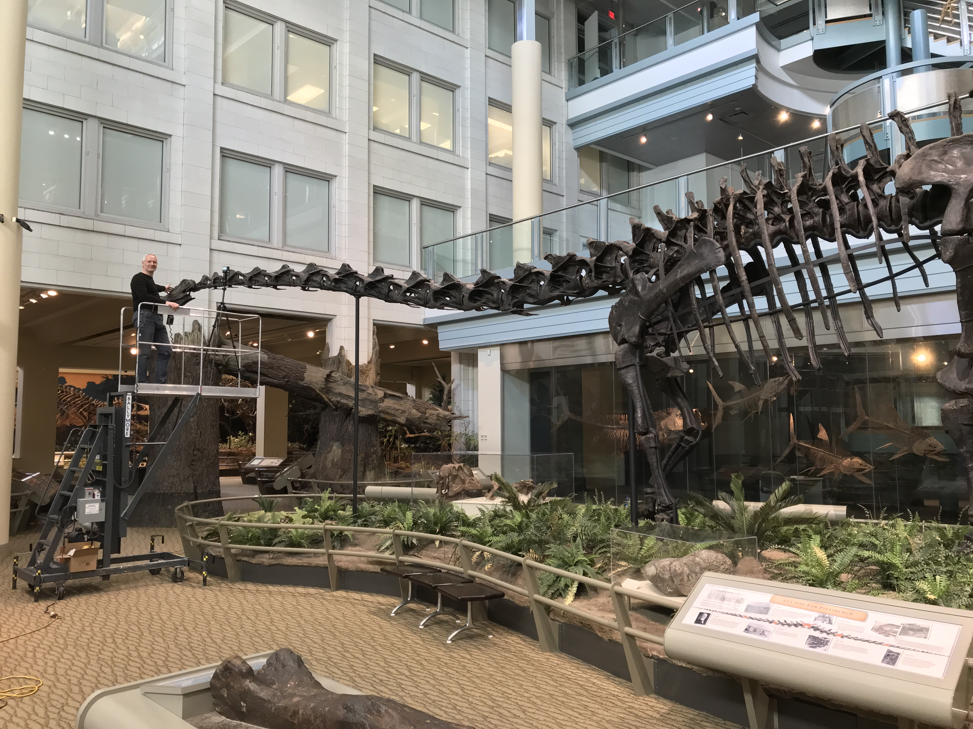

**Figure 2.** Six of the key players in the story of the Carnegie *Diplodocus* and its casts. **A.** Andrew Carnegie, the millionaire industrialist and philanthropist who funded the creation of the Carnegie Museum and after whom it is named. **B.** William J. Holland, second director of the Carnegie Museum, whom Carnegie tasked with sourcing a giant dinosaur to exhibit and who later published extensively on *Diplodocus*. **C.** Olaf A. Peterson, who led the excavation of the paratype specimen CM 94. (See Figure 5 for those who excavated the holotype specimen CM 84.) **D.** Arthur S. Coggeshall, who was the lead preparator of the *Diplodocus* fossils and supervised the subsequent mounting of both the original material and the casts. **E.** John B. Hatcher, who wrote the classic 1901 monograph describing the new species *Diplodocus carnegii* based on CM 84 and CM 94. **F.** Serafino Agostini, leader of the Italian crew that made the plaster molds and sculpted some of the elements that these were taken from.

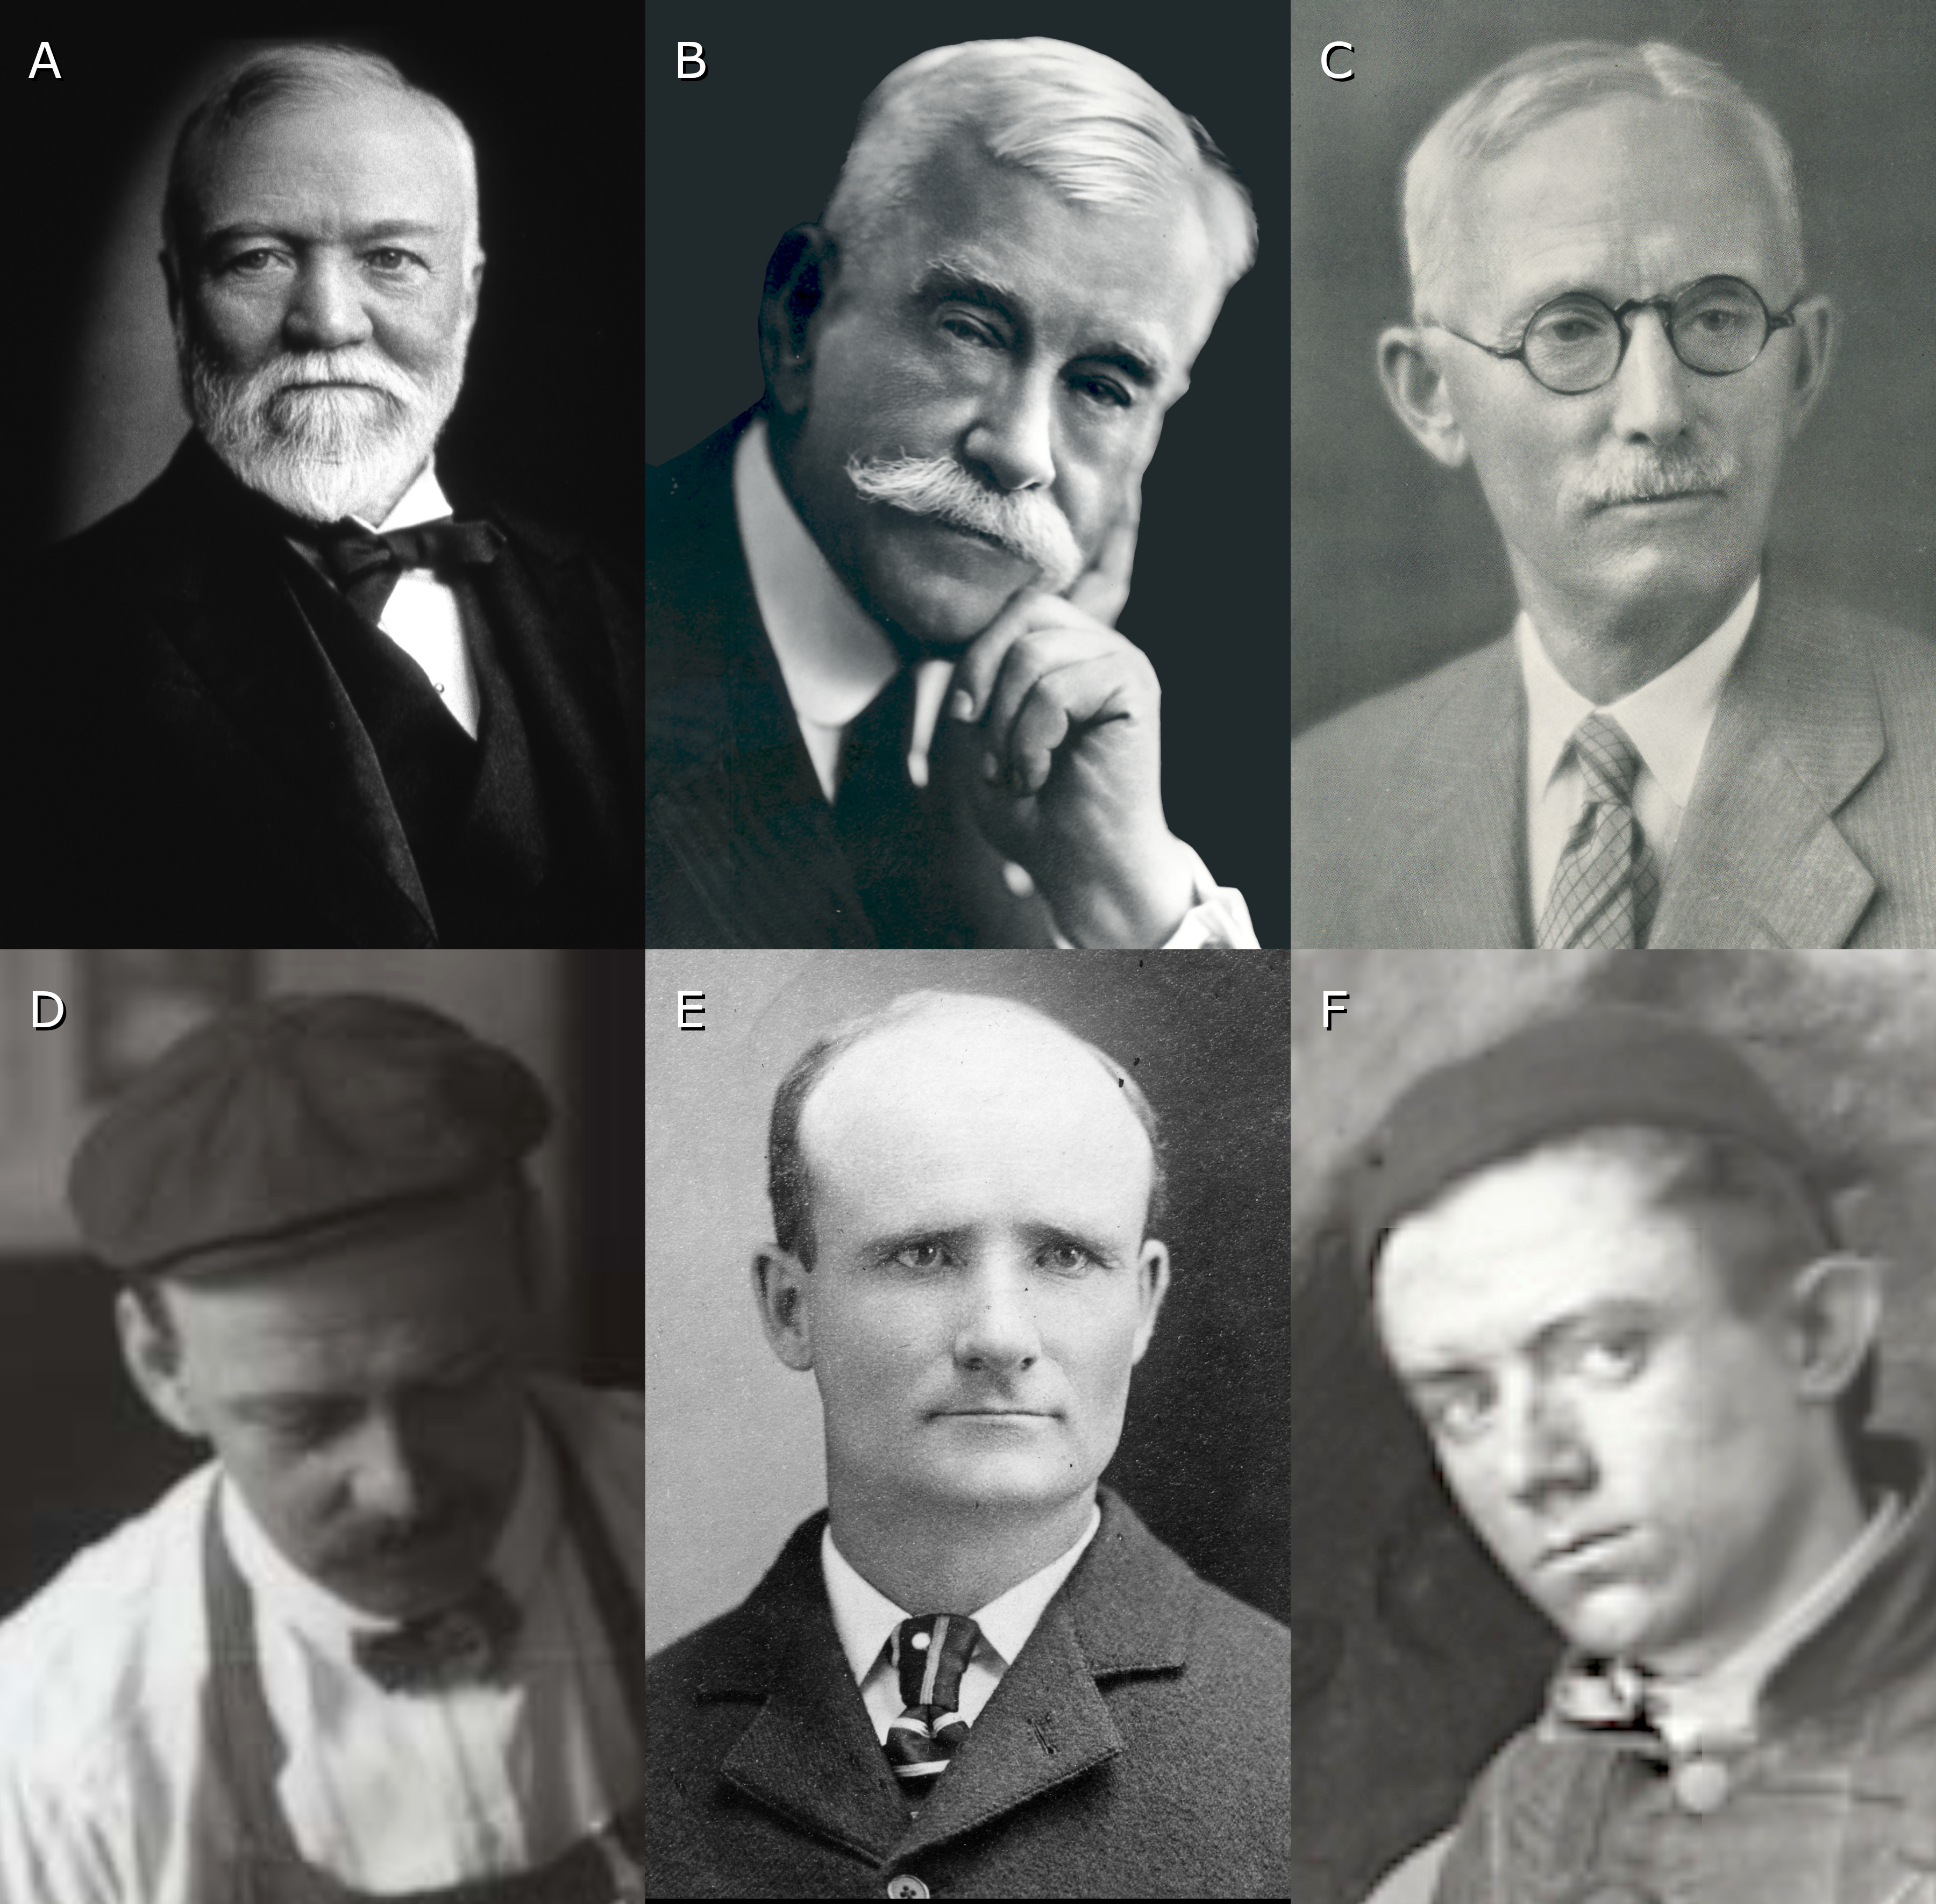

**Figure 3.** Newspaper article “The Dinosaur of Wyoming”, from the *New York Post* of 1 December 1898 (Anonymous 1898a), with Andrew Carnegie’s handwritten note to William J. Holland: “My Lord — Cant you buy this for Pittsburgh — try. Wyoming State University isnt rich — get an offer — hurry AC”. (The “C” at the very end has a double loop characteristic of Carnegie when signing his own name.)

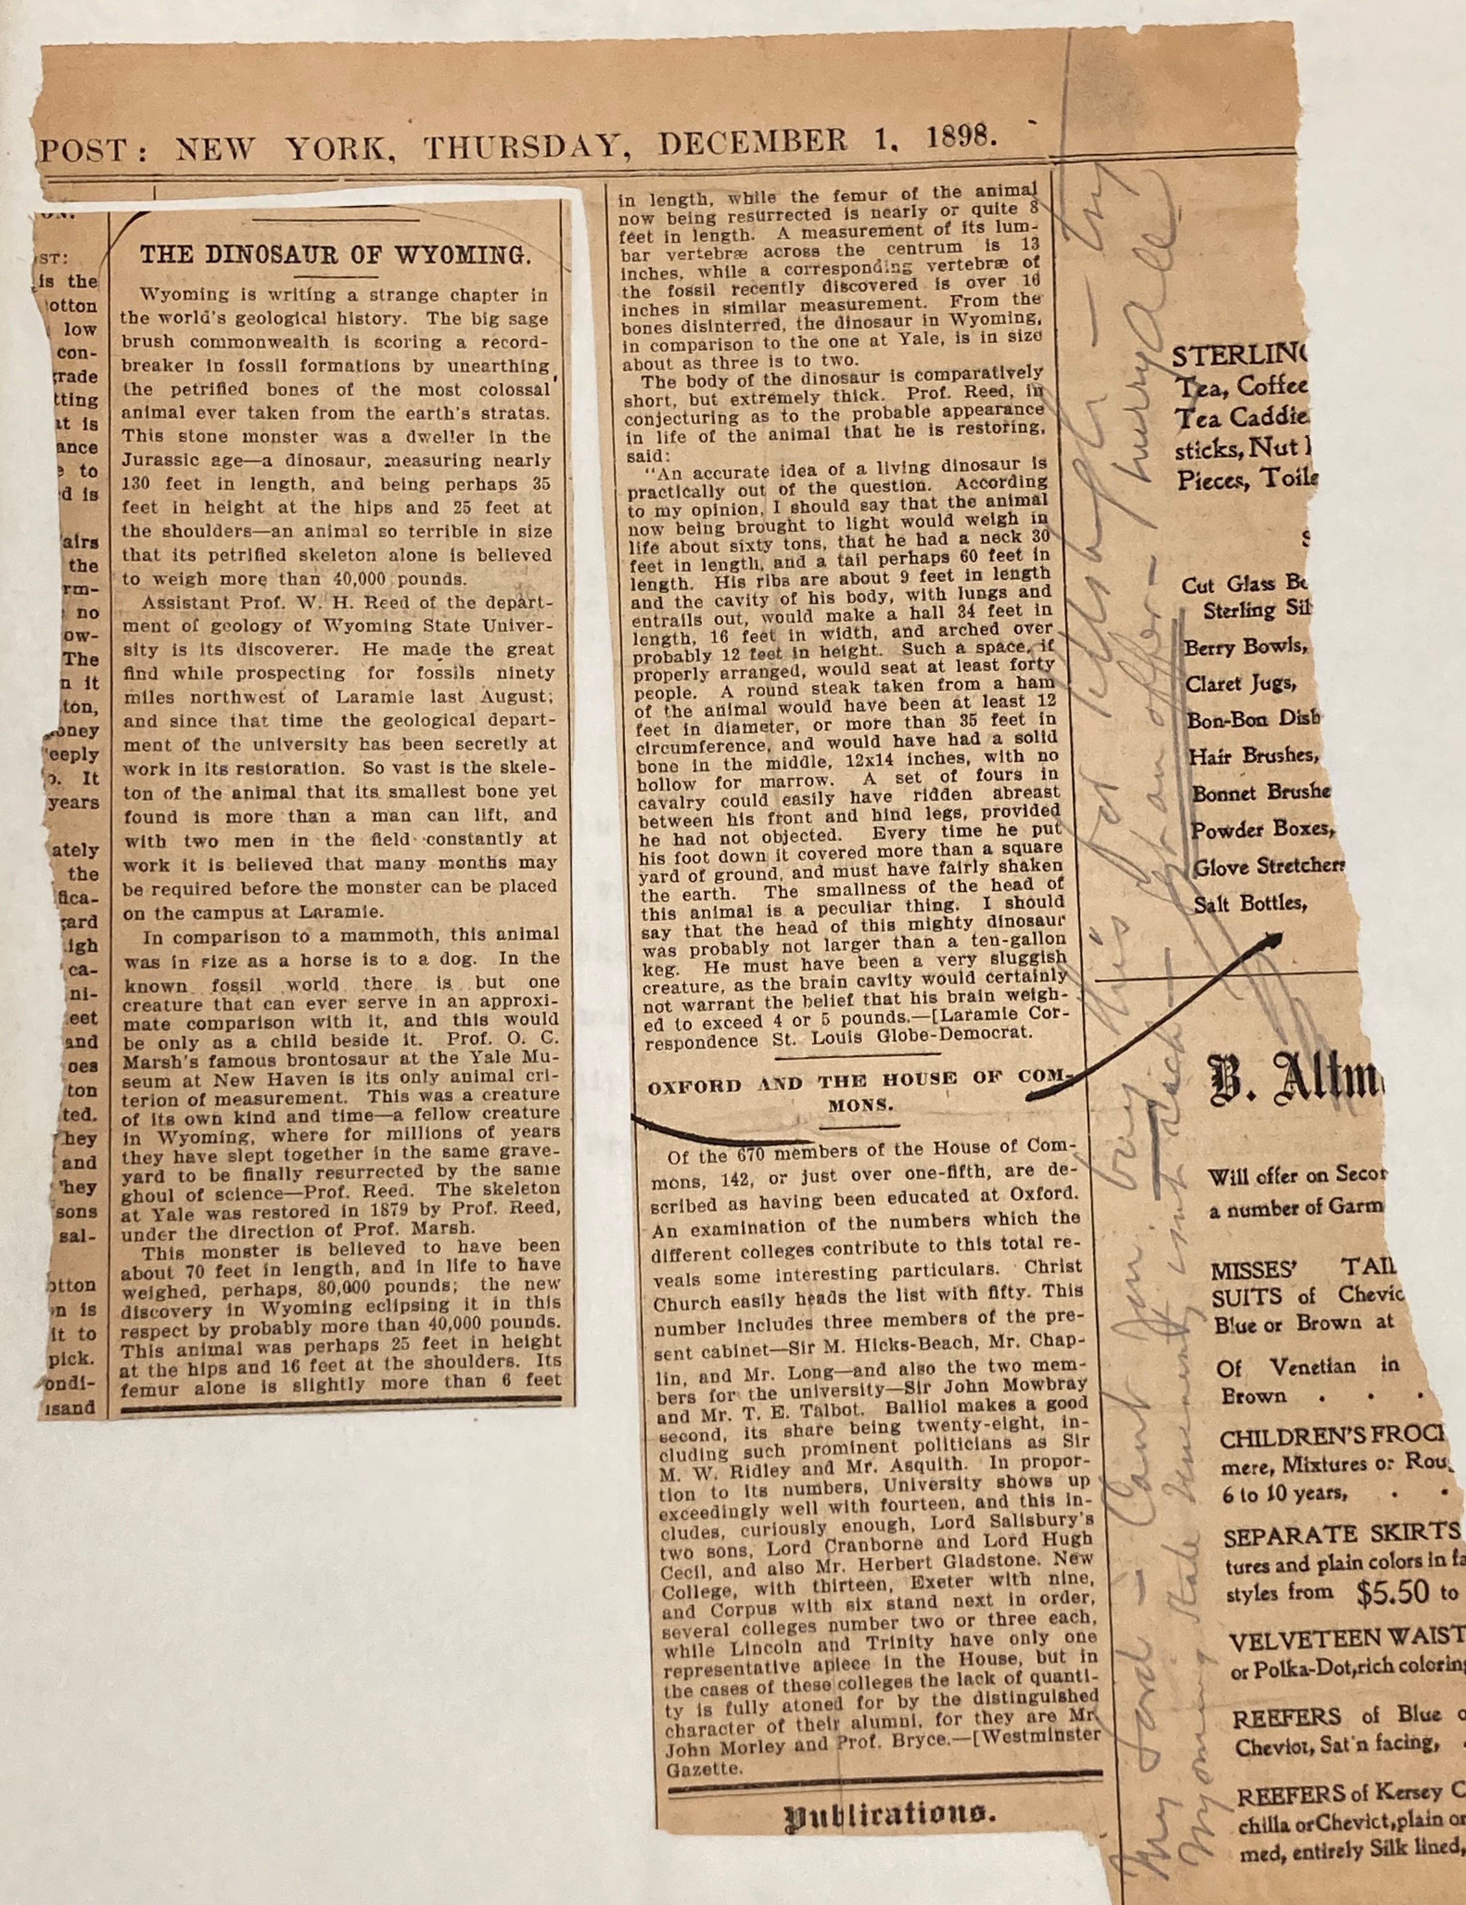

**Figure 4.** William Harlow Reed of the 1899 field team, in Quarry D at Sheep Creek, Albany County, Wyoming, as the *Diplodocus carnegii* holotype CM 84 is being excavated. Before him is the right femur in medial view with the posterior side facing upwards and the proximal end to the left. Closer to the camera is a pelvic girdle bone, probably the right pubis in medial view with proximal to the left. Carnegie Museum of Natural History Section of Vertebrate Paleontology Archive, photograph #29.

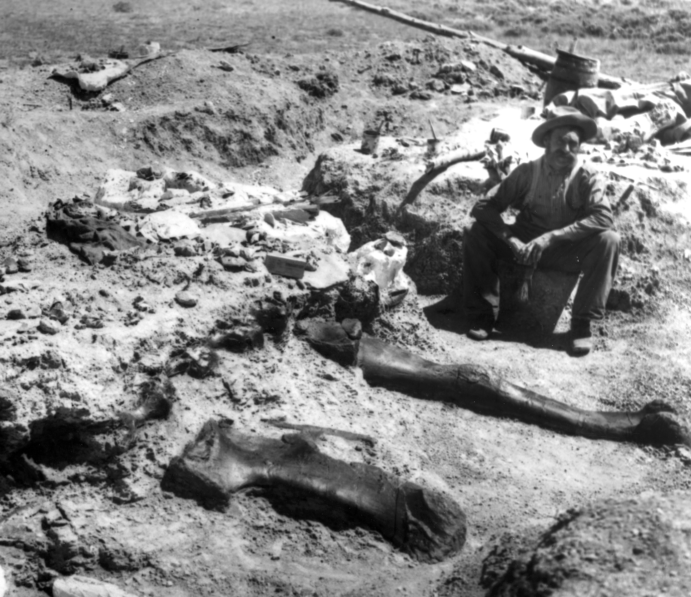

**Figure 5.** The field crew that excavated the *Diplodocus carnegii* holotype CM 84 at Bonediggers Camp, Sheep Creek, Albany County, Wyoming in 1899. From left to right: Paul Miller, Jacob L. Wortman, William H. Reed, and William Reed, Jr. Not pictured: Arthur S. Coggeshall. Carnegie Museum of Natural History Section of Vertebrate Paleontology Archive, photograph #37.

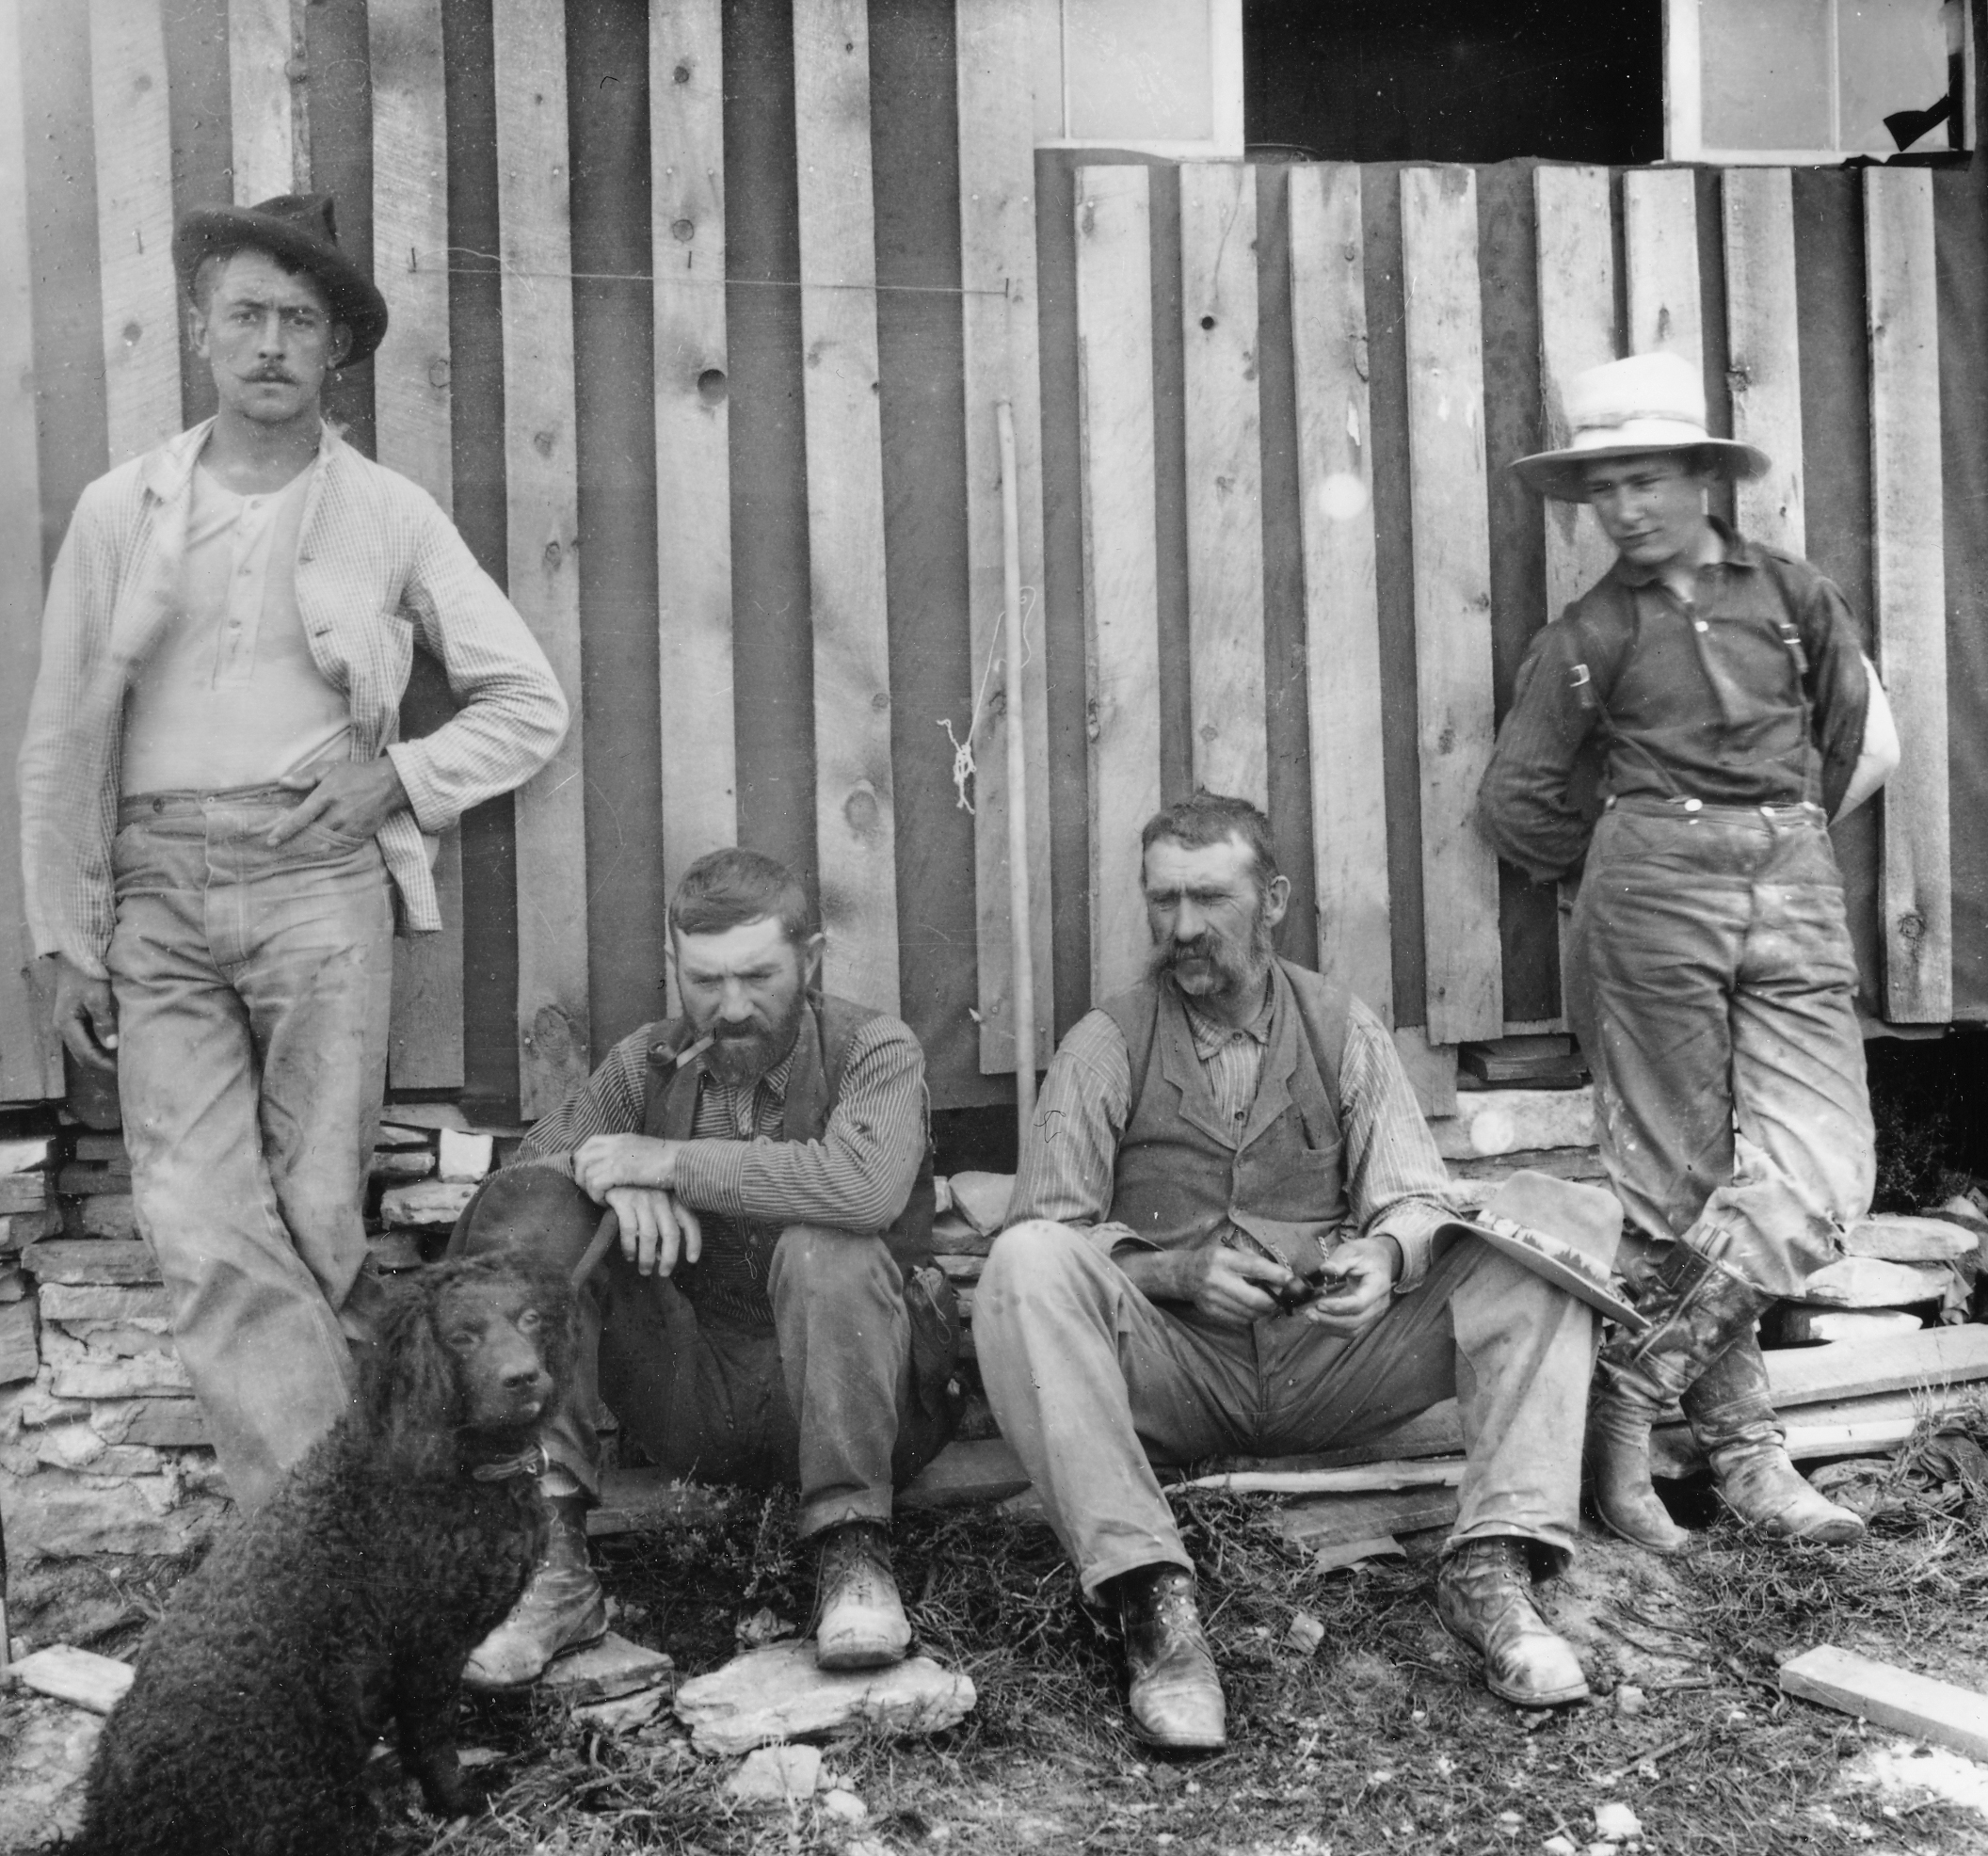

**Figure 6.** Carnegie Museum preparation laboratory, with key personnel, in 1903 — probably January 1903, based on the calendar on the right wall. (Carnegie Museum of Natural History Section of Vertebrate Paleontology Archive, photograph #1010.) Foreground: various fossils still in matrix. Right: a sequence of caudal vertebrae, anterior to the front, possibly from the *Apatosaurus excelsus* referred specimen CM 563 (subsequently transferred to the University of Wyoming (as UW 15556) and referred to *Brontosaurus parvus* by Tschopp et al. (2015:229) (Anthony Maltese, pers. comm., 2022)). People are, from left to right:

* Far left, mostly cropped from image: field collector William H. Utterback
* Seated, facing right: field collector and researcher Olaf A. Peterson
* Standing at rear: fossil preparator Louis S. Coggeshall (Arthur’s brother)
* Seated, looking toward camera: fossil preparator and researcher Charles W. Gilmore
* Seated at far table: field collector Earl Douglass
* Standing behind far table: chief fossil preparator Arthur S. Coggeshall
* Sitting at far table, facing left: fossil preparator Asher W. VanKirk
* Seated: illustrator Sydney Prentice
* Sitting on bench: John Bell Hatcher, whose description of *Diplodocus carnegii* had been published two years previously

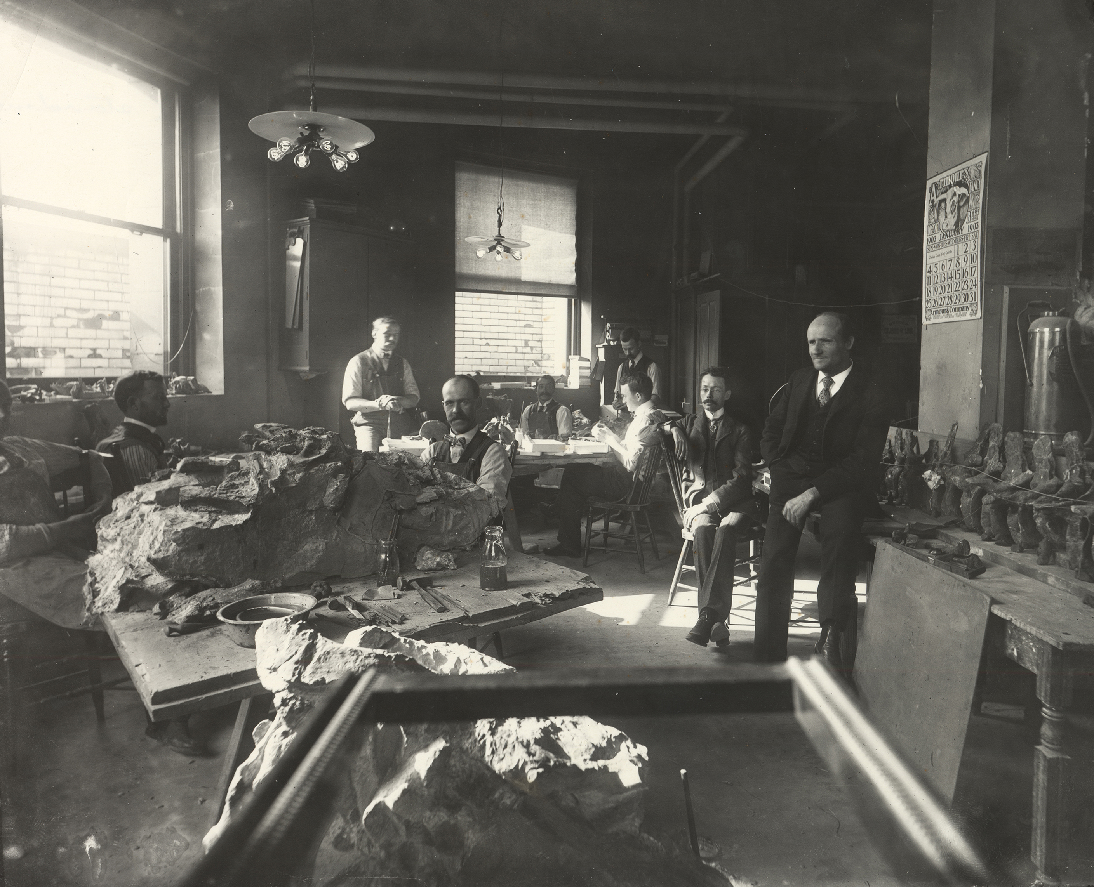

**Figure 7.** John Bell Hatcher’s reconstruction of the skeleton of *Diplodocus* (Hatcher 1901:plate XIII). Andrew Carnegie had a framed print of this reconstruction at his home at Skibo Castle, and it was seeing this that provoked King Edward VII of England to ask Carnegie for a *Diplodocus* for the British Museum (see text). Hatcher’s reconstruction, now over 120 years old, remains mostly accurate: only the forefeet, which were unknown to him, are badly wrong, with splayed digits rather than the vertical arcade of metacarpals that is now known to make up the sauropod manus. The tail is much too short, and its dragging posture is also wrong: sauropod tails were habitually held above ground level, and the base of the tail should be distinctly inclined upwards from the sacrum rather than downwards as here. The low posture of the neck illustrated by Hatcher was probably not habitual (Taylor et al. 2009), but certainly could be attained in order to drink.

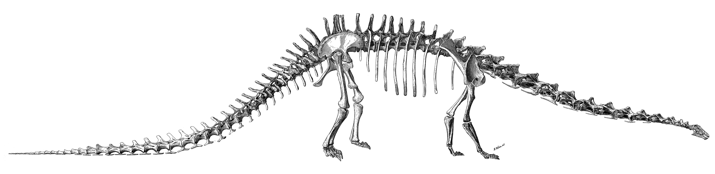

**Figure 8.** The original print of *Diplodocus carnegii* that caught the eye of King Edward VII on his visit to Andrew Carnegie at Skibo Castle in early October 1902, leading to the creation of the London cast and, indirectly, all other casts of the Carnegie *Diplodocus*. This print is held by the Andrew Carnegie Birthplace Museum as ACBM 1928/461. It is evidently a cut-down copy of the reconstruction from Plate XIII of Hatcher’s (1901) descriptive monograph, with the headings and titles removed.

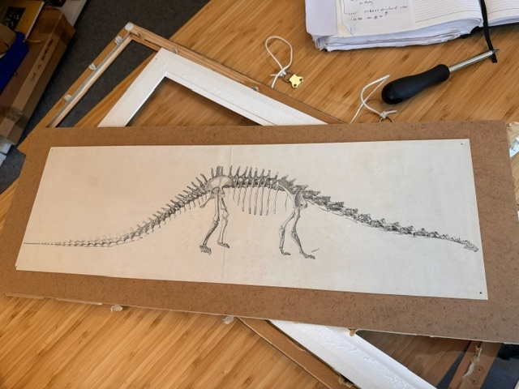

**Figure 9.** Letter from Andrew Carnegie to William J. Holland, 2 October 1902. “The King was attracted to the *Diplodocus* when here. He wants one for the British Museum badly. I read your note which told of the new finds. He is on your track now for duplicate.”

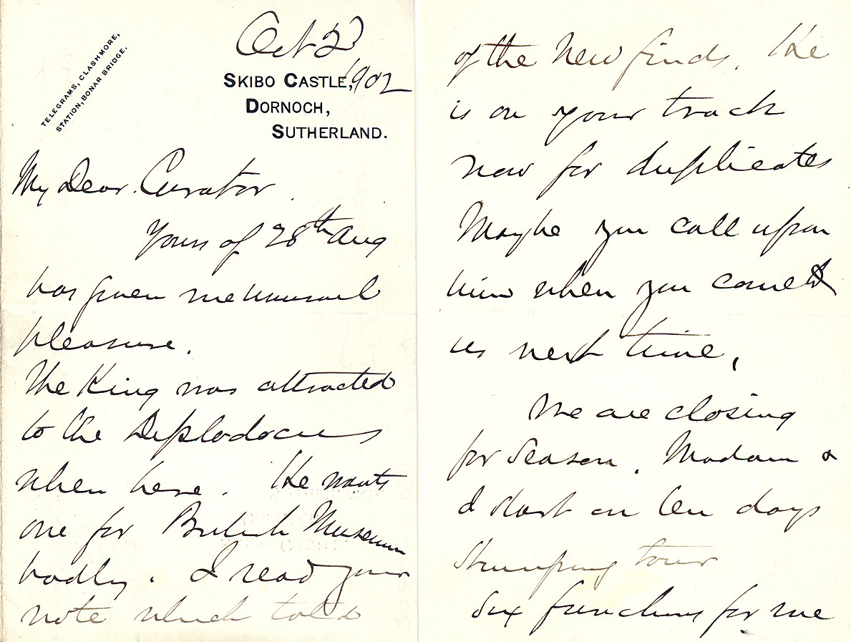

**Figure 10.** Trial mount of the first Carnegie *Diplodocus* replica, before it was shipped to London, in the old Exposition Building, downtown Pittsburgh, USA. Seated on the plinths, from left to right: preparators Asher W. VanKirk, Arthur S. Coggeshall, and Louis Coggeshall. Carnegie Museum of Natural History Section of Vertebrate Paleontology Archive, photograph #620, taken on 1 or 2 July 1904.

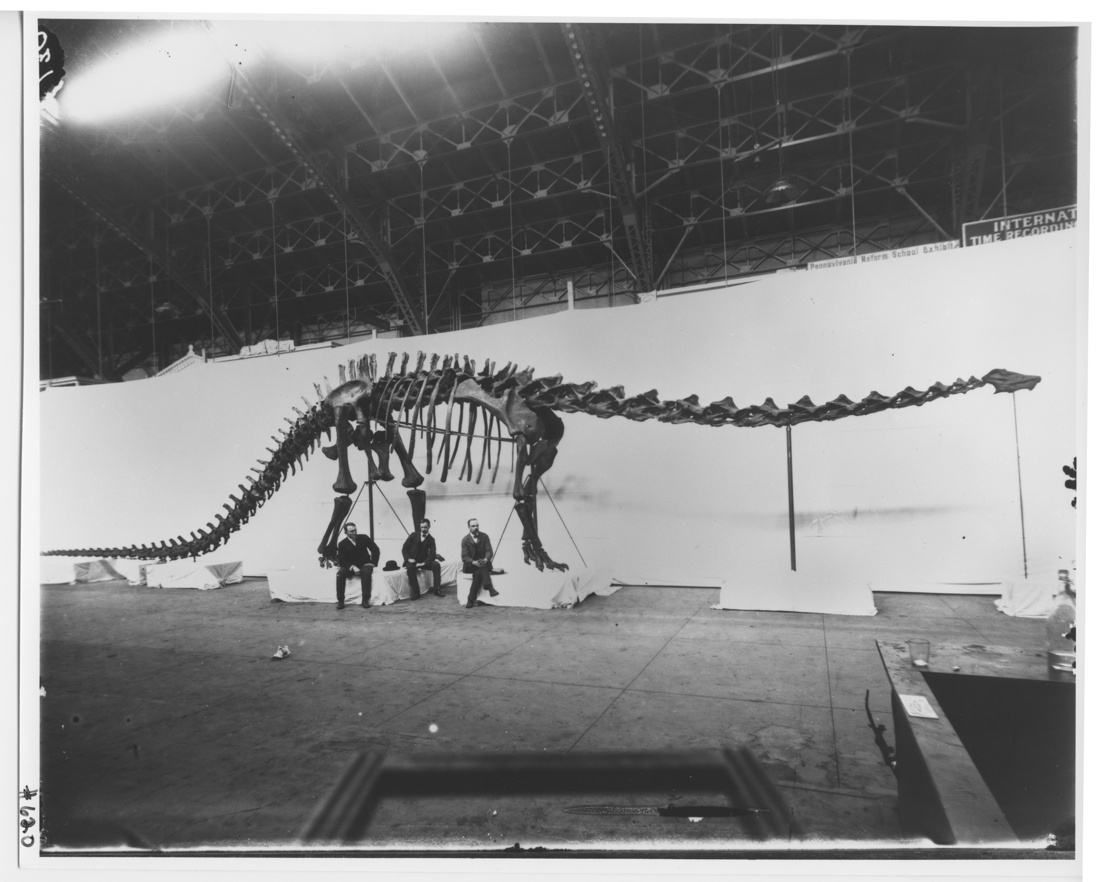

**Figure 11.** Pectoral region of the mounted *Diplodocus* skeleton at the Carnegie Museum as it is today, in left anterolateral view. Highlighted bones: scapulae in blue, coracoids in red, sternal plates in yellow. Note the absence of the putative clavicles that Holland tentatively added to the mounted BMNH cast in May 1905, as shown in his photographs (Holland 1906:figures 25–26), before removing them. Photograph by Michael P. Taylor.

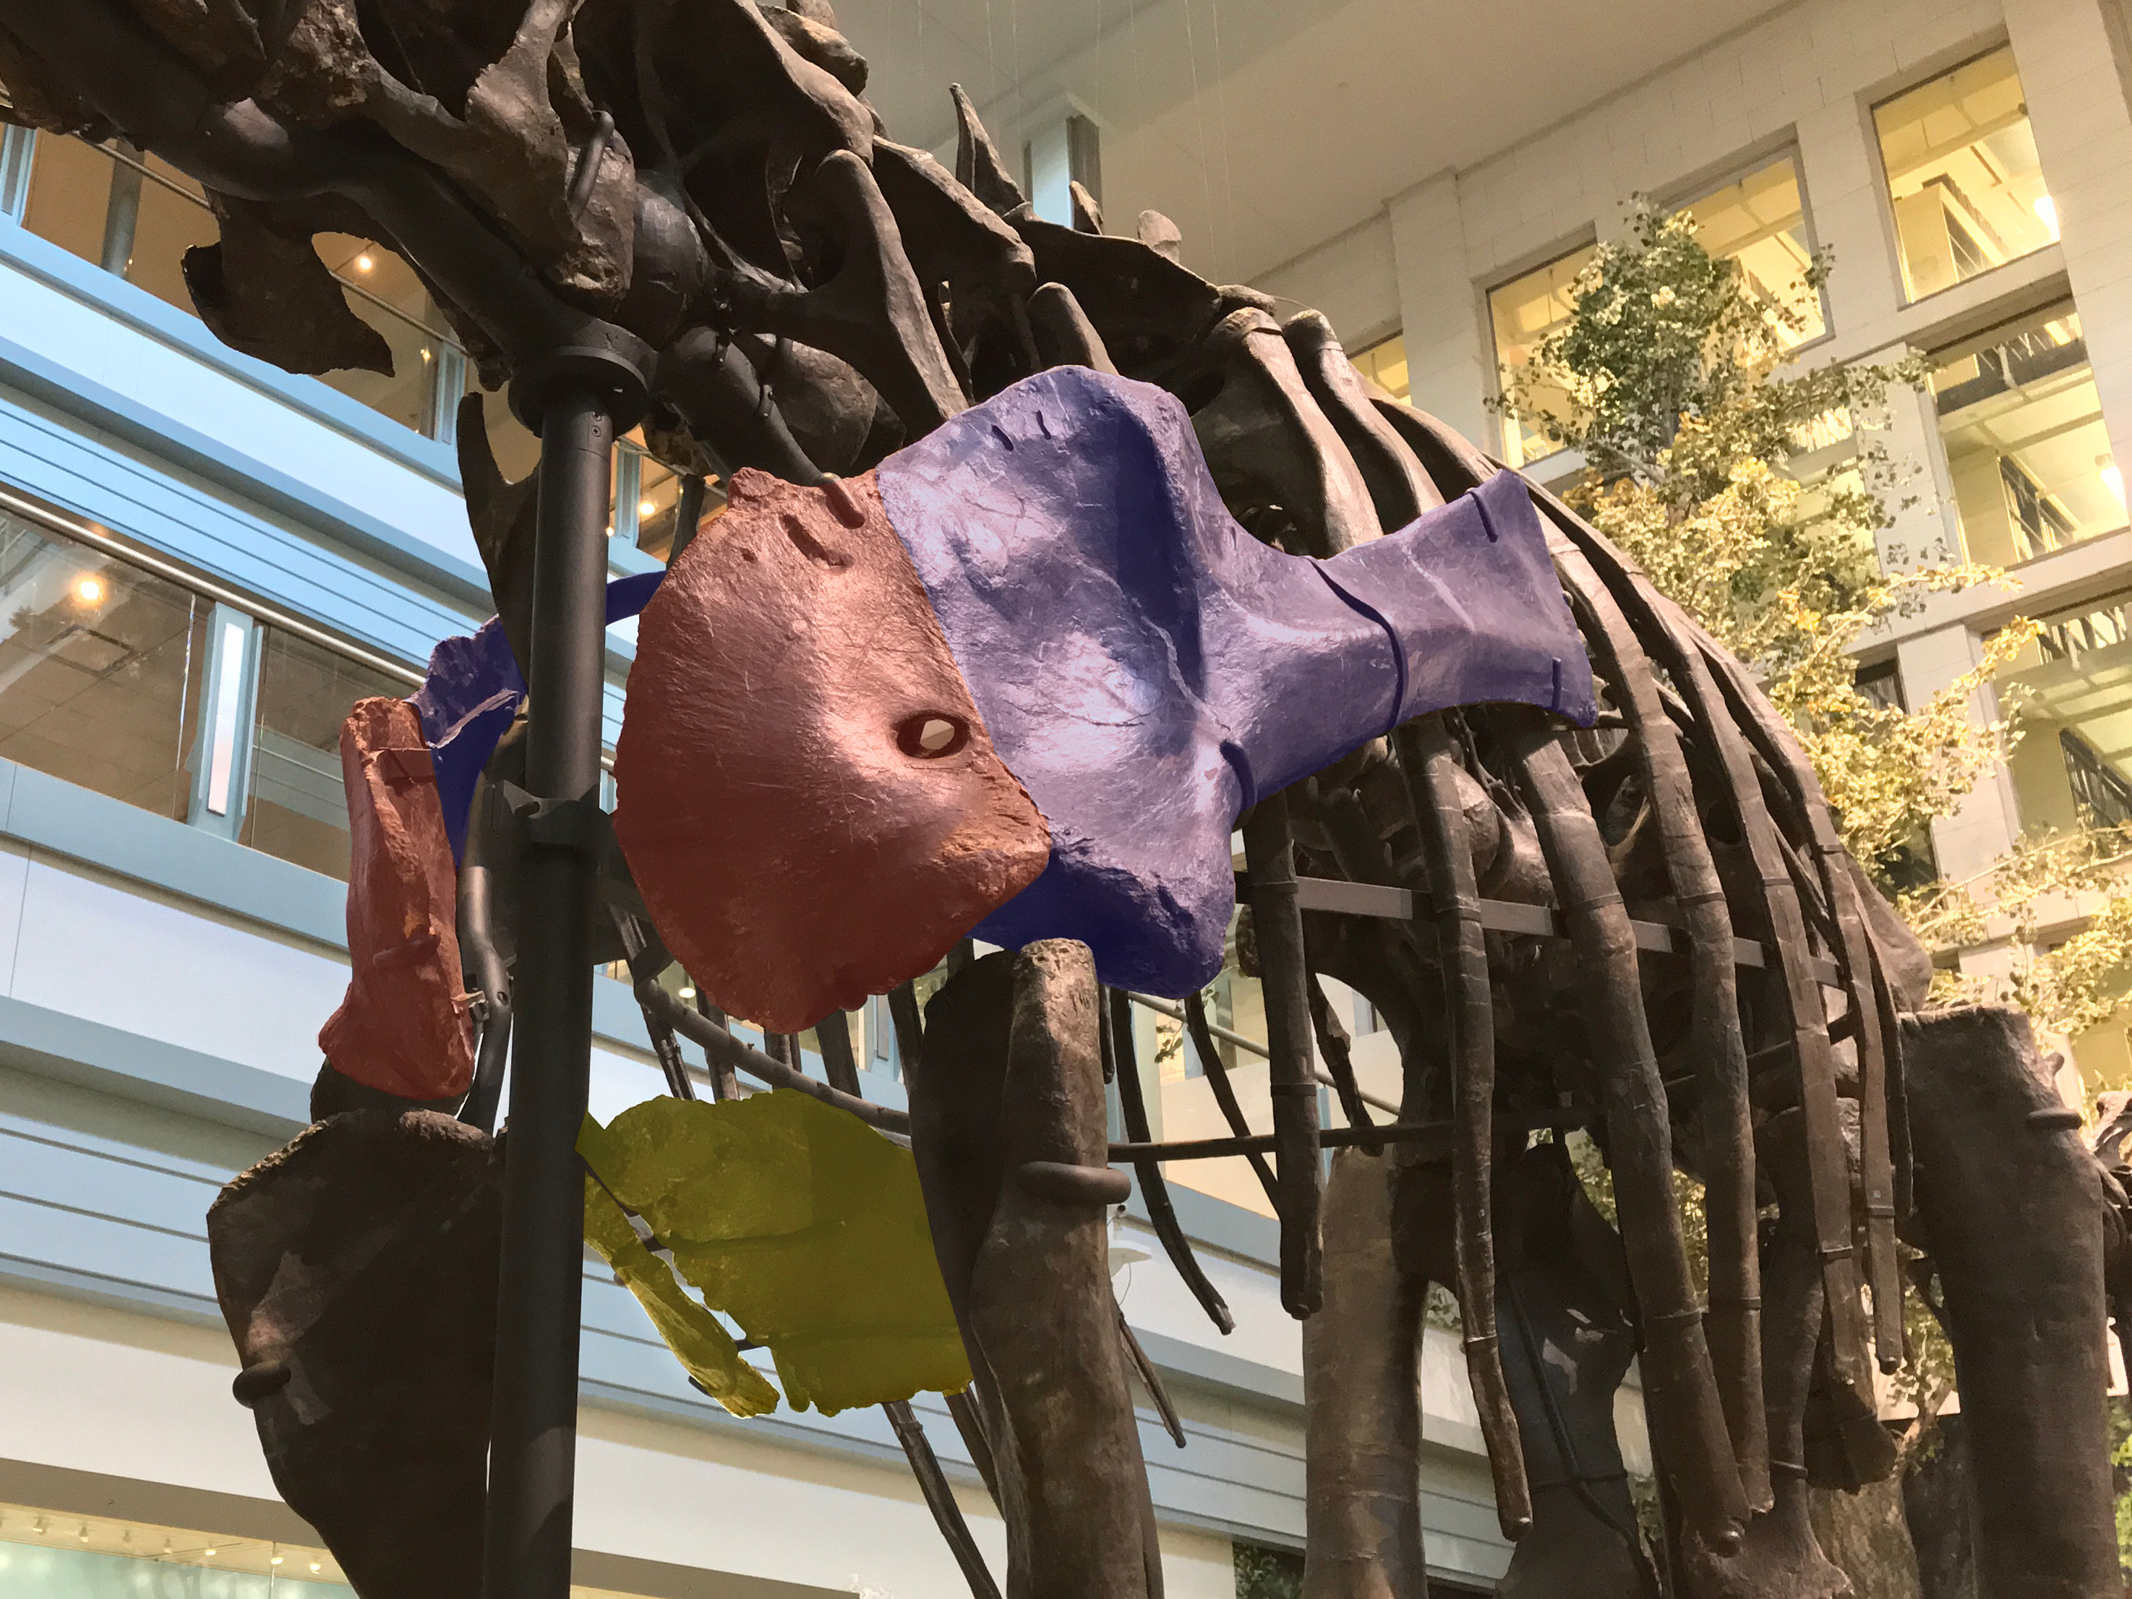

**Figure 12.** Comparison of atlas (cervical vertebra 1) of various specimens referred to *Diplodocus*, all in left lateral view, scaled to about the same size. **A.** A highly fused atlas illustrated by Marsh (1896:plate XXVII, part 1) and described by him as belonging to *Diplodocus longus*. This was reproduced by Hatcher (1901:figure 4) as the only then-known atlas referred to *Diplodocus*, although the referral must be considered highly uncertain. The specimen number is unknown. As noted by Holland (1906:248), the posterodorsal process of the neural arch is broken off, and Marsh’s restoration of its tip is too short. **B.** The atlas of AMNH 969, showing the neural arch in left lateral view (from Holland 1906:figure 14) with a speculative drawing of the intercentrum (which Holland illustrated in anterior, posterior, and ventral views, but not lateral view). Holland considered this atlas to belong to *Diplodocus*, but Tschopp et al. (2015:219) referred it to *Galeamopus* sp. **C.** The atlas of the Paris mount, unchanged since its original installation. The neural arch appears pale gray in this photograph while the intercentrum is a darker brown. Two areas of the image have been lightened where the atlas is obscured in lateral view by part of the skull and by the atlantal rib (see text). Photograph by Vincent Reneleau (MNHN). This is evidently the same as the atlas used in the original London mount, as illustrated by Holland (1906:figure 1). **D.** The atlas of the current Carnegie mount. Note that this differs from all three of the other specimens in having longer and slenderer posterior processes of the neural arch, and it has an anteroposteriorly longer intercentrum than shown in parts B and C.

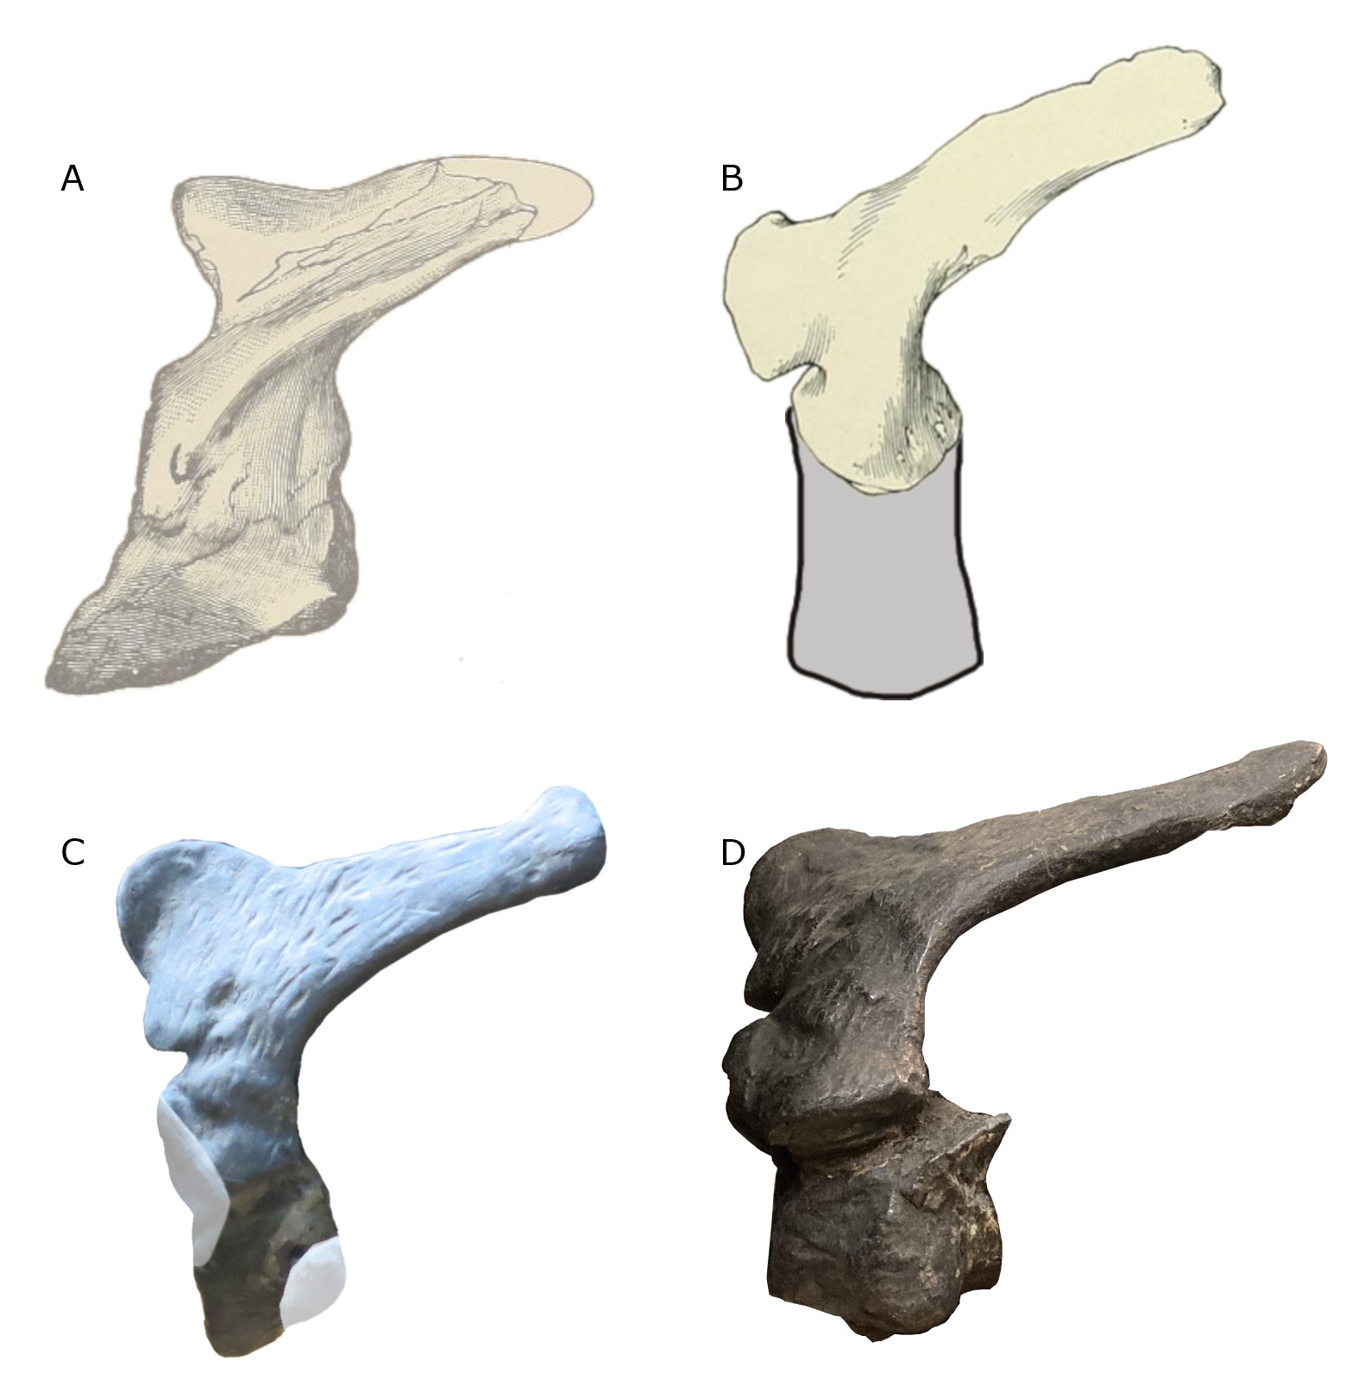

**Figure 13.** Skeletal atlas of the Carnegie mount of *Diplodocus* as originally erected in 1907, with bones color-coded according to the specimen they belonged to or were cast or sculpted from. Modified from a skeletal reconstruction by Scott Hartman, used with permission. Bones are colored as follows: CM 84 (most of the skeleton), yellow; CM 94 (right scapulocoracoid, lower right hindlimb, much of the tail and some chevrons), sculpted left tibia, red; CM 307 (the rest of the tail), blue; CM 662 (sculpted braincase, right humerus, radius and ulna), green; AMNH 965 (sculpted forefeet and carpus), purple; CM 21775 (left humerus, radius and ulna), cyan; CM 33985 (left fibula and lateral metatarsals), orange; USNM 2673 (sculpted remainder of skull), gold. White elements were sculpted, but the specimens on which these sculptures were based are not definitively known, though are most likely the corresponding CM 84 elements from the other side. Hyoids, clavicles, interclavicle, sternal ribs, and gastralia were all omitted from the mounted skeleton. Source of chevrons past the first seven is uncertain. See Table A and text for details.



**Figure 14.** Two views of the mounted skeleton of *Diplodocus carnegii* as originally exhibited at the Carnegie Museum, highlighting the mismatched humeri. **A.** Skeleton in almost directly anterior view, taken between 1932 and 1936, part of photograph used by Gilmore (1936:plate XXXV). **B.** Skeleton in right anterolateral view, taken in 1907, the year of the unveiling. Note that in both A and B, the left humerus is significantly shorter and more robust than the right, and that the forefeet are splayed and carry unguals on all of the first three digits. **C.** Line drawing of right humerus of *Diplodocus* sp. AMNH 5855 in anterior view, modified from Mook (1917:figure 2A). **D.** Right humerus of the Carnegie mount in right anterolateral view, enlarged from part B, sculpted from CM 662, a slightly smaller diplodocine individual then thought to belong to *Diplodocus*, subsequently referred to the new species *Diplodocus hayi* Holland 1924, and now referred to its own genus *Galeamopus* Tschopp et al. 2015. **E.** Left humerus of the Carnegie mount in anterior view, enlarged from part B, CM 21775, assigned by McIntosh (1981:16) to *Camarasaurus*, but considered by Tschopp et al. (2019:29–37) to be Camarasauridae indet. This bone measures 1000 mm in proximodistal length (Tschopp et al. 2019:table 10). **F.** Right humerus of *Camarasaurus supremus* AMNH 5761/H.1 in anterior view, modified from Osborn and Mook (1921:figure 84B). Parts C and F scaled to the same heights as parts D and E respectively.

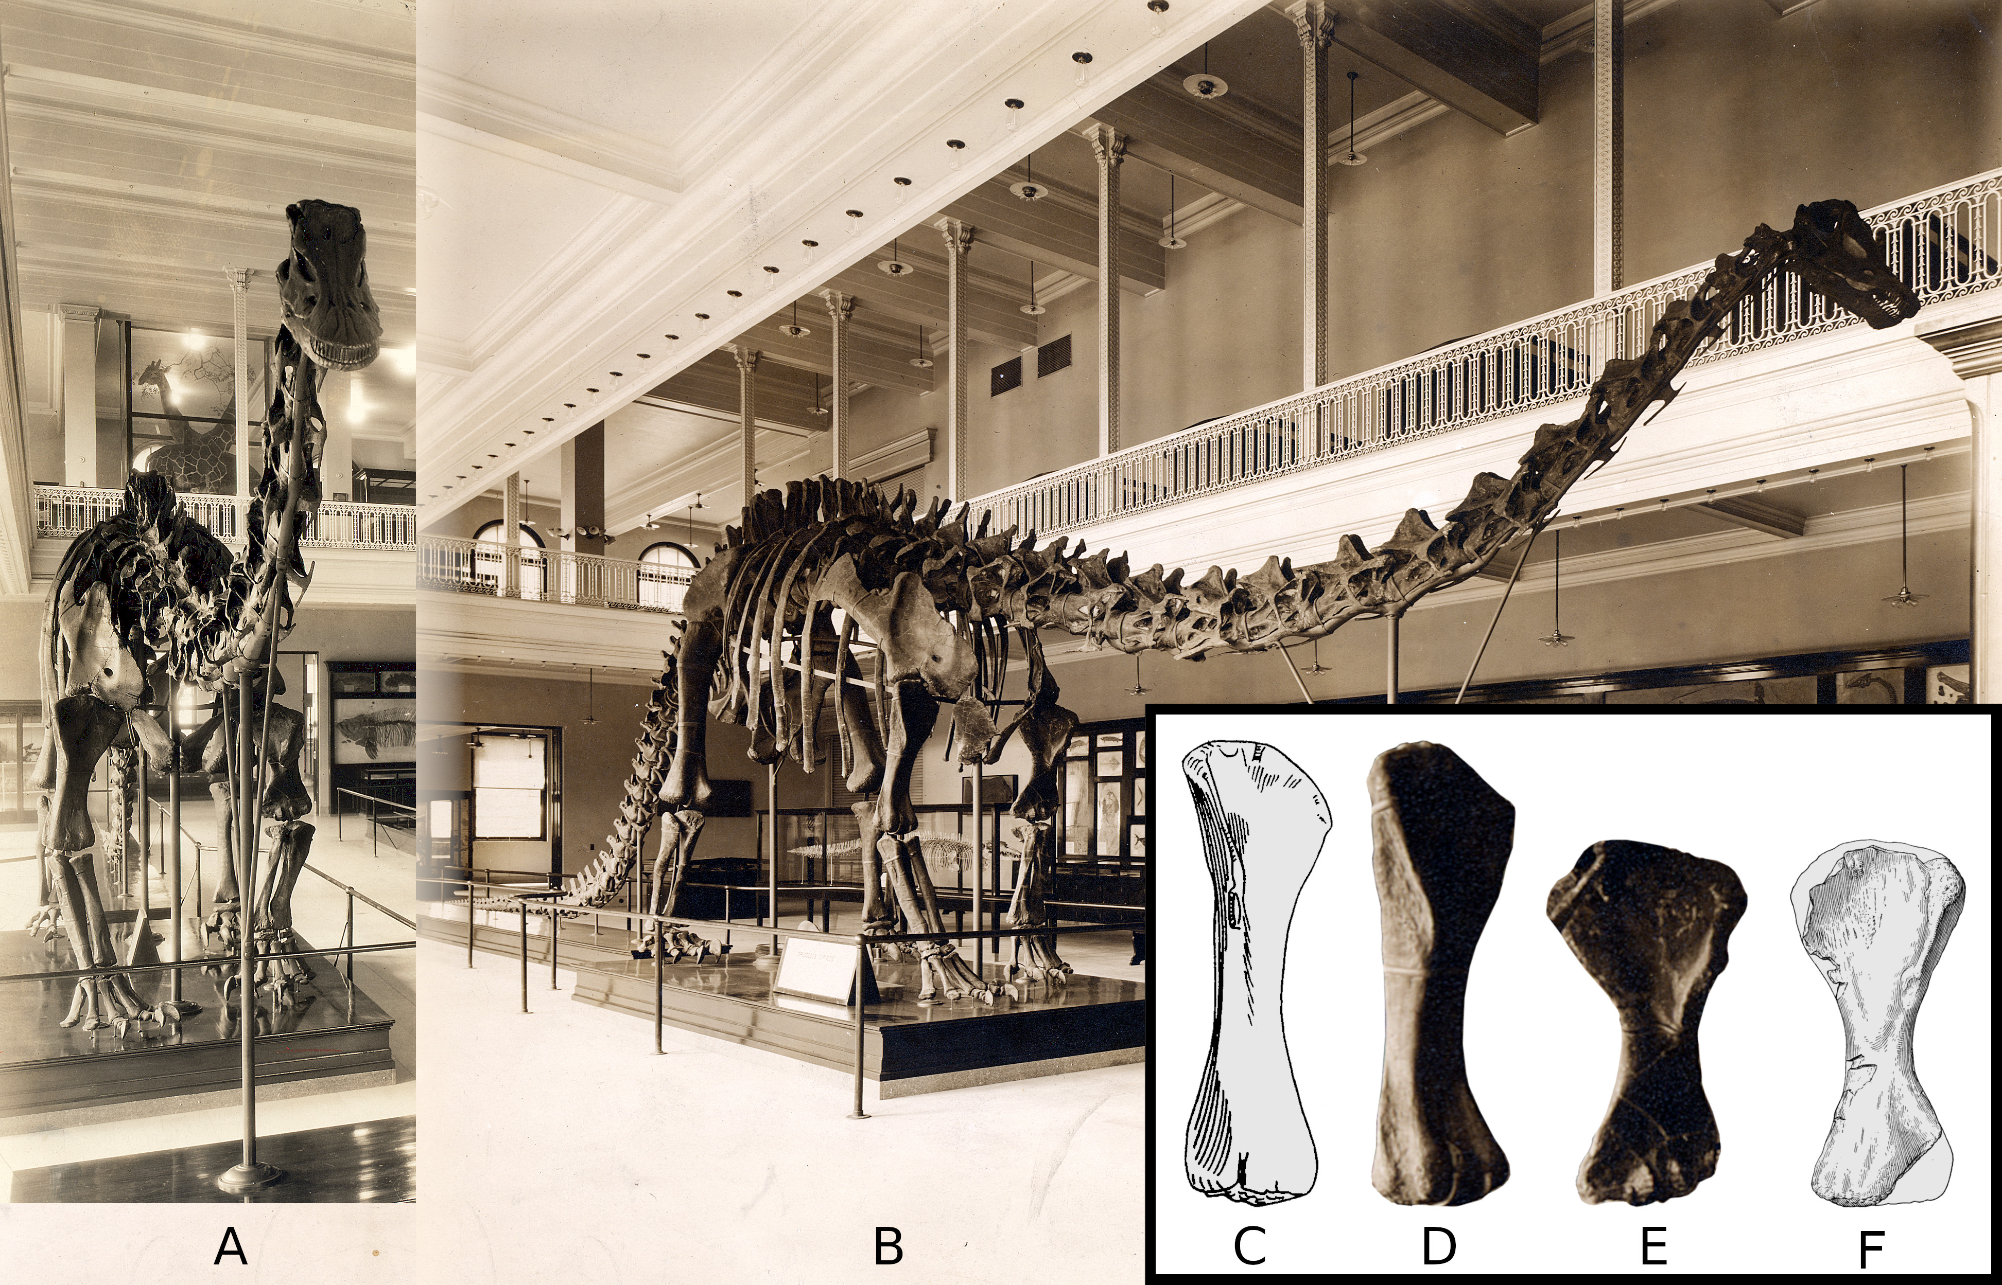

**Figure 15.** The present skull on the mounted skeleton of *Diplodocus carnegii* at the Carnegie Museum, in right anterolateral view. This is believed to be a cast of the complete and largely undistorted diplodocine cranium and mandible CM 11161. Note the realistic bone texture, including damage, especially on the mandible. Photograph by Joshua Franzos, used with permission.

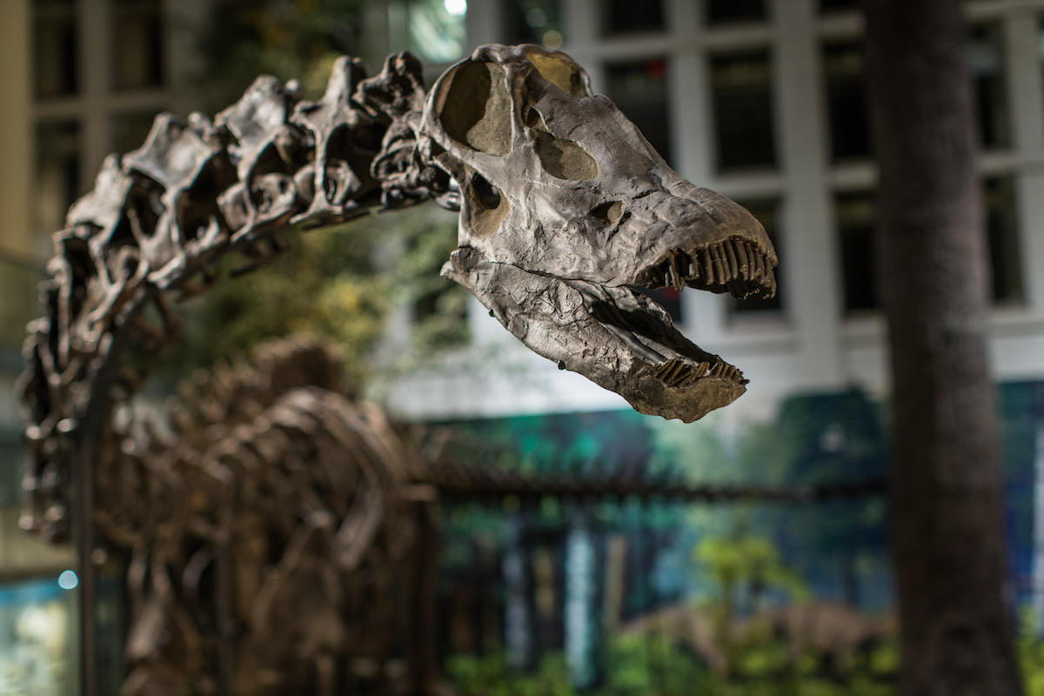

**Figure 16.** The mounted skeleton of *Diplodocus carnegii* at the Carnegie Museum in left anterolateral view, by Melinda McNaugher/Carnegie Museum of Natural History. This photograph was taken some time between 1985, when McNaugher became the exhibit photographer, and 1999. It cannot date from later than 1999 because the original replica forefeet are still in position, with their splayed metacarpals and unguals on digits 1–3. Note that the neck support had by this time been changed since earlier photographs (e.g., Figure 14A–B), now suspended from the ceiling rather than supported from below by a tripartite pole.

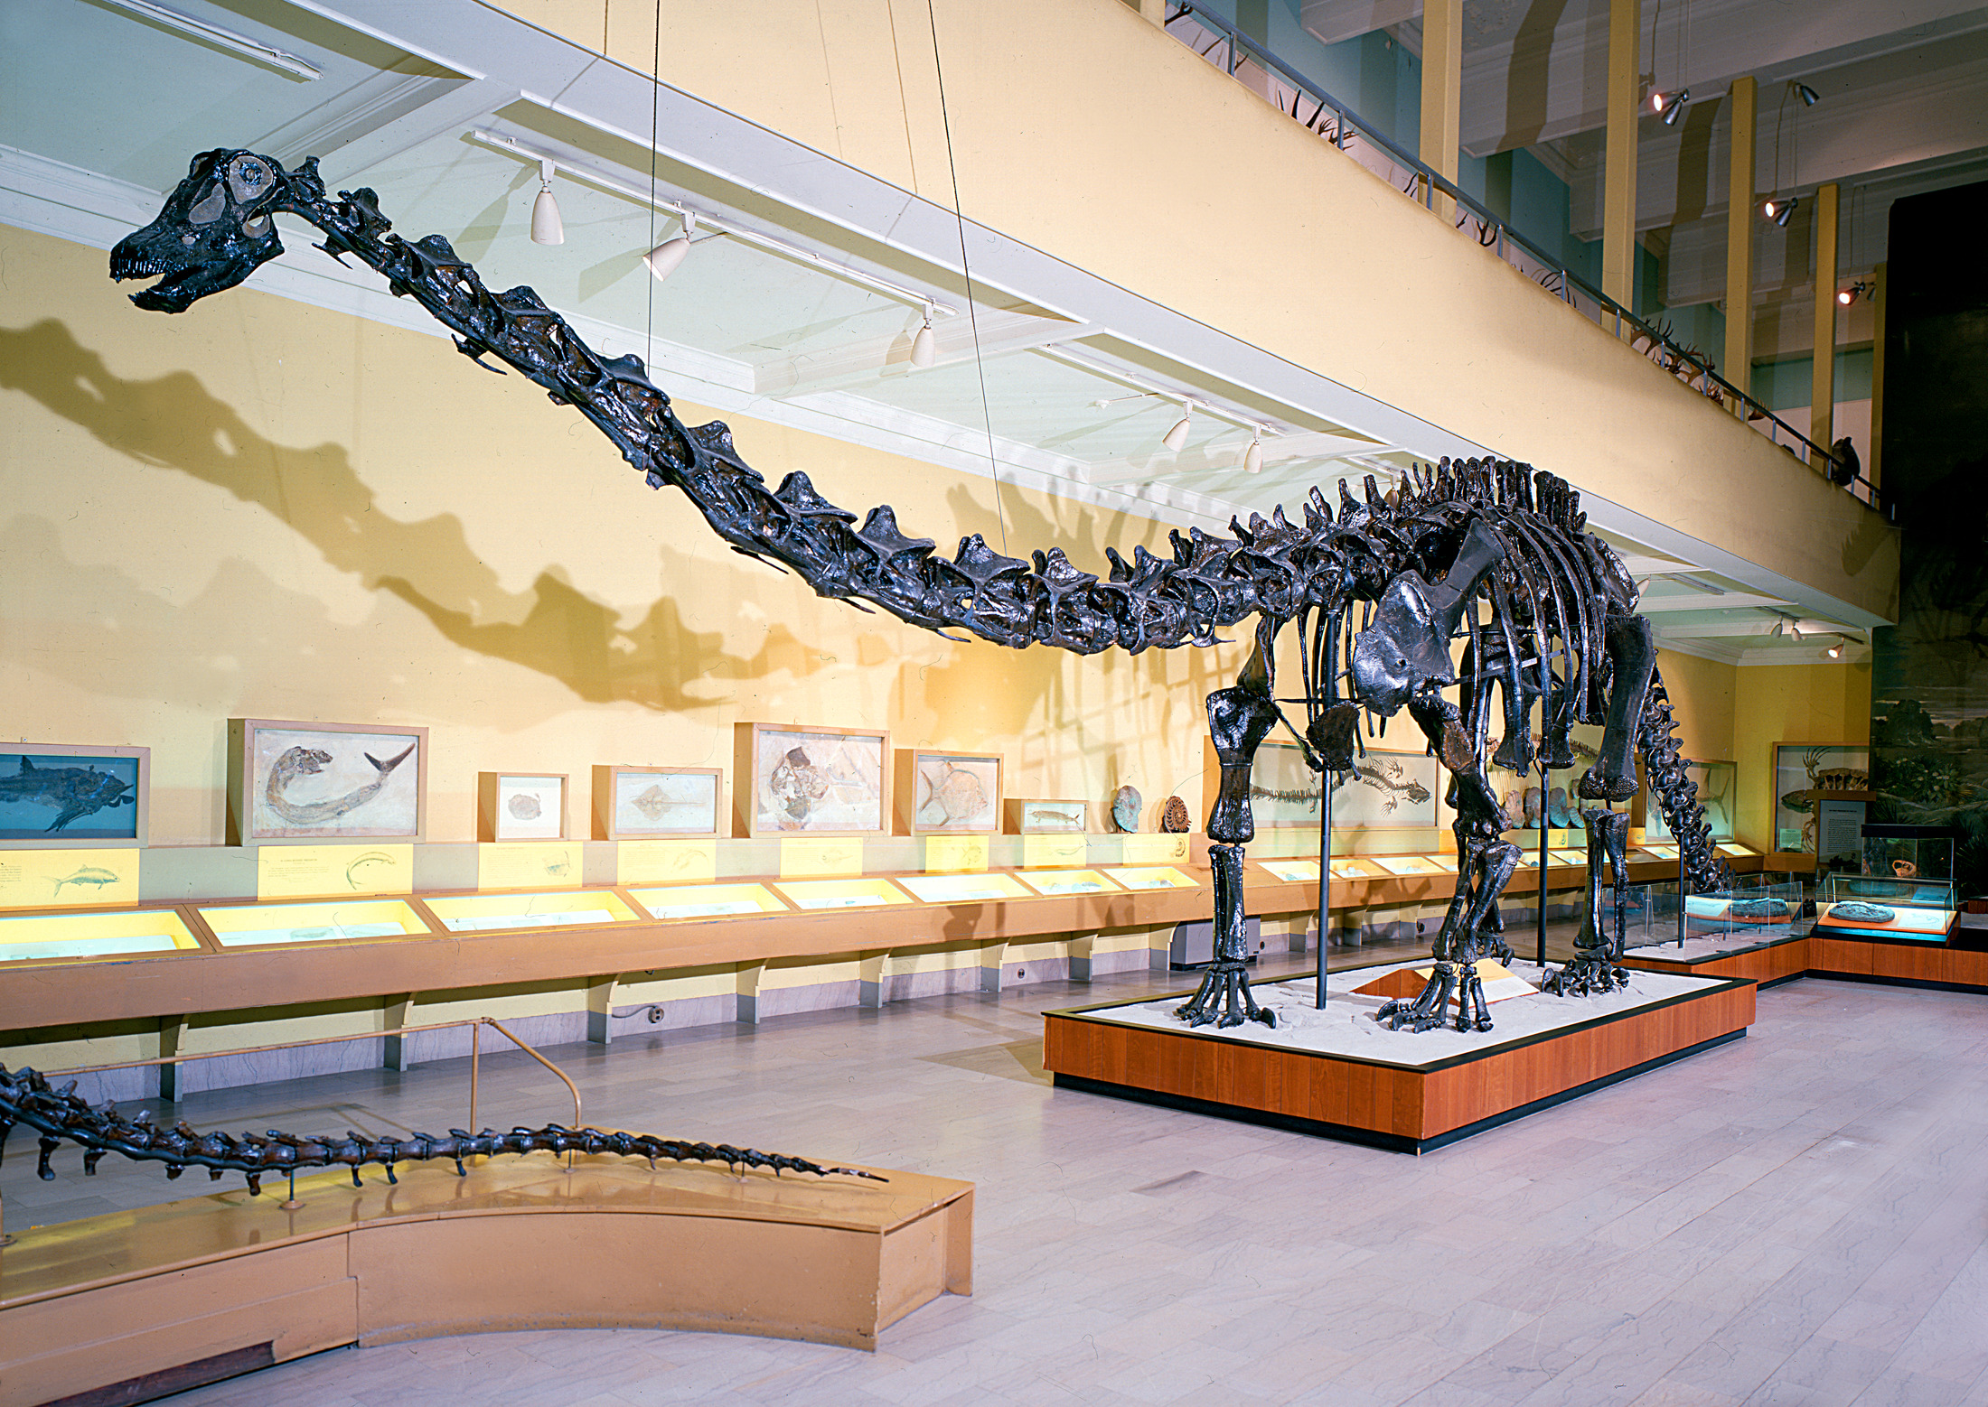

**Figure 17.** Right forefeet of the Carnegie *Diplodocus* and its casts, all in approximately anterior view. **A.** The feet as originally mounted in 1905 (in the London cast), 1907 (in the first iteration of the Carnegie Museum original-material mount), and subsequent casts, as supervised by Hatcher and Holland and executed by Coggeshall. This photograph shows the right forefoot of the Paris mount, which is unchanged since its original mounting. This forefoot material, sculpted from the camarasaurid specimen AMNH 965, has elongate metacarpals splayed in a semi-plantigrade posture, with multiple phalanges on each of the three medial digit and large unguals on digits I, II, and III. Photograph by Vincent Reneleau (MNHN). **B.** The right forefoot of the Berlin mount, as remounted in 2006 by Research Casting International, supervised by Kristian Remes. This consists of the original casts mounted in 1908 by Holland and Coggeshall, reposed in a more modern digitigrade posture, with superfluous phalanges and unguals discarded (see text). Photograph by Verónica Díez Díaz (MfN). **C.** The forefeet of *Galeamopus* (= “*Diplodocus*”) *hayi* HMNS 175 (formerly CM 662), casts of which were used in the Carnegie mount between 1999 and 2007. Note the much shorter metacarpals, the fully digitigrade posture, the reduction in phalangeal count, and the single large manual ungual on digit I. Photograph by Jeremy Huff (TAMU). **D.** The present forefeet of the Carnegie mount, modelled in 2007 after those of WDC-FS001A, then thought to belong to *Diplodocus carnegii* (Bedell and Trexler 2005) but currently thought to belong to an as-yet unnamed basal diplodocine (Tschopp et al. 2015:229–230). Note the resemblance to the diplodocine forefoot in part C, with short metacarpals, digitigrade posture, reduced phalangeal count, and a single large manual ungual. Photograph by Matthew C. Lamanna (CM).

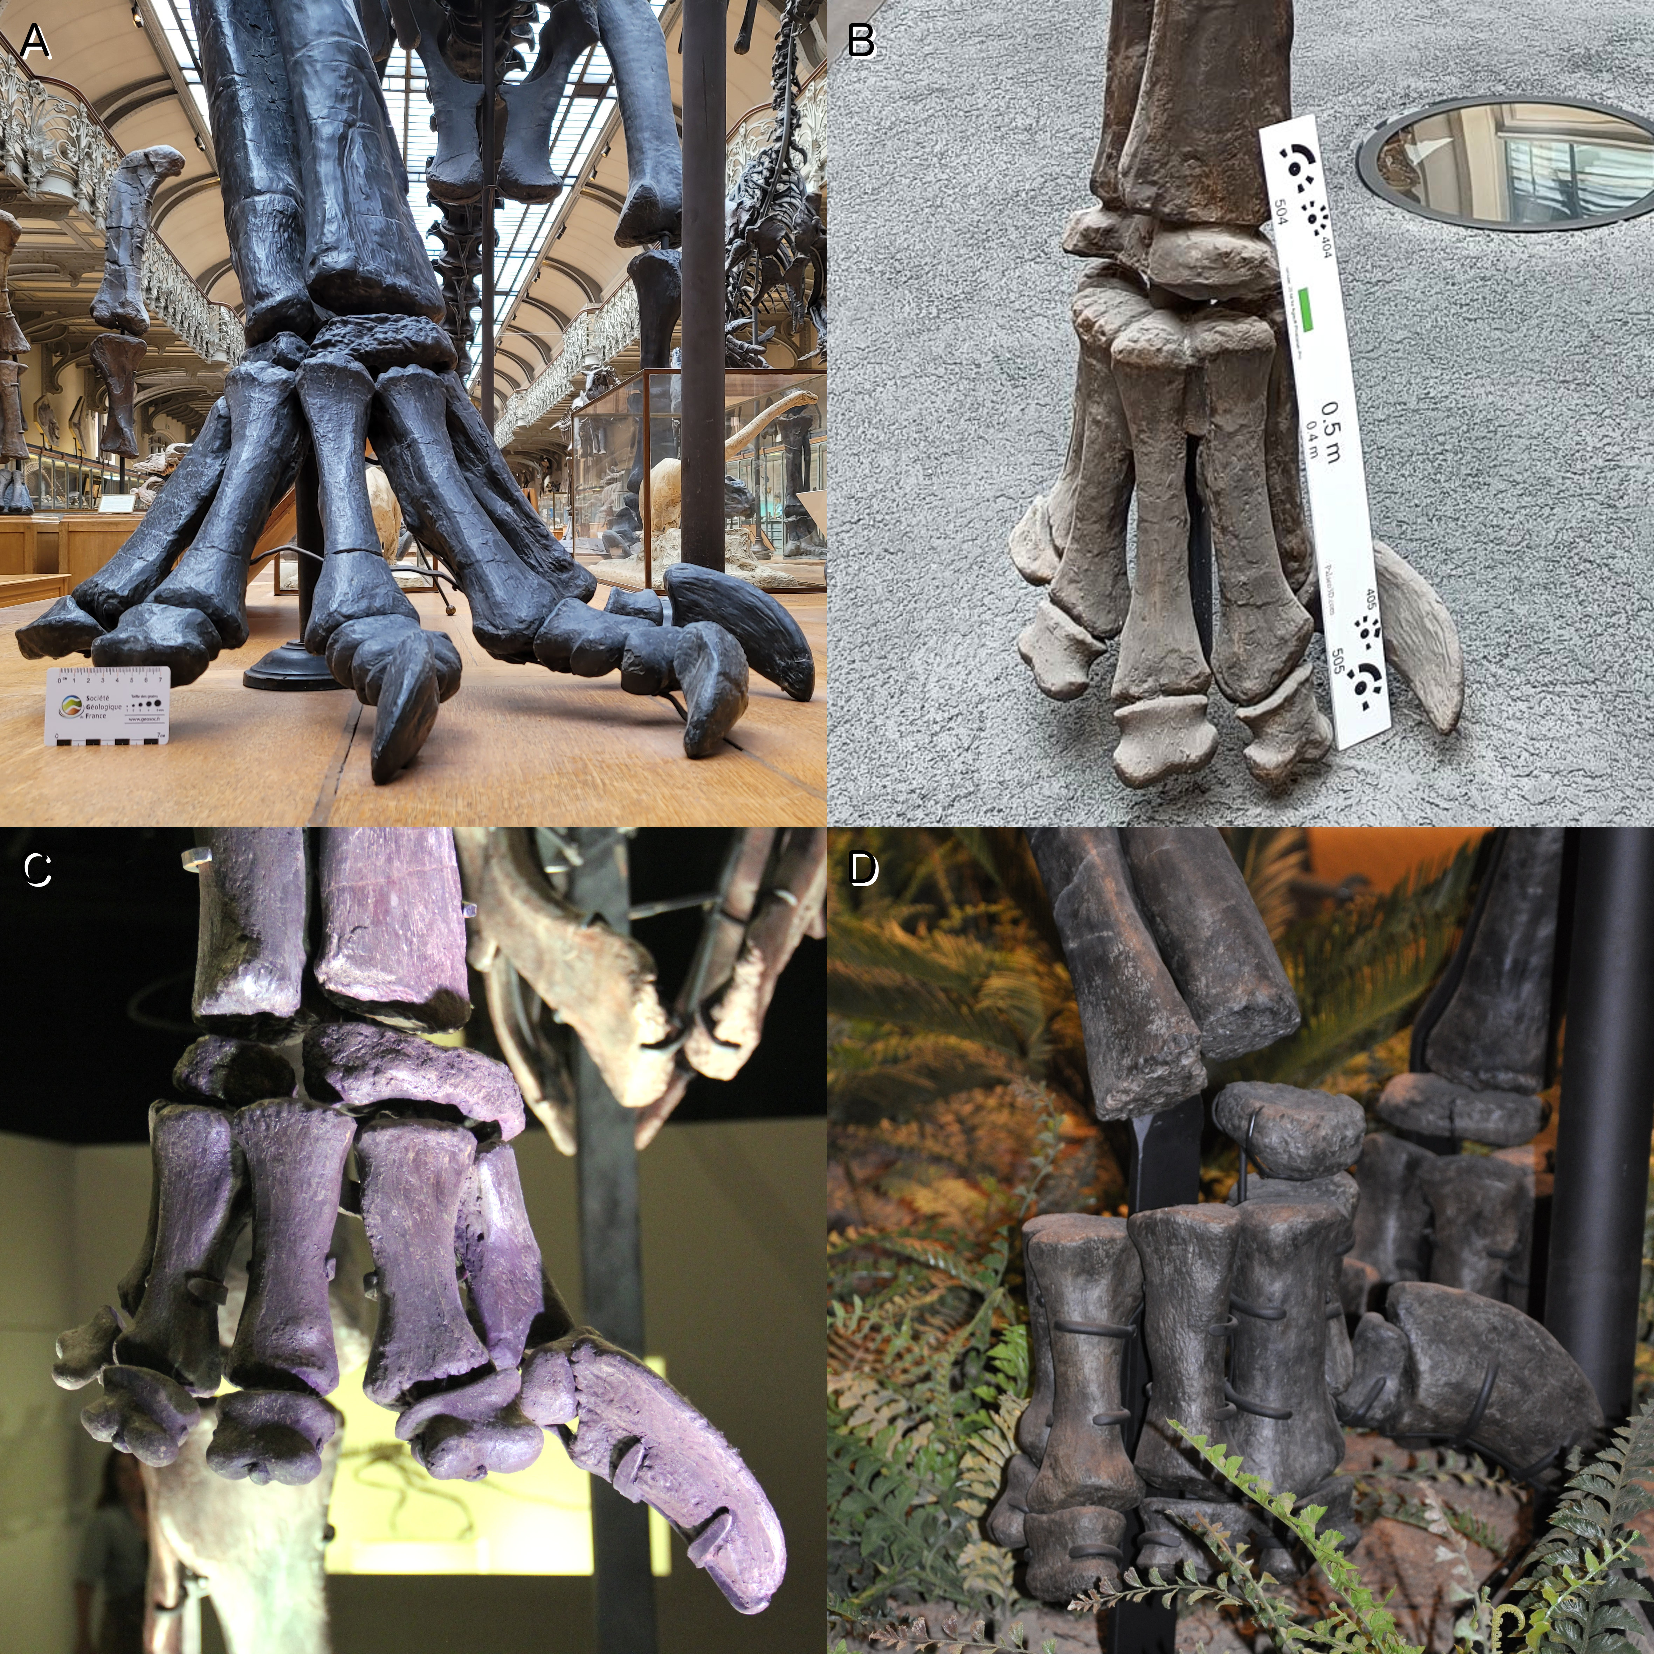

**Figure 18.** The Carnegie *Diplodocus* in left posterolateral view, toward the end of the remounting process at Phil Fraley Productions’ studio (Hoboken, New Jersey) in 2007. The armature has not yet been painted to match the bone, and the posterior segment of the tail has yet to be fitted. Photograph by Phil Fraley.

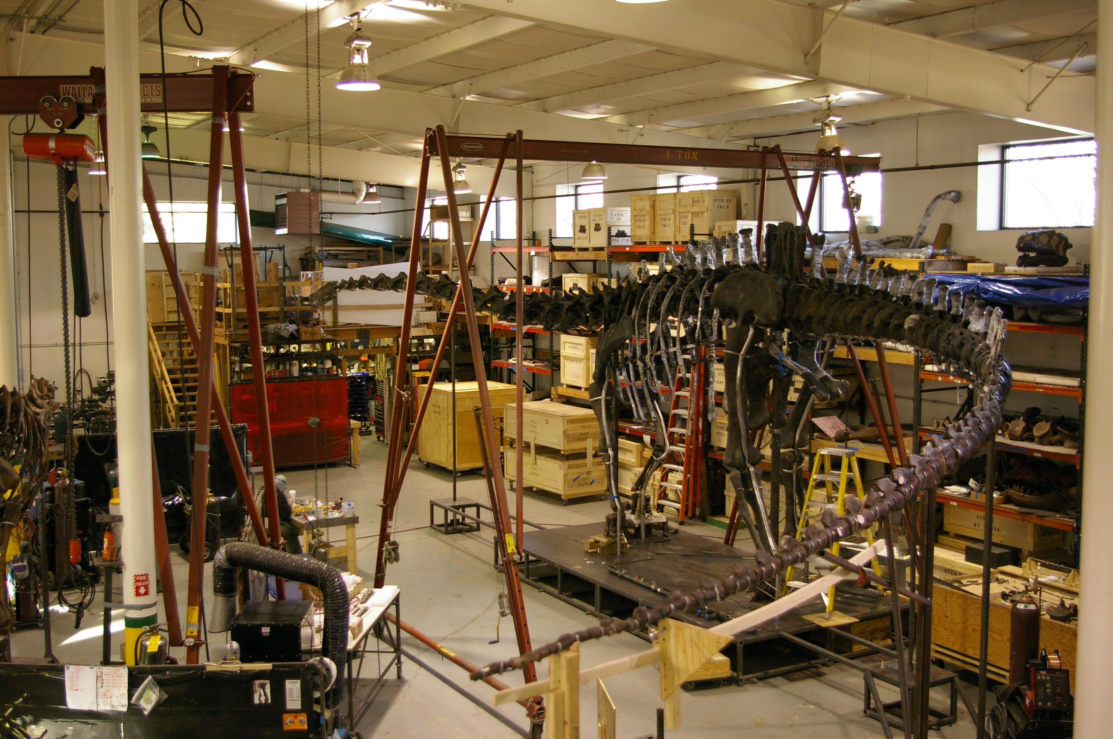

**Figure 19.** Caudal vertebrae 37–48 of Diplodocidae indet. CM 307 in left lateral view. Top rows: Ca37–43 (labelled as 37, 38a, 38b and 39–42). Bottom rows: Ca44–51 (labelled as Ca43–50). Photographs provided by Phil Fraley, drawings reproduced from Holland (1906:plate XXIX). Note that Holland’s illustrations are rather optimistic, and that the real fossils preserve less of the neural spines and zygapophyses than suggested.

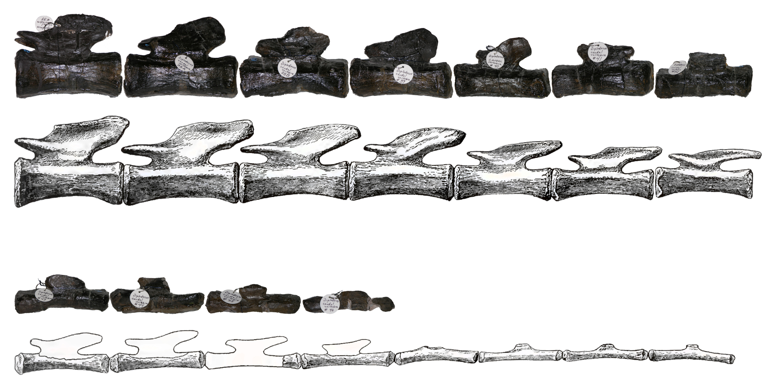

**Figure 20.** The tail of the current mounted skeleton of *Diplodocus carnegii* in right lateral view, consisting of original fossil and sculpted elements from the holotype CM 84 and paratype CM 94, and Diplodocinae indet. CM 307. The five sacral vertebrae S1–5 and first 40 caudal vertebrae Ca1–40 are labelled above the elements: numbers with white backgrounds indicate real fossils, and those with gray backgrounds indicate sculpted models, except that it is likely that one of the grey CM 94 elements has been replaced by a fossil. All of the CM 307 caudals are real bone except the last four, which are sculptures created to replace the stolen posteriormost vertebrae. The sources of the bones (or of bones that models were based on) is shown below the tail: elements from CM 84 in red, those from CM 94 in green, and those from CM 307 in gold.

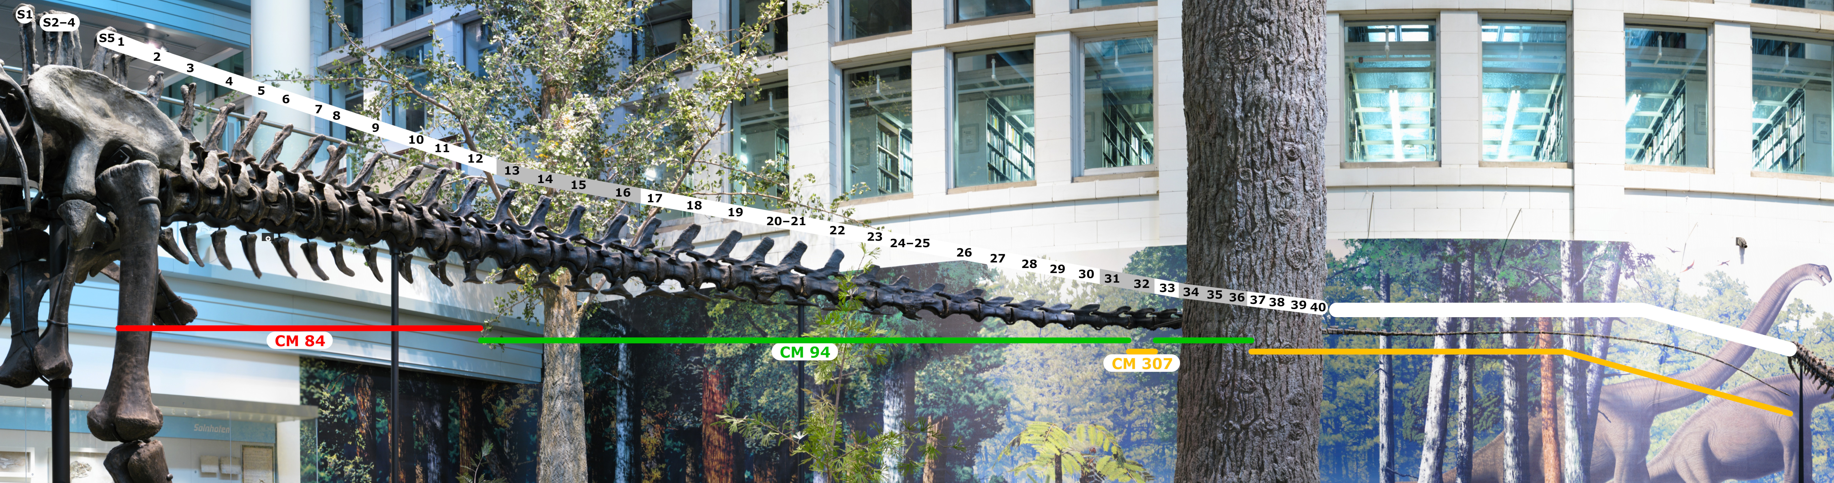

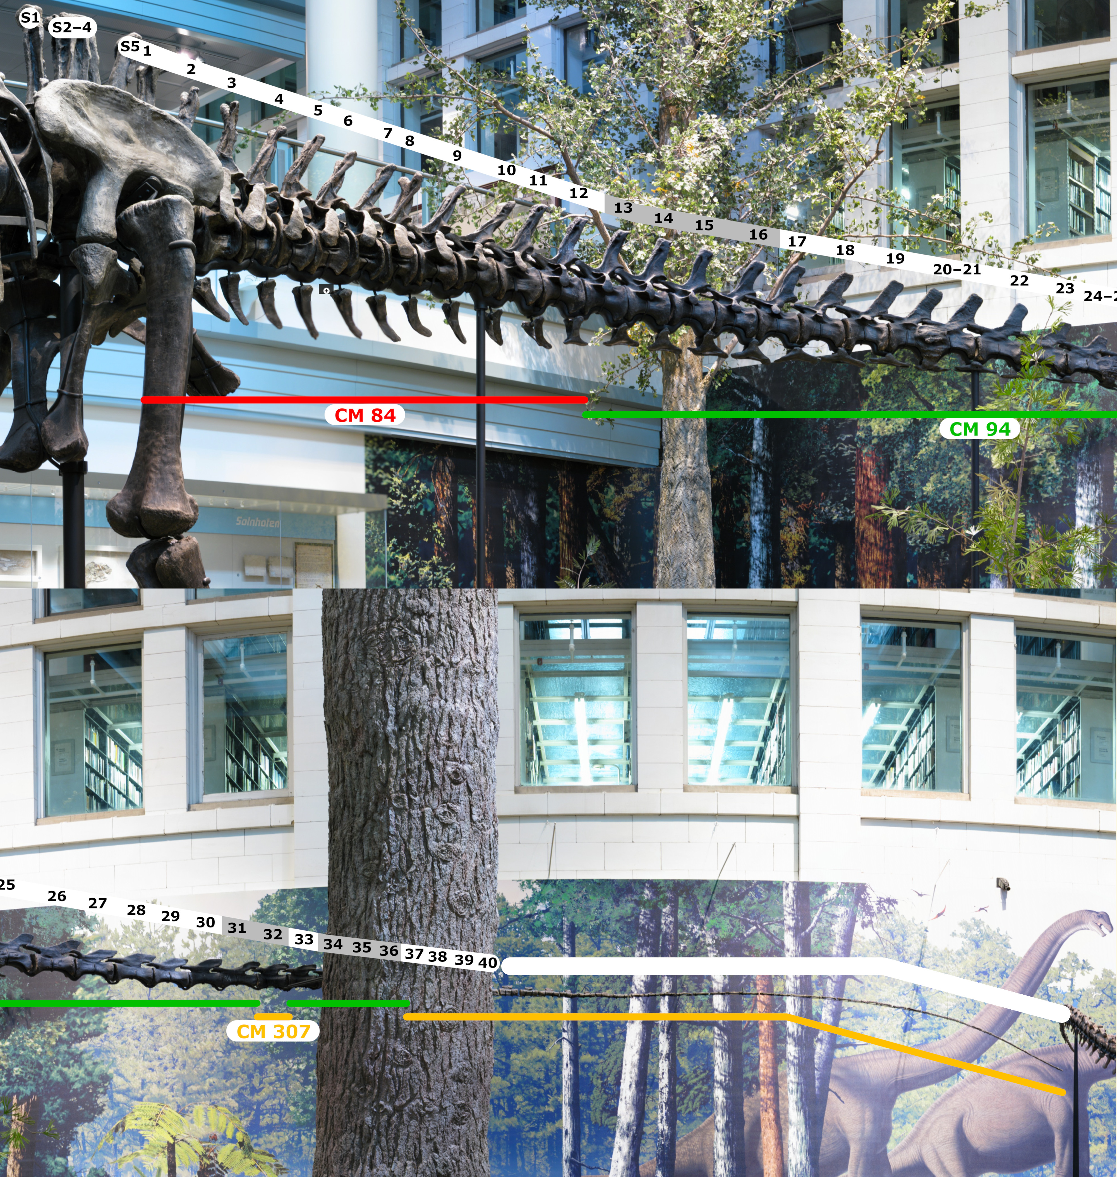

**Figure 21.** Mid-caudal vertebrae of diplodocine sauropods, all from approximately the same region of the tail, plus or minus two positions. **A.** *Diplodocus* *longus* CM 887. **B.** *Diplodocus* *carnegii* CM 94. **C.** *Diplodocus* sp. CM 11975. **D.** *Galeamopus* (= “*Diplodocus”*) *hayi* HMNS 175 (formerly CM 662). Scale bar 10 cm. Reproduced from an in-prep manuscript by permission of Ken Carpenter.

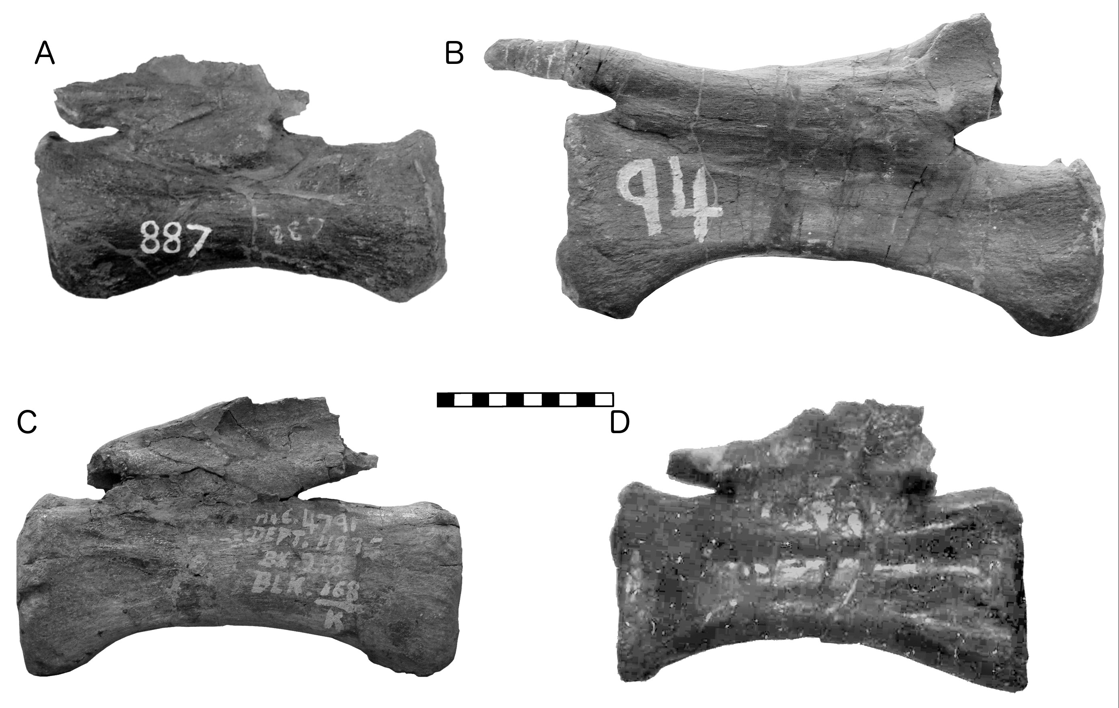

**Figure 22.** Digital models used for measuring the total length of the current Carnegie *Diplodocus* mount. **A.** Photogrammetric model created by Peter Falkingham (Liverpool John Moores University) from photographs taken by former Carnegie Museum volunteer Hannah Smith (now Hannah Rak). This screenshot, viewing the model as though from above and slightly to the left of the mounted sauropods, shows the *Diplodocus carnegii* mount at top left and the *Apatosaurus louisae* holotype CM 3018 at bottom right. Pale blue dots along the midline of the *Diplodocus* model show where markers were placed: at the tip of the snout, at mid-neck, at the cervicodorsal junction, on the neural spine of each of the first 33 caudal vertebrae, at the tip of the tail, and at a point midway between Ca 33 and the tail tip. The total length was calculated as the sum of the measurements between consecutive markers: 6.76 m for the head and neck, 3.78 m for the trunk, and 15.51 m for the tail, totaling 26.05 m. **B.** LIDAR-based model by Dakota Campbell (Eye-Bot Aerial Solutions, New Kensington, Pennsylvania). Blue boxes show lengths of measured segments in feet and inches. The total of these measurements is 85 feet, 8+11/16 inches (= 26.13 m).

